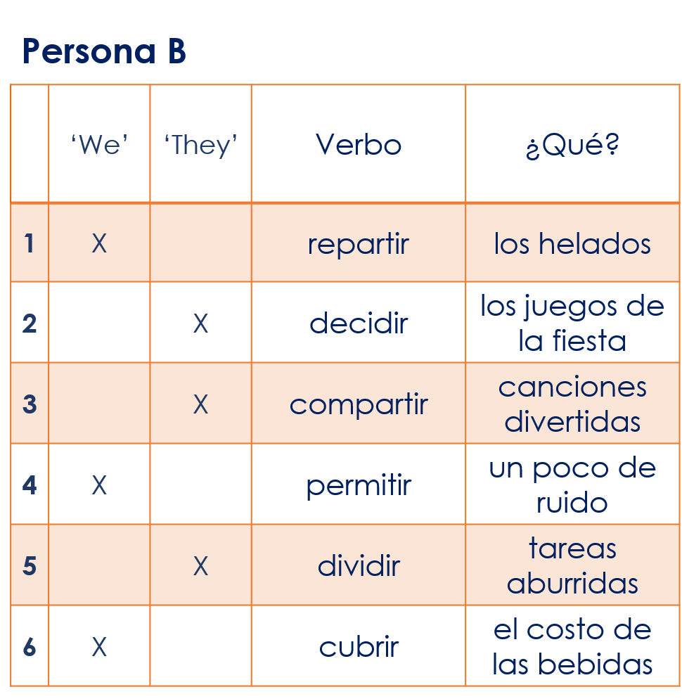
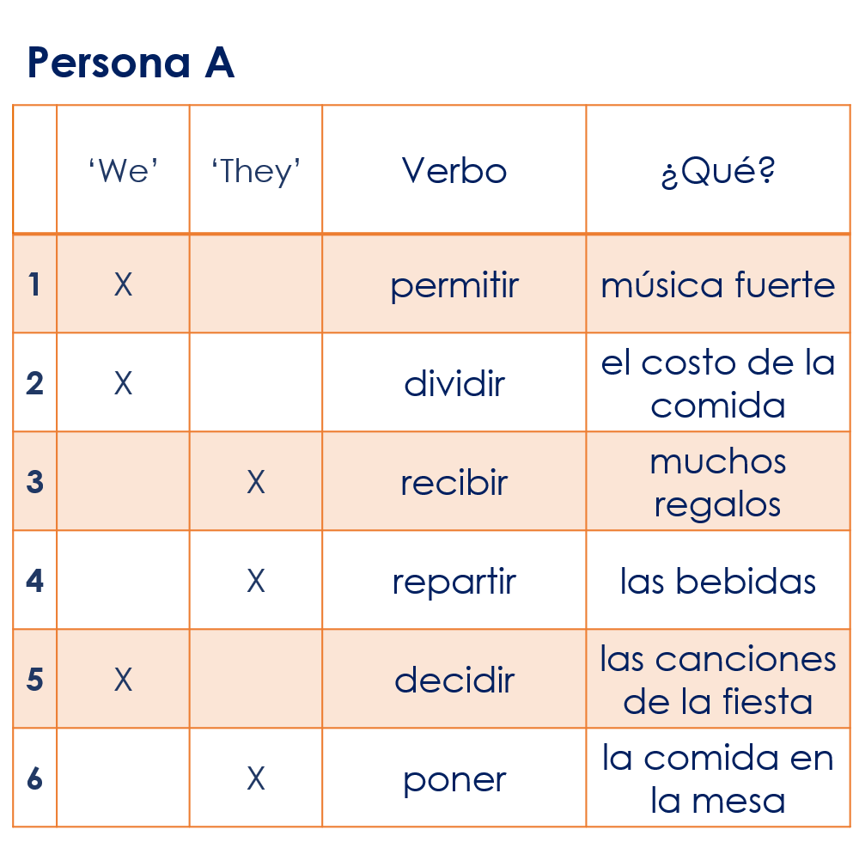
Year 8 Spanish Term 1.1 Week 7 – Lesson 1 speaking cards

