Names and ages jigsaw task – French
-----------------------------------------------------------------------------------------------------------------------
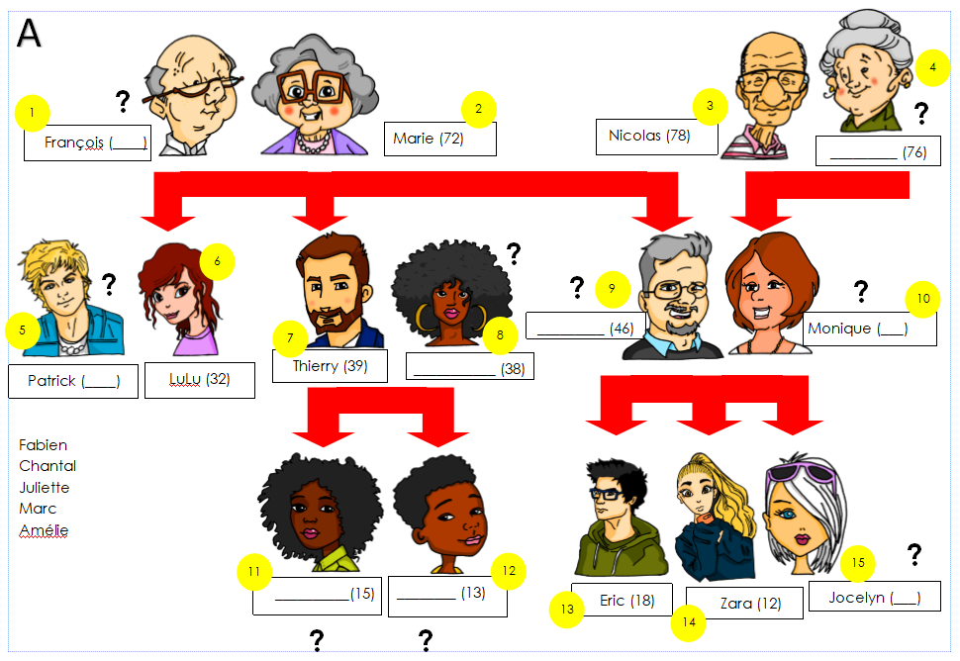
Picture A

-----------------------------------------------------------------------------------------------------------------------
Picture B
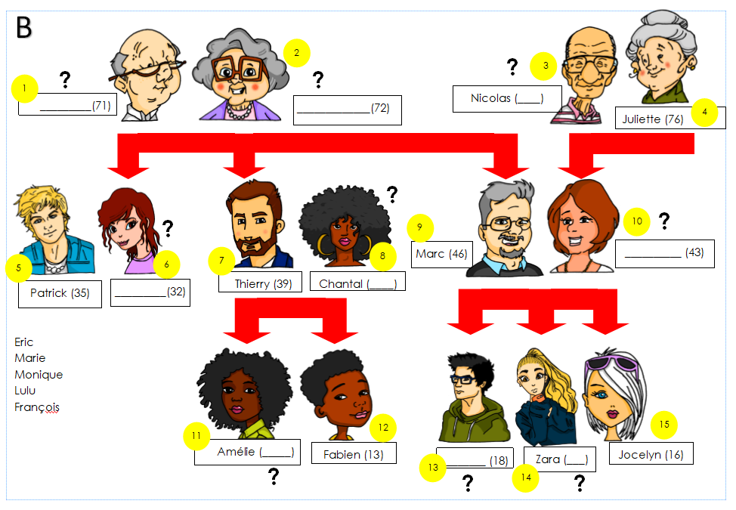

Teacher instructions
This activity is designed for Year 7 or beginner students. Divide students into pairs and give each student one picture, A or B. Both A and B have information missing.
To complete the family tree, students ask:
‘Numéro 1 a quel âge?’
OR
Numéro 1, c’est qui?
Language required
Correct use of ‘a’ [avoir] for age and ‘est’ [être] for identification, and numbers.
In addition, students use their decoding knowledge to sound out the names.
On this version, pupils have a list of names to recognise from their partner’s pronunciation.
On a second version below, the names are removed, and students transcribe the names, using their SSC knowledge.

Names and ages jigsaw task – French [Version 2]
-----------------------------------------------------------------------------------------------------------------------
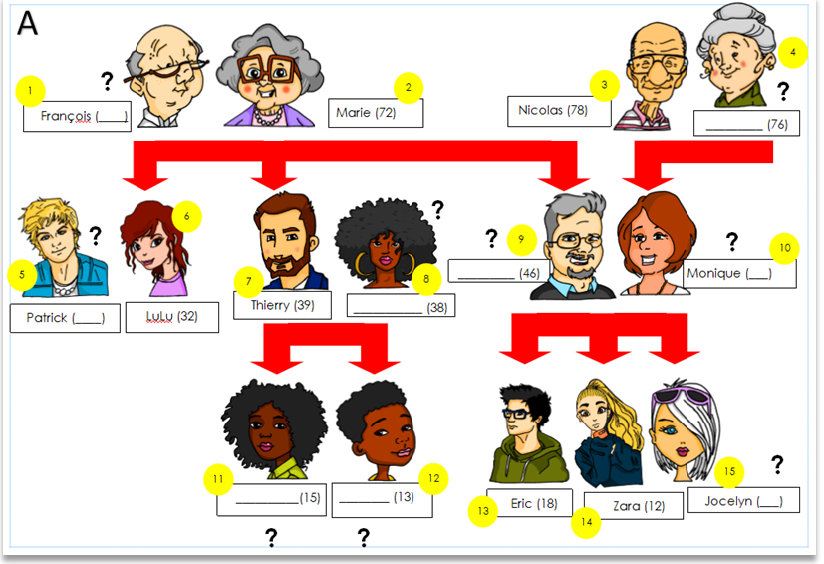
Picture A

-----------------------------------------------------------------------------------------------------------------------
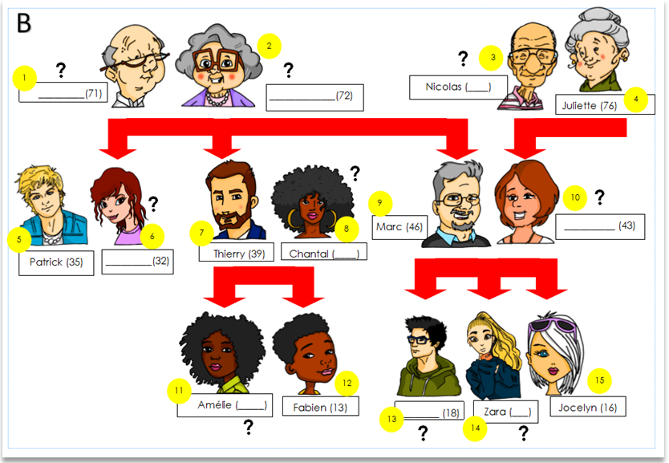
Picture B

