How can I download all resources for a language year group from the NCELP Resource Portal?
- From the Resource Portal home page, click on ‘All Collections’.

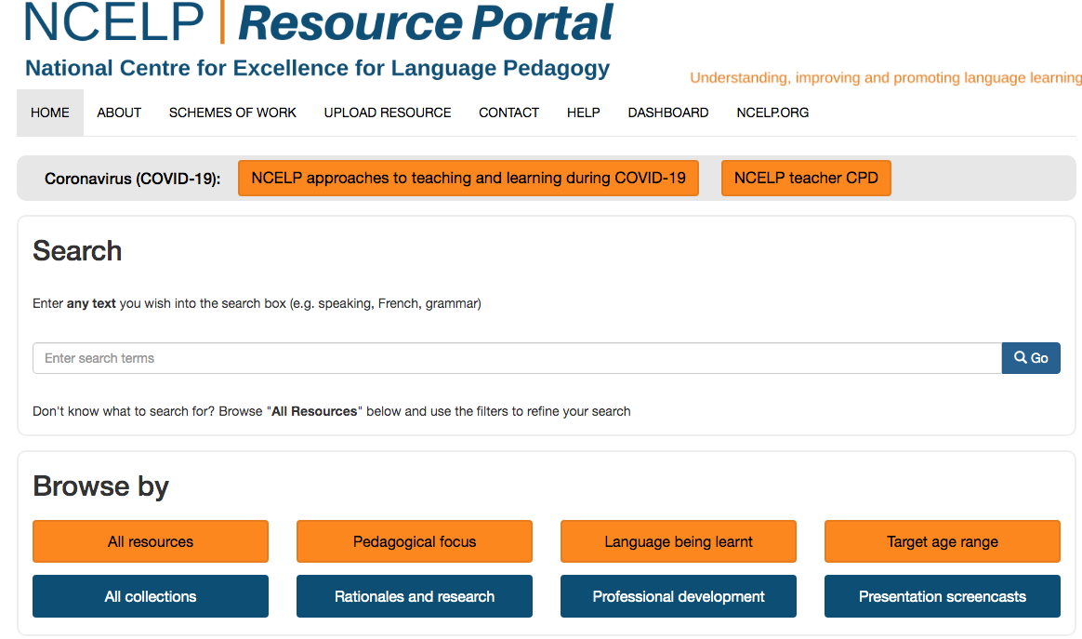

- Scroll down to Schemes of Work and teaching materials for French, German or Spanish. You can see links for SOW and materials for each year group and term. Click the term you want, for example French Year 7 Term 1 full lessons.

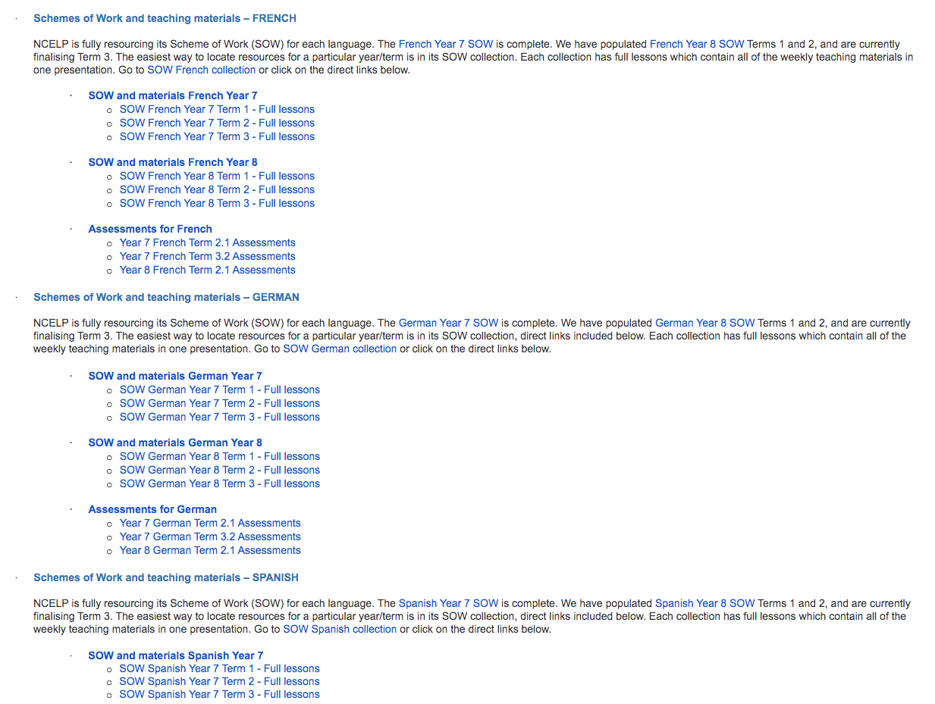

- Scroll down to the bottom of the page, and click on the blue ‘Download All’ button in the bottom left corner.

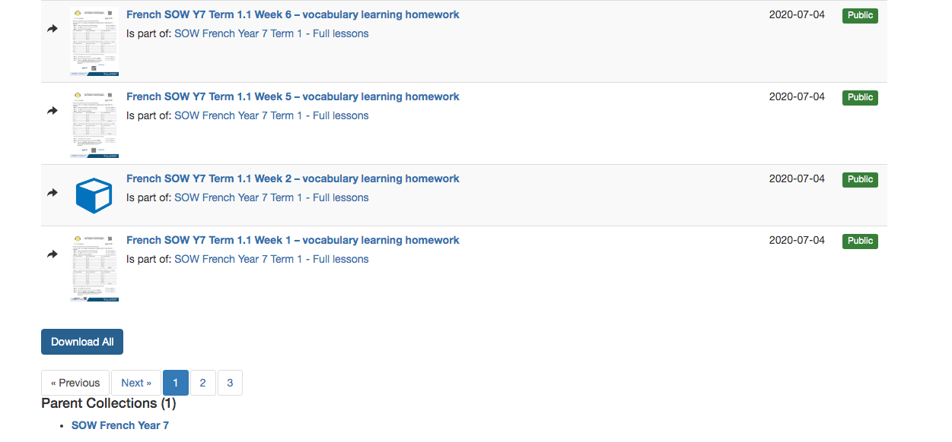

- This will download a Zip file which once downloaded can be opened to ‘unpack’ the resources for French Year 7 Term 1.

