How do I find teaching resources on the NCELP Resource Portal?
There are various search options depending on if you know what resource you are looking for. The easiest way is to use the Scheme of Work to see what the name of the resource is for each week.
Searching for resources which accompany the Schemes of Work
1. NCELP lessons are named in the following format: Language, Year Number, Term (1.1 for term 1 first half term), Week Number. This corresponds to how they are listed in the SoW.
For example, if you want to find the full lesson for the very first Spanish lesson of Year 7, you would type in ‘Spanish Y7 Term 1.1 Week 1 Full Lesson’ in the search box on the Resource Portal. Then click the ‘Go’ button.
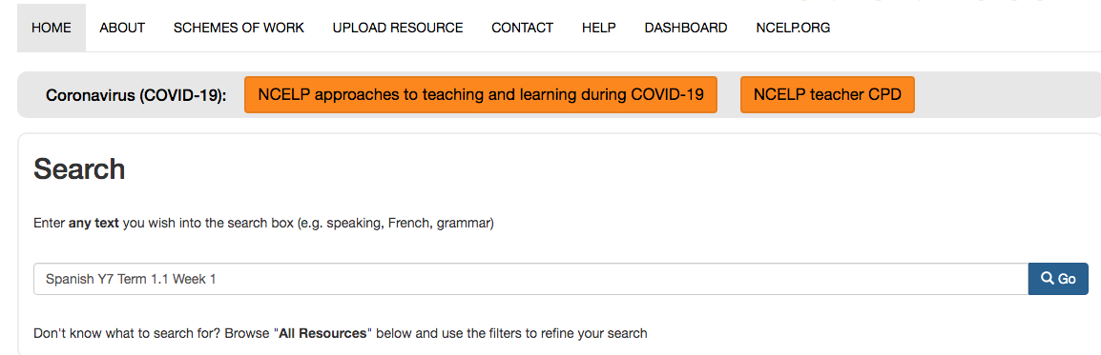
2. Then click on the title of the resource. The resources will have a description of the Phonics and Grammar focus of the lesson. Read the descriptions to ensure you pick the correct resource for you (note that in the second link below there is integrated audio support).
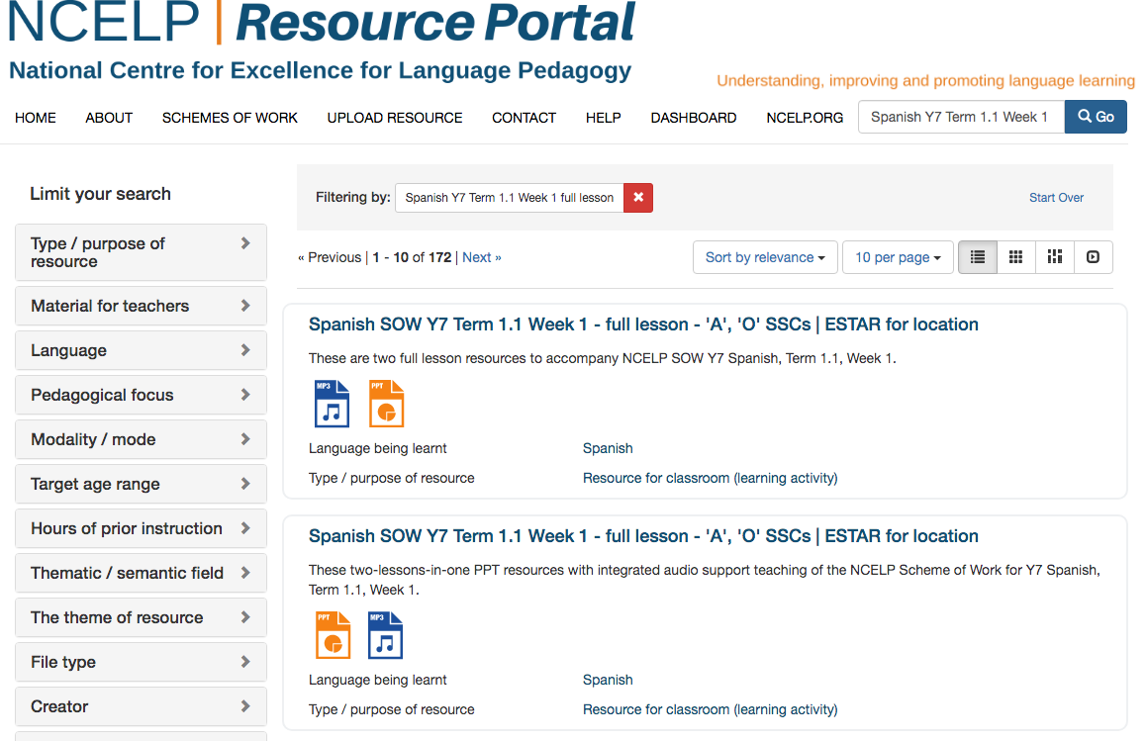
3. On the next page you will find the full lesson and any accompanying resources that can be downloaded and printed out for activities in the lesson (usually these are speaking cards). Simply click on the blue button to download the resource you need.

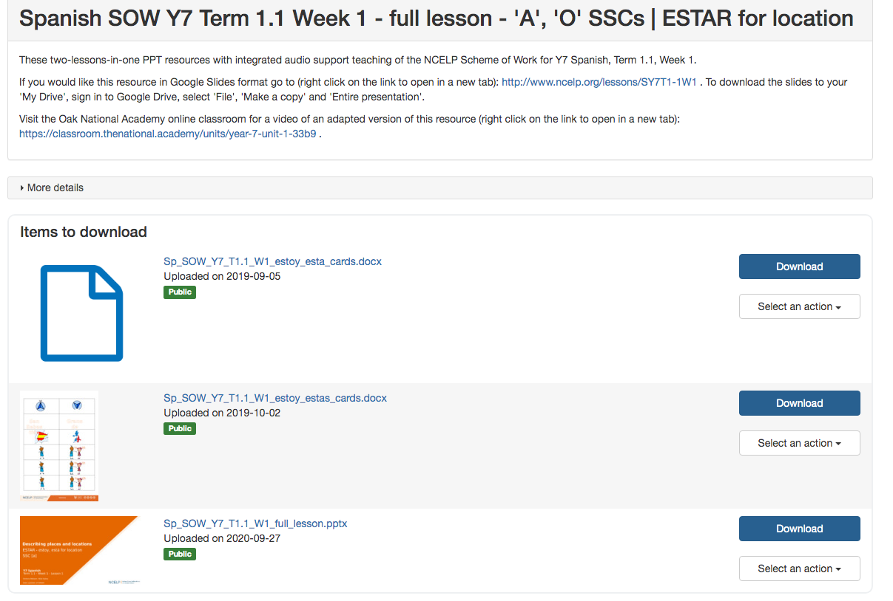

4. When the download has been completed, you can click on it to open it and then ‘Save As…’ to save it to your preferred location on your own computer.
5. Another option is to go directly from the SOW. Click on the ‘Resources’ tab at the bottom of the SOW and then click on the resource that you wish to open. They are all linked to the Resource Portal.

Searching for resources via ‘Pedagogical focus’ or ‘Language being learnt’
1. Resources can also be searched via clicking on ‘Pedagogical focus’ or ‘Language Being Learnt’ from the Resource Portal homepage. Selecting the former option allows you to search via categories such as ‘Phonics’, ‘Grammar’, ‘Vocabulary’ and ‘Type of Practice’.

