Worksheet A (writing and speaking)
Instructions: Person A
- Look at the four pictures.
- Write what you see.
- Your sentence should start with ‘sie’, which can mean ‘she’ or ‘they’.
- Make sure you use the correct form of the verb!
- Say your four sentences to your partner.
- Now swap roles!

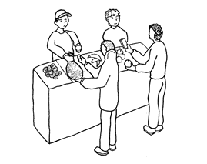

- Sie______________________________

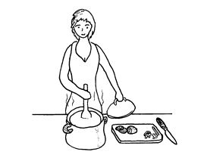

- Sie______________________________

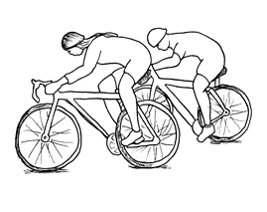

- Sie______________________________

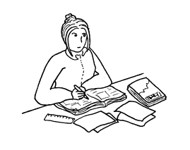

- Sie______________________________

- Listen to your partner’s description.
- Write down what you hear.
- Then circle the picture your partner described.
- Remember to pay attention to the verb ending!
Person A (continued)
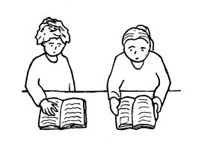
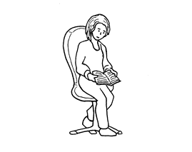

- ODER

Sie______________________________
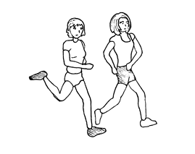
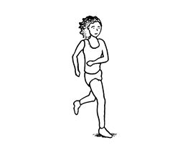

- ODER

Sie______________________________
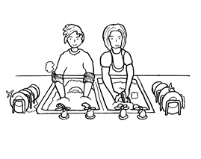
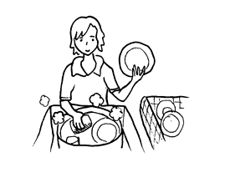

- ODER

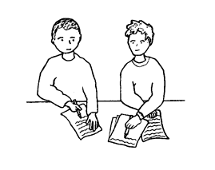
Sie______________________________
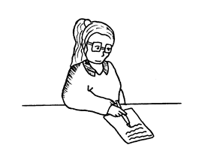

- ODER

Sie______________________________

Worksheet B (writing and speaking)
Instructions: Person B
- Listen to your partner’s description.
- Write down what you hear.
- Then circle the picture your partner described.
- Remember to pay attention to the verb ending!
- Now swap roles.
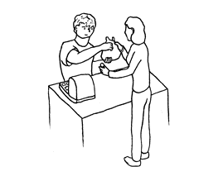

- ODER

Sie______________________________
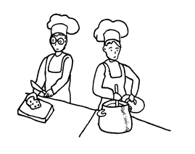

2. ODER

Sie______________________________

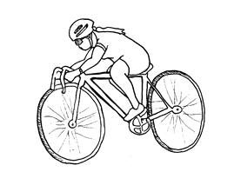

3. ODER

Sie______________________________
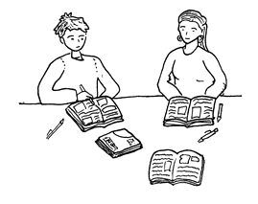

4. ODER

Sie______________________________

Person B (continued)

- Look at the four pictures.
- Write what you see.
- Your sentence should start with ‘sie’, which can mean ‘she’ or ‘they’.
- Make sure you use the correct form of the verb!
- Say your four sentences to your partner.

5. Sie______________________________

6. Sie______________________________

7. Sie______________________________

8. Sie______________________________

