**Im Zoo**

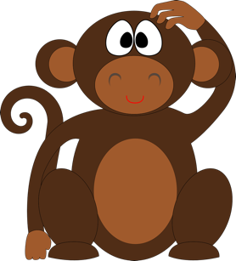You are visiting the zoo. The zookeeper is telling you all about the animals they have. But the animals are noisy!

Can you tell whether the zookeeper is talking about **one** or **more than one** of the animals?  
Circle the correct answer.

Remember to pay attention to the ending of the verb.

**B**

**A**

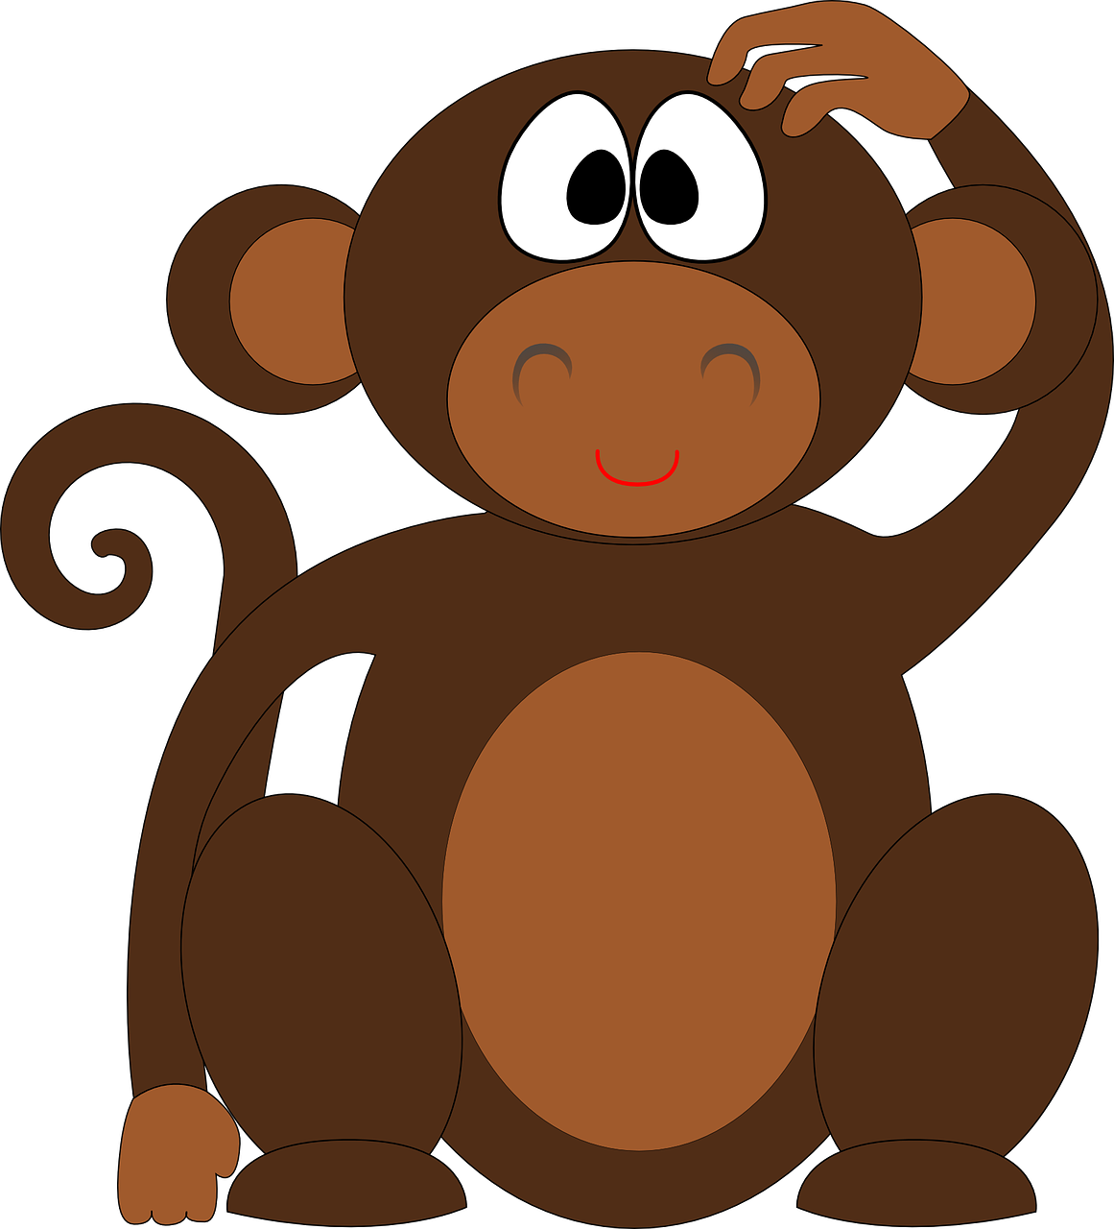

**1.**

**B**

**A**

**2.**  

**B**

**A**



**3.**  

**B**

**A**

**4.** 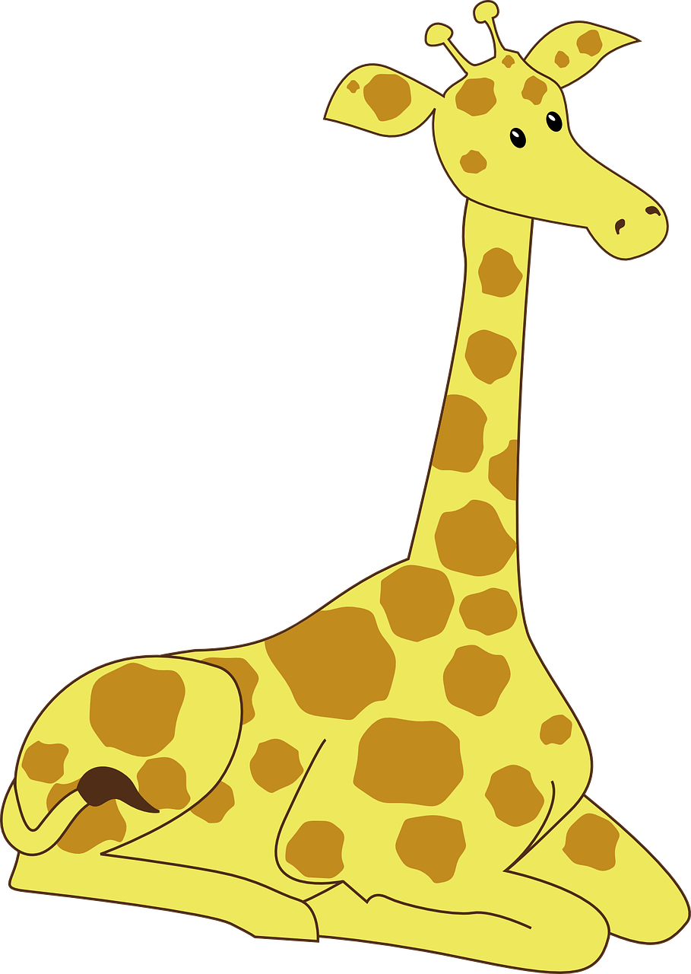 

**B**

**A**

 **5.** 