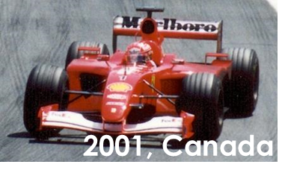
10.1.1.1 (Foundation)

Another yes/no question. There’s no room for ‘does’ in German questions!
Think about the R1 (nom.) adjective ending here:
ein ………….. F1 Fahrer.
Schreib die Sätze auf Deutsch.
Remember! There’s only one present tense in German. And how do you create yes/no questions?
1. Michael Schuhmacher was a German F1 driver.
Use the nationality noun here. Do you need the masculine or feminine version?
2. His wife Corinna is also German.
3. Is he driving F1 now?
4. No, in 2013, the German had a ski accident.
5. In 2021, Netflix makes a film in English, German and French.
Many nationality nouns are the country + -er, often with an umlaut.
6. The Englishmen Bernie Eccleston, Damon Hill and David Coulthard give interviews.
7. Does Schuhmacher speak in the film? Unfortunately not.
Image: Paul Lannuier from Sussex, NJ, USA, CC BY-SA 2.0 via Wikimedia Commons

10.1.1.1 (Higher)

Do you need a preposition if the action is finished?
Schreib die Sätze auf Deutsch.
1. Michael Schuhmacher was an F1 driver for 17 years.
This nationality noun behaves like an adjective.
Think: the German (citizen)
der ……… (Bürger)
2. In 2013, the German has a ski accident.
Remember! Use the present tense with the preposition since in German.
3. Since 2013, he has not been driving.
4. He was in a hospital* in Grenoble for a year.
Do you need to add anything to R3 (dat.) plural nouns?
5. In 2021, Netflix makes a film, which is in English, German and French.
6. There are interviews with three Englishmen, Bernie Eccleston, Damon Hill and David Coulthard.
Remember how to form yes/no questions in German.
7. Does Schuhmacher speak now? Unfortunately, the answer is no.
Image: Paul Lannuier from Sussex, NJ, USA, CC BY-SA 2.0 via Wikimedia Commons

