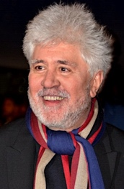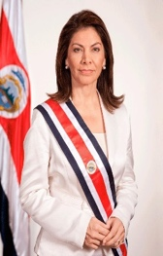

1. Where did you spend your childhood*?

2. What did you study?

3. When did you start your career?

4. How did you manage to be successful?

5. Why did you change job?

Pedro Almodóvar (director de cine)

1. Where did you spend your childhood*?

2. What did you study?

3. When did you start your career?

4. How did you manage to be successful?

5. Why did you change job?

Laura Chinchilla (presidenta de Costa Rica, 2010-2014)

**childhood = la infancia**

**childhood = la infancia**

1. Where did you spend your childhood*?

2. What did you study?

3. When did you start your career?

4. How did you manage to be successful?

5. Why did you change job?

Francia Márquez (abogada y activista)

Carlos Sainz Junior (piloto de Fórmula 1)

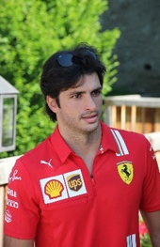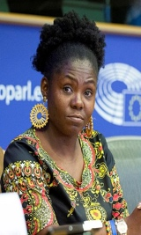

* I spent my childhood* in Madrid.
* In 2021 I changed team in order to drive a better car.
* I didn’t need to study at university.
* I worked hard!

**childhood = la infancia**

* When I was 7 I started to drive.

**childhood = la infancia**

1. Where did you spend your childhood*?

2. What did you study?

3. When did you start your career?

4. How did you manage to be successful?

5. Why did you change job?

Pedro Almodóvar (director de cine)

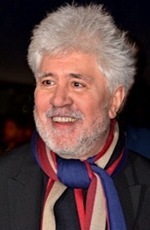

Laura Chinchilla (presidenta de Costa Rica, 2010-2014)

* I spent my childhood* in San José



* I studied politics*
* After university I started my career.
* In order to work in the USA



**politics = la política**

* I am calm and I try to help many people.

**childhood = la infancia**

**childhood = la infancia**

1. Where did you spend your childhood*?

2. What did you study?

3. When did you start your career?

4. How did you manage to be successful?

5. Why did you change job?

Francia Márquez (abogada y activista)

1. Where did you spend your childhood*?

2. What did you study?

3. When did you start your career?

4. How did you manage to be successful?

5. Why did you change job?

Carlos Sainz Junior (piloto de Fórmula 1)

**childhood = la infancia**

**childhood = la infancia**

1. Where did you spend your childhood*?

2. What did you study?

3. When did you start your career?

4. How did you manage to be successful?

5. Why did you change job?

Pedro Almodóvar (director de cine)

1. Where did you spend your childhood*?

2. What did you study?

3. When did you start your career?

4. How did you manage to be successful?

5. Why did you change job?

Laura Chinchilla (presidenta de Costa Rica, 2010-2014)



Francia Márquez (abogada y activista)



**childhood = la infancia**

**childhood = la infancia**

1. Where did you spend your childhood*?

2. What did you study?

3. When did you start your career?

4. How did you manage to be successful?

5. Why did you change job?

Carlos Sainz Junior (piloto de Fórmula 1)

* I studied law* at university
* I spent my childhood near Cali, Colombia.

**law = el derecho**

* I didn’t change job
* I started to take part in demonstrations when I was 13
* I always do everything to protect my community

**childhood = la infancia**

**childhood = la infancia**

Pedro Almodóvar (director de cine)



* I spent my childhood in the city of Cáceres, Spain.
* I made* my first film 40 years ago.



* I tried to study cinema in Madrid, but they closed the school.
* My films are unique.
* I left my first job to make more films

1. Where did you spend your childhood*?

2. What did you study?

3. When did you start your career?

4. How did you manage to be successful?

5. Why did you change job?

Laura Chinchilla (presidenta de Costa Rica, 2010-2014)

**to make = realizar**

**childhood = la infancia**

**childhood = la infancia**

1. Where did you spend your childhood*?

2. What did you study?

3. When did you start your career?

4. How did you manage to be successful?

5. Why did you change job?

Francia Márquez (abogada y activista)

1. Where did you spend your childhood*?

2. What did you study?

3. When did you start your career?

4. How did you manage to be successful?

5. Why did you change job?

Pedro Almodóvar (director de cine)

d

**childhood = la infancia**

**childhood = la infancia**