Spot the difference – 15 verbs [3rd person singular] Spanish version
-----------------------------------------------------------------------------------------------------------------------
Picture A
Instructions
Look at the pictures. Describe to your partner what each person does.
Use the numbers to identify the people. E.g. (Número) uno habla.
Find out how many activities you have in common.
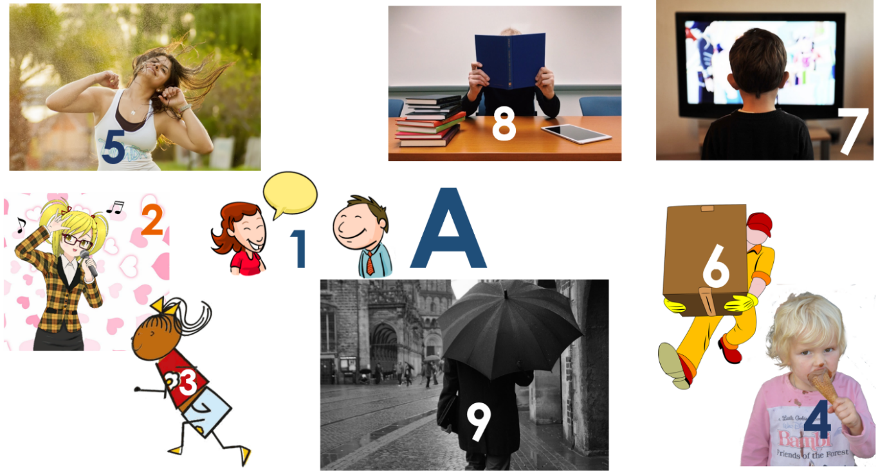

-----------------------------------------------------------------------------------------------------------------------
Picture B
Instructions
Look at the pictures. Describe to your partner what each person does.
Use the numbers to identify the people. E.g. (Número) uno escribe.
Find out how many activities you have in common.
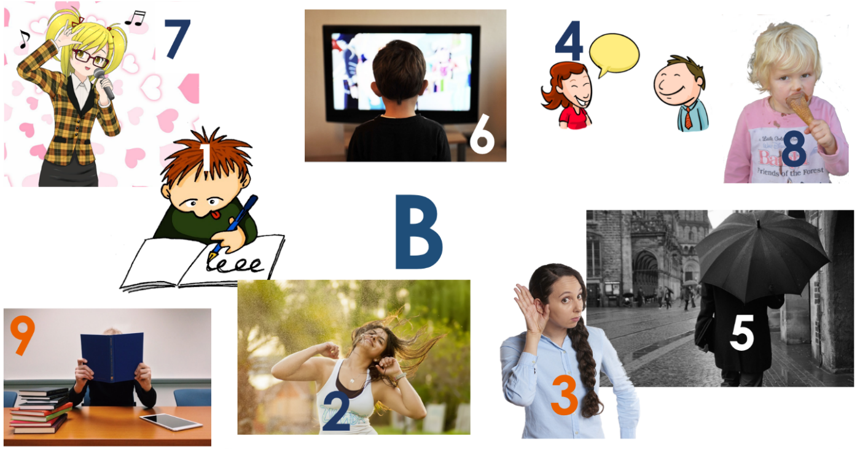

Teacher instructions

This activity is designed for Y7 or beginner learners of Spanish. Divide students into pairs and give each student one picture, A or B. Students describe what the people in their picture do. Each person is numbered to reduce the cognitive load and focus attention on verbs rather than nouns. For example: (Número) uno baila / escribe.
NB: the numbers do not match across the sets so as not to give the solution away in that way. This sustains the focus on the verbs alone.
The verbs are taken from the set of 15 high-frequency prototype verbs and/or the 25 most common verbs accompanying PowerPoint resources.
* Word frequencies are given for the infinitive form of the verbs.
Word | Word class | Word frequency
escribe | verb | 198
baila | verb | 1323
escucha | verb | 281
habla | verb | 90
sale | verb | 114
ve | verb | 38
canta | verb | 718
come | verb | 347
aprende | verb | 428
corre | verb | 343
lleva | verb | 101

Source of frequency rankings : Davies, M. & Davies, K. (2018). A frequency dictionary of Spanish: Core vocabulary for learners (2nd ed.). London: Routledge.

