Spot the difference – Transport [German version]
-----------------------------------------------------------------------------------------------------------------------
Picture A
Instructions
Look at the pictures. Describe your pictures to your partner. Use the numbers to identify them. E.g. Eins – das Auto fährt langsam.
Find out which pictures you have in common with your partner.
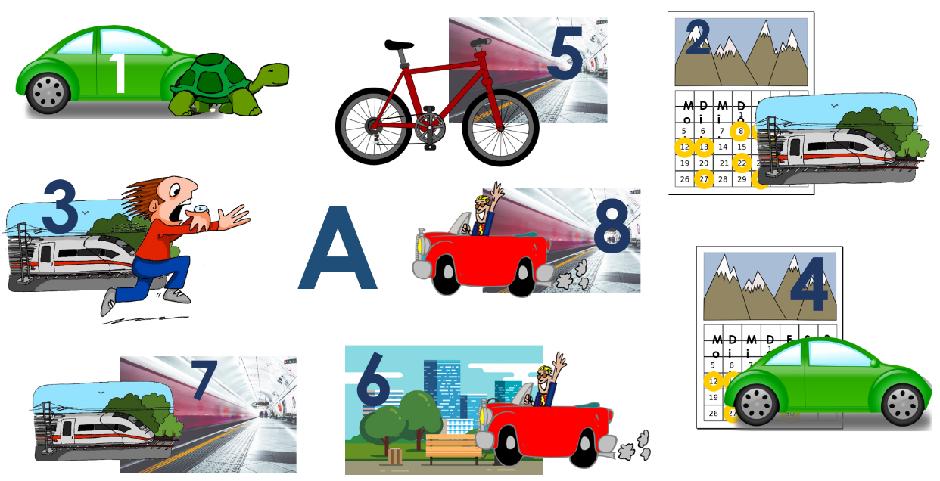

-----------------------------------------------------------------------------------------------------------------------
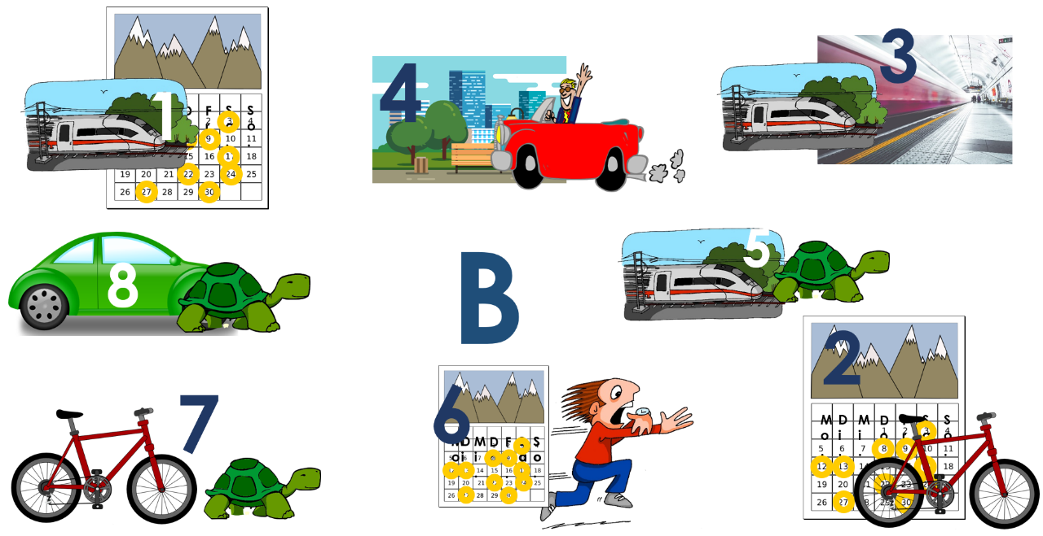
Picture B
Instructions
Look at the pictures. Describe your pictures to your partner. Use the numbers to identify them. E.g. Eins – [Er/Sie] nimmt oft den Zug.
Find out which pictures you have in common with your partner.

Teacher instructions

This activity is designed for Y7 or beginner learners of German. Divide students into pairs and give each student one picture, A or B. Students describe what the people in their picture are doing. Each person is numbered to reduce the cognitive load.
NB: the numbers do not match across the sets so as not to give the solution away too easily. The pictures are spread around the page at random, to prevent pupils glancing at each other’s sheets and getting the information without speaking.
NB: The picture cues rely on students’ familiarity with those used in the Transport PowerPoint teaching sequence.
Word | Word class | Word frequency
das Auto | noun | 490
der Zug | noun | 613
spät | adjective | 171
schnell | adjective | 233
langsam | adjective | 604
fahren | verb | 169
das Fahrrad | noun | 1596
nehmen | verb | 139
oft | adverb | 215
die Stadt | noun | 186
das Auto | noun | 490

Note. Source of frequency rankings: Jones, R.L & Tschirner, E. (2011). A frequency dictionary of German: Core vocabulary for learners. London: Routledge.

