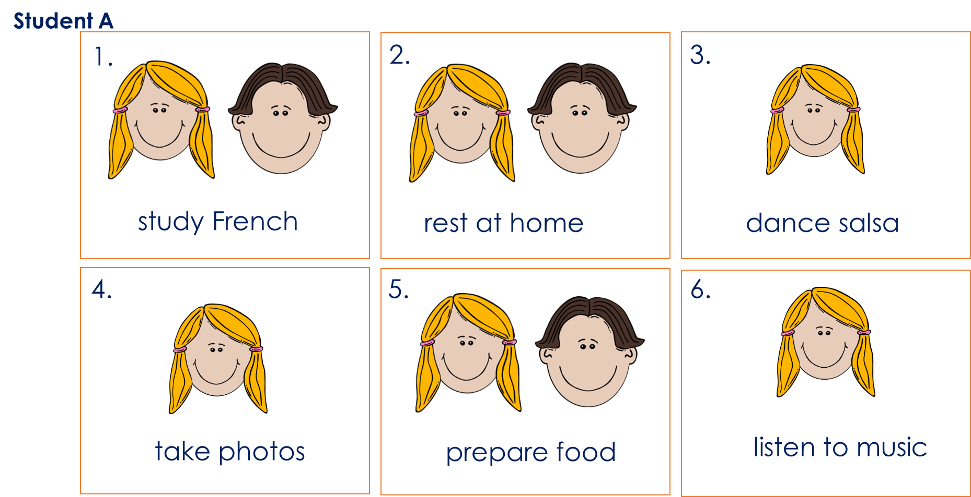
Student A

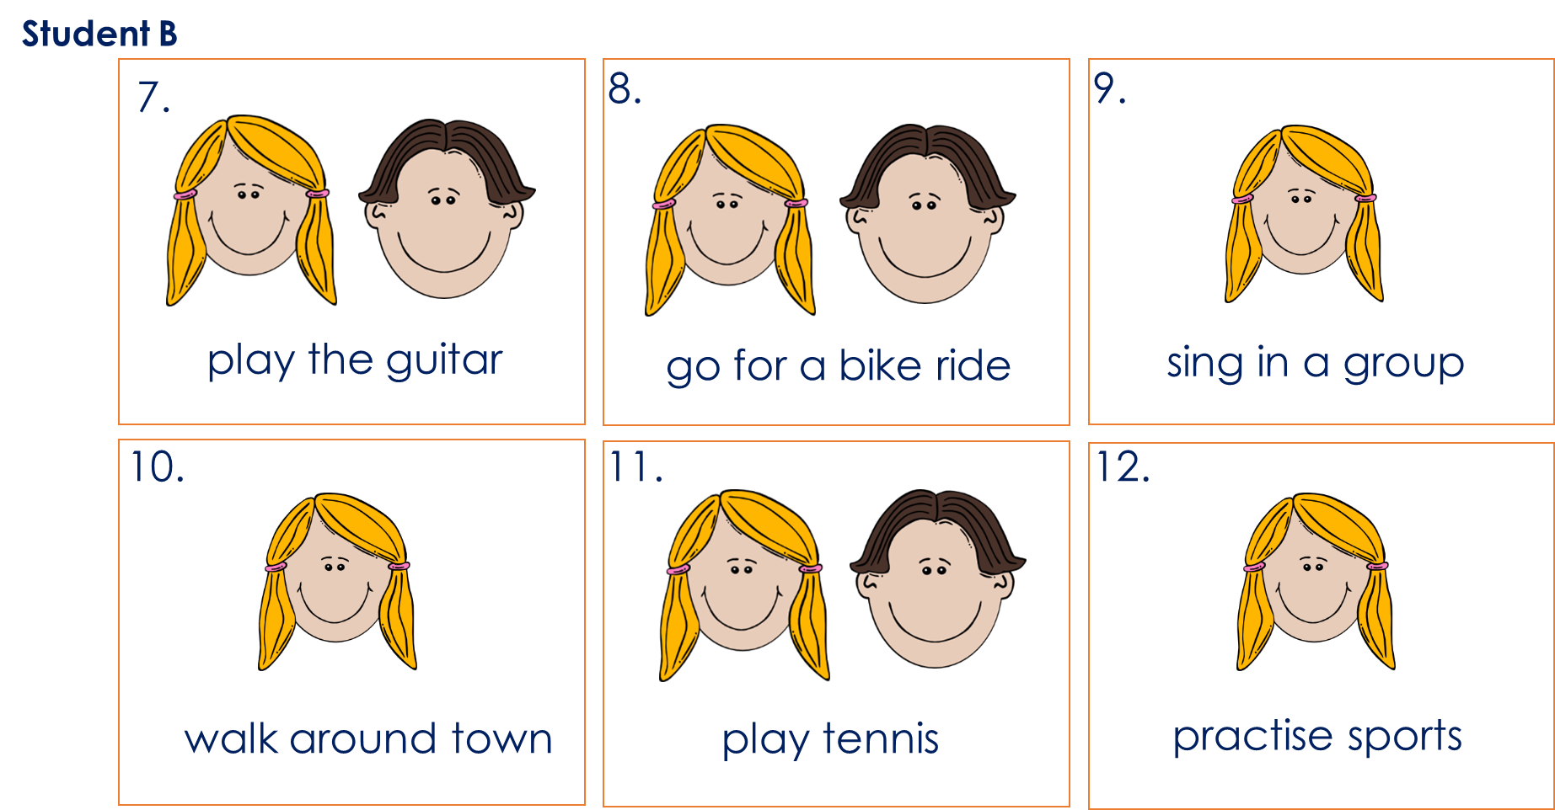
Student B

Student B | alone | with boyfriend
1. study French
2. rest at home
3. dance salsa
4. take photos
5. prepare food
6. listen to music
-------------------------------------------------------------------------------------------------------------------------------------------------------------------
Student B | alone | with boyfriend
1. study French
2. rest at home
3. dance salsa
4. take photos
5. prepare food
6. listen to music

