Partner A speaks, Partner B listens

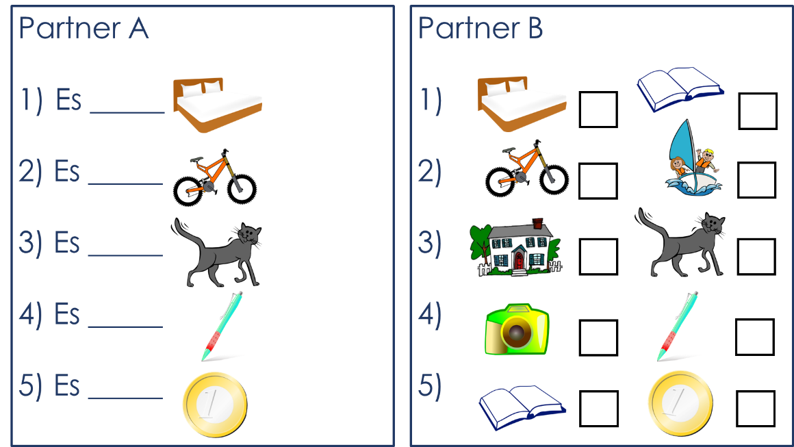

Partner B speaks, Partner A listens

