24 euros

2 euros

93 euros

4 euros

9 euros

7 euros

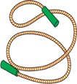

[rope]



[story book]

[souvenir]

[painting, picture]

[4-day journey]

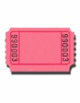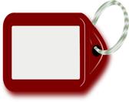

[a quarter of a kilo of corn]

precio: ______

precio: ______

precio: ______

precio: ______

precio: ______

precio: ______

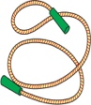

una **cue**rda

[rope]



un libro de **cue**ntos

[story book]

un re**cue**rdo

[souvenir]

un **cua**dro

[painting, picture]

un viaje de **cua**tro días

[4-day journey]

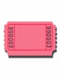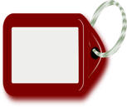

un **cua**rto kilo de maíz



[a quarter of a kilo of corn]



**1**

**2**

**3**

**4**

**5**

**6**

**1**

**4**

**Persona B**

**Persona A**

**2**

**5**

**3**

**6**

precio: ______

precio: ______

precio: ______

precio: ______

precio: ______

precio: ______

una chaqueta de **cue**ro

[leather jacket]

un viaje a E**cua**dor

[a trip to Ecuador]

una crema para el **cue**rpo

[body cream]

un huevo de Pas**cua**

[Easter egg]

una entrada a un cir**cui**to de Fórmula -1

[admission to a formula 1 circuit]

una li**cua**dora

[a blender,

food processer]

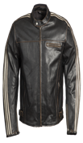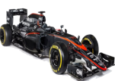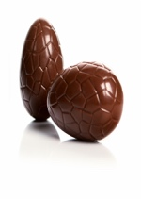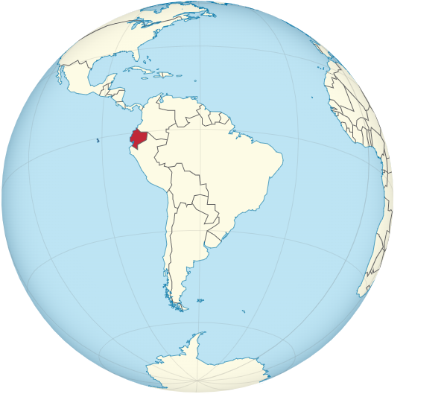

**4**

**1**

9 euros

15 euros

28 euros

5 euros

29 euros

195 euros

[leather jacket]

[a trip to Ecuador]

[body cream]

[Easter egg]

[admission to a formula 1 circuit]

[a blender,

food processer]

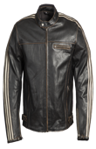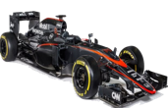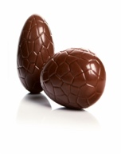

**4**

**1**

**2**

**5**

**5**

**2**

**6**

**3**

**3**

**6**