Applying Your Knowledge Test
Y9 Term 2 French

Your name: ______________________ Your class / name of teacher: ______________________

The test is in four sections:

Section A: Listening (10 minutes)
Section B: Reading comprehension (20 minutes)
Section C: Writing (20 minutes)
Section D: Speaking (5-10 minutes)
Section E: Reading aloud (5-10 minutes)

This makes a total of around 60-70 minutes to complete the entire test.

Your teacher will have sent you an audio file for the listening test. Please check you have this ready to play.

Remember – always just have a go! If you know some words, just write / say them!

Just do what you can!

Total marks

Listening | 24
Reading comprehension (written modality) | /8
Writing | /20
Speaking | 20
Reading aloud and comprehension (oral modality) | /12
TOTAL SCORE | /84
TOTAL %

SECTION A (LISTENING)

PART A

You will hear Amir talking about family holidays. He discusses what used to happen in childhood, what is happening now, and what is going to happen next year.

In the grid below, you will see some activities he mentions. You must decide who does the activity, and when. For each question, circle one answer for ‘who?’ and one answer for ‘when?’.

You will hear the story twice, with a 20 second gap in between. After hearing the story for the second time, you will have another minute to complete the grid. First, you have 20 seconds to read the activities.

 | Activity | Who? |  | When?
1. | on holiday in Spain | Amir | Léa | childhood | in the future
 |  | Amir & Léa | their pets | now

2. | study for an exam | Amir | Léa | childhood | in the future
 |  | Amir & Léa | their pets | now

3. | go to Asia | Amir | Léa | childhood | in the future
 |  | Amir & Léa | their pets | now

4. | travel a lot in France | Amir | Léa | childhood | in the future
 |  | Amir & Léa | their pets | now

5. | sleep in a house in the countryside | Amir | Léa | childhood | in the future
 |  | Amir & Léa | their pets | now

6. | play outside | Amir | Léa | childhood | in the future
 |  | Amir & Léa | their pets | now

7. | stay at home | Amir | Léa | childhood | in the future
 |  | Amir & Léa | their pets | now

8. | look for a job | Amir | Léa | childhood | in the future
 |  | Amir & Léa | their pets | now

PART B

Now listen to the story for a third time. You will then have two minutes to answer the questions in English.

Write as many details as you can
(2 marks per question)
a) | Why is Amir sad?
b) | What is France like in summer?
c) | What other types of holiday does Amir like?
d) | What is Amir’s dream?

TOTAL MARKS AVAILABLE (LISTENING): 24
SECTION B (READING COMPREHENSION)

Read the text about Marie Curie below and answer the questions that follow.
*amoureux = in love
*la mort = death
À l'école, Marie Curie aimait beaucoup les sciences et elle a eu de très bonnes notes. Marie a quitté son pays pour aller étudier dans le même pays que sa sœur. Marie est arrivée en France en 1891. Ici, elle a étudié à la Sorbonne (l'université de Paris) où elle a fait des examens de sciences et de maths. En 1894, Marie est tombée amoureuse* avec Pierre Curie. Ils ont eu leur première fille ensemble.
Marie et Pierre ont beaucoup travaillé ensemble sur les sciences. Pour ce travail important, ils ont gagné un prix Nobel en 1903. Mais, en 1906, Pierre a eu un accident. Après la mort* de Pierre, Marie a fait plus de travail sans Pierre et elle a gagné un deuxième prix Nobel en 1911.

PART A

Number these events in the order that they happened. Write the numbers 1-6 in the boxes on the right (1= happened first, 6 = happened last).

Marie and Pierre won a Nobel prize.
Marie studied at the Sorbonne.
Marie and Pierre had their first child.
Marie moved to France.
Marie and Pierre fell in love.
Pierre had an accident.
PART B
Put a cross (x) in the correct column to show whether the statements below are true (T), false (F), or not mentioned in the text (NM).

 | T | F | NM
Marie was born in France.
Marie and Pierre were in love.
Marie won two Nobel prizes.
Marie had two children.
Marie’s sister went to France before her.

TOTAL MARKS AVAILABLE (READING COMPREHENSION): 8

SECTION C (WRITING)

PART A

Read Anna’s postcard. Fill the blanks with a sensible word that starts with the given letter.
Salut Sébastien,
Je fais une visite de Bordeaux avec mes collègues. Je suis a____________ à Bordeaux la semaine dernière après huit h____________ de voyage. Je suis très c____________ parce qu’il fait beau et il y a toujours du s____________ ! On a déjà fait beaucoup de choses. Hier, on a p____________ l’après-midi au musée. Le soir, on a regardé un s____________ au Grand Théâtre. C’est un b____________ bâtiment historique qui est à côté de notre hôtel. P____________, on e____________ retourné à l’hôtel pour manger. Aujourd’hui, on va p____________ un jour à Saint Émilion. C’est une petite et très vieille ville près d’ici. Je pense qu’on va prendre le train. Je n’ai j____________ pris le train en France !
À bientôt, Anna

PART B
What happened last week? What will happen next week?
Write between one and three sentences in French for each picture. Write your sentences in the blank box on the right. Use all of the French words under the boxes.
Try to show that you know what the words mean by writing full sentences that make sense. Remember that you will need to change the form of some of the words. You can use your imagination if you like!

1. Last week
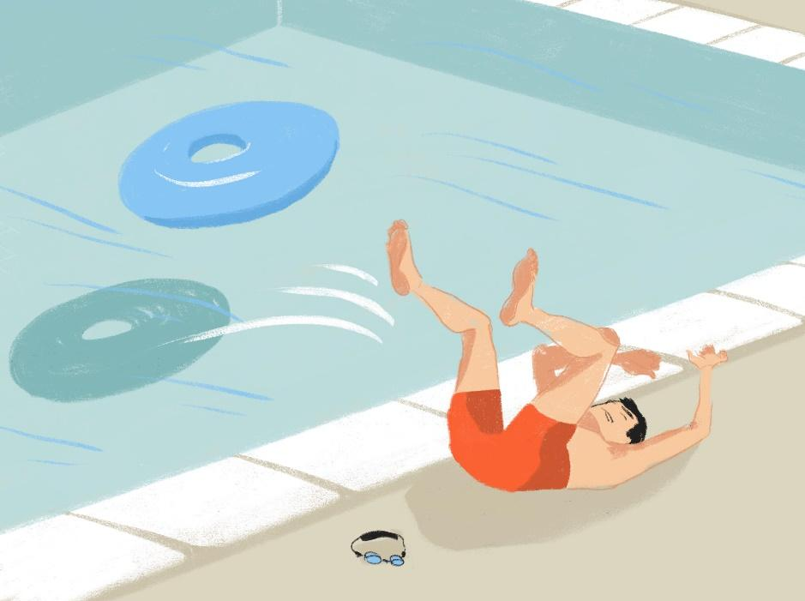
tomber / un accident / la piscine / avoir mal /
2. Next week
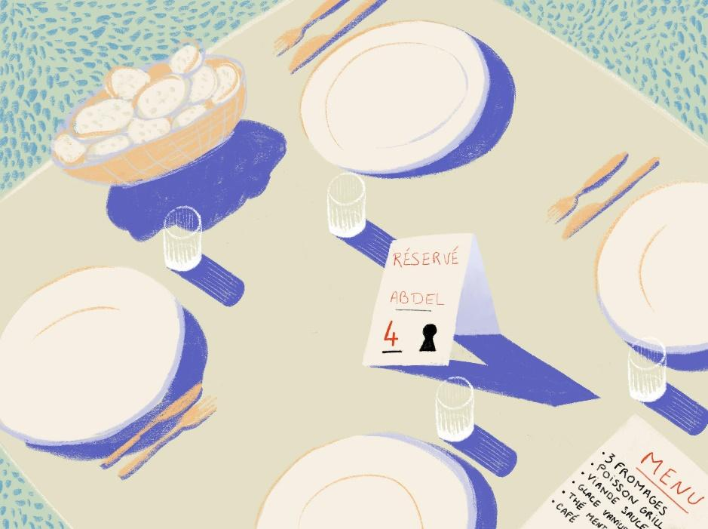
déjeuner / réserver / une table / pour

TOTAL MARKS AVAILABLE (WRITING): 20

SECTION D (SPEAKING)
Before you start this section of the test, please go to this website: vocaroo.com.
It will open in a new tab. Click the red record button, then come back to this test.

Océane and her friends are talking about what they all did last week, when it was the school holidays. Look at the pictures showing some of the things they got up to.

Then, complete the six sentences (numbered 1 - 6, below the photos) about what they could say about their school holidays. Pick a different activity and use a different verb for each sentence.

For each sentence you say, you will get 2 marks for expressing the meaning (comprehensibility), and 1 mark for speaking accurately (clarity). You can also get up to 2 marks for speaking fluently, across the whole activity.
You have 2 minutes to prepare your answers before you speak.

Do your best to say something, even if you’re not totally sure what to say. The main thing is to have a go! You can make up funny sentences if you wish!
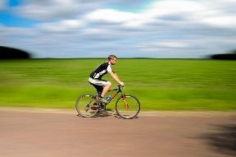

La semaine dernière, pendant les vacances …

1. | 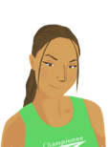 | lundi matin, je / j’ …
2. |  | mardi, Apollon…
3. | 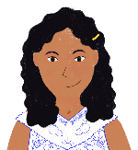 | mercredi, nous…
4. | 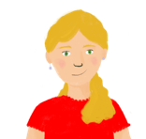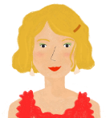 | samedi soir, elles…

Now, ask Océane and Amir two questions in French.
Remember to choose a different activity for each question.

5. |  | Océane, did you …?
6. |  | Océane, did you and Amir …?

TOTAL SCORE AVAILABLE (SPEAKING): 20

SECTION E (READING ALOUD & COMPREHENSION)

PART A

Read the following text aloud.

You won’t know some of the words – don’t worry! Just do your best to read them aloud as you think they should sound in French.

There are five paragraphs. For each paragraph you read, you can get up to 1 mark for being understandable (clear) and up to 1 mark for being fluent.

Le Canada est un pays immense, plus grand que tous les autres pays du monde à l'exception de la Russie.

C’est un pays bilingue : on parle français et anglais ici. La Mauricie une région francophone du Canada.

C’est aussi une région montagneuse. Chaque hiver, il y a beaucoup de neige.

Le hockey sur glace, c’est un sport très populaire.

En été, on peut visiter les parcs nationaux et faire des promenades dans la nature.

PART B

Now say, in English, any 4 facts mentioned in the text about Canada. You will get half a mark for each fact.

TOTAL SCORE AVAILABLE (READING ALOUD & COMPREHENSION): 12

When you have finished, go back to the Vocaroo window. Click on the red button.
Click on "Save & Share". Copy the URL. Paste the URL for your Vocaroo recording below:
Vocaroo link:

