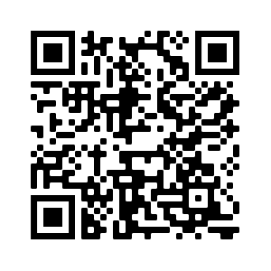

Vocabulary Learning Homework
Year 7 French – Term 3.2 Week 7

Icon made by Darius Dan
Audio file QR code:

Access your audio file here (or scan the QR code above).
Then follow all 7 steps. Steps 1-6 take about 10 minutes. Step 9 takes about 10 minutes.

- Listen to the new words and their meanings.
- Say with me (3 times – just say the French).
- I say French, you write English.
Tick once completed: ⃝
Tick once completed: ⃝
Tick once completed: ⃝

No. | English Word | No. | English Word | No. | English Word
1 |  | 2 |  | 3
4 |  | 5 |  | 6
7 |  | 8 |  | 9
10 |  | 11 |  |  | [blank]
- I say French, you write French. Check answers at Step 6 - the order is as in Quizlet.
No. | French Word | No. | French Word | No. | French Word
1 |  | 2 |  | 3
4 |  | 5 |  | 6
7 |  | 8 |  | 9
10 |  | 11 |  |  | [blank]
Now turn your sheet over so that you cannot see the French words.
- I say English, you say French.
- Now go to Quizlet to check your answers to Step 4.
- Practise on Quizlet for 10 minutes. Do the following tasks on Quizlet: Write (both translating into English and into French); Spell (hear & type); Test (all questions).
Tick once completed: ⃝
Tick once completed: ⃝
Tick once completed: ⃝

Quizlet link
Quizlet QR code:

