Applying your knowledge test
(Y8 Term 3 Spanish)
Mark scheme and transcript

SECTION A (LISTENING)

TRANSCRIPT

[For part A, students hear the text twice, with 20 seconds in between. For part B, students hear the text one more time.]

Daniel y yo somos muy activos. A Daniel le encantan los paseos en el campo porque puede aprovechar la naturaleza y descansar allí. En cambio yo voy al centro de la ciudad. Por ejemplo, el sábado pasado fui a una tienda de ropa para comprar una falda verde y unos zapatos preciosos. Daniel pasó tiempo al lado de un río y después subió una montaña para ver las vistas y sacar fotos.
Si estamos en casa, jugamos en el jardín o ayudamos a nuestra mamá. Esta tarde yo voy a lavar el coche y él va a limpiar la cocina. También vamos a comer tapas en un bar nuevo. Este bar es más caro que otros bares, pero la comida es mejor.

PART A
play in the garden read a book spend time by a river
meet some friends look for and listen to birds
go to the city centre clean the kitchen go to a clothes shop

1 mark = Correctly assigning an activity to a person(s)
1 mark = Correctly assigning an activity to a time period
If a student writes more than one answer in the same box, they receive zero points for all items in that box.

2 marks / item = max. 12 marks in total

^{when?}  _{who?} | in the past | in general | in the future
Lucía | 1. go to a clothes shop | 1. go to the city centre | [1. wash the car]
Daniel | 1.spend time by a river  [2. went up a mountain] | [1. loves going to the countryside] | 1. clean the kitchen
Lucía y Daniel |  | 1. play in the garden | 1. meet some friends

PART B
2 marks / item = max. 8 marks in total

a) | Why does Daniel love going on trips to the countryside? | make the most of nature (1) and rest (1)
b) | What did Lucía buy? | a green skirt (1) and some beautiful shoes (1)
c) | Why did Daniel go up the mountain? | to see the views (1) and to take photos (1)
d) | How does Lucía compare the new bar with the other bars? | the new bar is more expensive (1) but the food is better (1)

SECTION B (READING)
PART A
0.5 marks / item = max. 4 marks in total
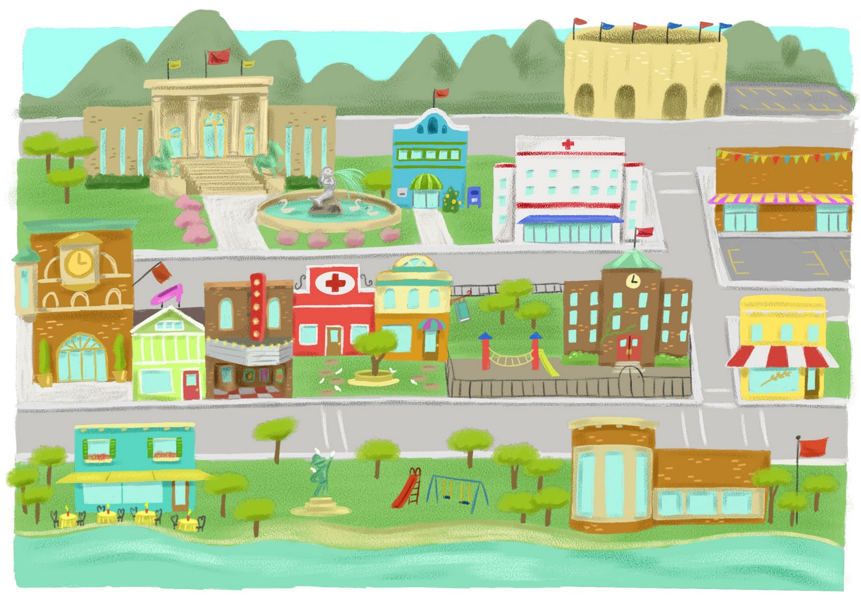
gift shop
history museum
school
stadium
tower
book shop
café
church
teatro
PART B
0.5 marks / item = max. 2 marks in total
a train station |  |  | a park | ✓
a stadium | ✓ |  | a theatre
a cinema | ✓ |  | a bank
a market |  |  | old buildings | ✓

PART C
0.5 marks / item = max. 2 marks in total
Half-marks may be awarded for correct recognition of a tense (but not adverb). Thus:
1.5 marks are awarded for the following order: ‘3, 2, 4, 1’, because the boat race and the traditional music concert are both referred to using the periphrastic future (ir + infinitive).
boat race on the river | 4
Santa Orosia festival | 2
traditional music concert | 3
art classes | 1

SECTION C (WRITING)

PART A
1 marks / item = max. 12 marks in total
Notes on tolerance:

0.5 mark awarded for an otherwise correctly-spelled word with an unnecessary accent added to a non-accented letter.

Note on this tolerance: The NCELP achievement test rewards full accuracy of accent use, and more tolerance is desirable in the Applying Your Knowledge test so that a large proportion of the marks (1/6th in this case) of the marks cannot be lost due to the wrong choice of an accent.

Daniel, Diego y Ana están en la cocina y tienen unos problemas. Diego no quiere comer porque los platos están sucios. Él parece bastante cansado. Ana está enojada porque hay agua en el suelo. Daniel parece aburrido. No quiere hacer los deberes. Él debe leer un libro, pero hay mucho ruido.

PART B
‘Sentence’ refers to groups of words that include a verb phrase.
1 mark awarded for the use of a word where its meaning is fully and accurately communicated.
0.5 mark awarded where the meaning of a word is communicated but it is not used accurately (e.g., the tense or person is inaccurate).
0 marks awarded where knowledge of the meaning and use of a word is not demonstrated.
NB: This test is based on the NCELP scheme of work. Thus, the mark scheme below assumes no prior knowledge of Spanish other than the language covered in the NCELP SOW. Credit should also be given - following the above criteria - where language that has not been covered is used.

4 marks / set of 2-3 sentences = max. 8 marks in total

SECTION D (SPEAKING)
For overall fluency (parts A & B combined) = max. 2 marks in total
3 marks / idea (parts A & B) = max. 18 marks in total
For each idea in parts A and B we suggest awarding 2 marks for meaning and 1 mark for accuracy for each, giving 3 points for each idea in total.
In addition, overall, there are 2 marks available for fluency in total over parts A and B.
For meaning:
2 marks awarded where the meaning of the idea is communicated with little effort required on the part of the listener.
1 mark awarded where the meaning of the idea is communicated with some effort required on the part of the listener.
0 marks awarded where the meaning of the sentence is not communicated.
For accuracy:
1 mark awarded where all or most of the features (vocabulary, grammar, pronunciation, intonation) are accurately produced.
0.5 mark awarded where some of the features (vocabulary, grammar, pronunciation, intonation) are accurately produced.
0 marks awarded where few or none of the features (vocabulary, grammar, pronunciation, intonation) are accurately produced.
For fluency for both parts A & B combined:
2 mark awarded where speech does not contain many hesitations in between clauses and/or only contains a small number of self-corrections.
1 mark awarded where there are a few hesitations and/or self-corrections
0 marks awarded where speech contains many hesitations or self-corrections.
Notes on tolerance
Where comprehension is not impeded, allow for a foreign accent in pronunciation.
Tolerance is likely to be greater in year 8 than in later years when students will have had more practice.

SECTION E (READING ALOUD & COMPREHENSION)
PART A
This text is composed of roughly 80% words which have been covered in the NCELP Scheme of Work up to the point of these assessments. The other 20%, which have not yet been covered, are shaded grey in the marking grid below. These unfamiliar words are transparent cognates of English, whose SSCs have been covered in the SoW to date. The cognates provide a good test of SSC knowledge (as learners must inhibit their English SSCs), and aid comprehension for Part B where they must demonstrate understanding.

For each sentence we suggest awarding 1 mark for comprehensibility and 1 mark for fluency, giving 2 points for each sentence in total. However, there must a minimum level of comprehensibility (0.5 points) before points can be awarded for fluency.
1 mark awarded where words are pronounced very clearly and comprehensibly, with all or most of the features (SSCs, syllables and stress patterns) accurately produced.
Plus 1 mark awarded where the sentence is read very fluently (with few hesitations
and/or self-corrections)
Plus 0.5 mark awarded where the sentence is read quite fluently (with some
hesitations and/or self-corrections).
0.5 mark awarded where words are pronounced quite clearly and comprehensibly, with most of the features (SSCs, syllables and stress patterns) accurately produced.
Plus 1 mark awarded where the sentence is read very fluently (with few hesitations
and/or self-corrections).
Plus 0.5 mark awarded where the sentence is read quite fluently (with some
hesitations and/or self-corrections).
0 marks awarded where words are pronounced neither clearly nor comprehensibly, with few of the features (SSCs, syllables and stress patterns) accurately produced.
0 marks awarded for fluency where the unit is not awarded any marks for comprehensibility.
2 marks / sentence = max. 10 marks in total
 | Idea | Notes on tolerance
1. | Juan Luis Guerra es un músico de la República Dominicana, un país pequeño en el Caribe. | ignore [gue]  SSCs include: [ñ], [rr], [ca]  Stress includes: república, músico (ante-penultimate syllable)
2. | Su música es muy conocida, especialmente la canción ‘Ojalá que llueva café.’ | SSCs include: [ci], [j], [ll]  Stress includes: ojalá, café (final syllable)
3. | Antes de aprender la guitarra, Guerra estudió filosofía en la universidad. | ignore [gue]  SSCs include: [rr]  Stress includes: estudió, filosofía (final syllable)
4. | Ahora da conciertos en todo el mundo y gana muchos premios. | SSCs include [ci], [ga]  Stress includes: gana, ahora (penultimate syllable)
5. | Dice que su música celebra y honra la cultura de su nación. | SSCs include [silent h], [cu], [ci], [que], [ce]  Stress includes: nación (final syllable), celebra (penultimate syllable)

PART B
Notes:

Award 1/2 point for each fact correctly identified in the text, up to a maximum of 1 point for facts from a single sentence.
Permissible facts are listed in the grid below, each within [ ].
The facts can be expressed using any reasonable English formulation. Given the use of narrative present in the text, it is OK if the present tense is used in the English renderings (or the past, or a mixture).
max. 2 marks in total

 | Allow something like | Disallow
1. | Guerra is a [musician] from [the Dominican Republic], [a small country] in [the Caribbean]
2. | [his music is very well-known] [especially the song ‘ojalá que llueva café’]  Note: students may say the name of the song in Spanish. They wouldn’t be expected to translate this. The unknown words here are testing pronunciation of [z], [ll] and [v] SSCs, plus diphthong [ue].
3. | [before learning the guitar] Guerra [studied philosophy] [at university] | only ‘studied’
4. | Now [he gives concerts] [around the world / all over the world] and [wins many prizes / wins a lot of prizes]
5. | he says that [his music celebrates] and [honours the culture] [of his nation]

Image information:
1. Picture of Juan Luis Guerra by Lunchbox LP https://commons.wikimedia.org/wiki/File:Juan_Luis_Guerra_en_Acceso_Total_(3).jpg
This file is licensed under the Creative Commons Attribution 2.0 Generic license.

2. Picture of Feria de Sevilla by Edumund Gall
This file is licensed under the Creative Commons Attribution 2.0 Generic license.
https://www.flickr.com/photos/e_n_gall/14231548262

