Sam und Chloe im Urlaub [Person A]
Instructions
You are Sam, chatting with your friend Chloe about your holidays.
Using your cards, tell Chloe what you did last year on holiday and what you are doing now. Say one sentence for each card.
Remember to use the right verb(s) for past and present.
Don’t say ‘this year’ or ‘last year’.
Then listen to Chloe and note what she did last year and what she is doing now. Tick the grid.
Sams Urlaub
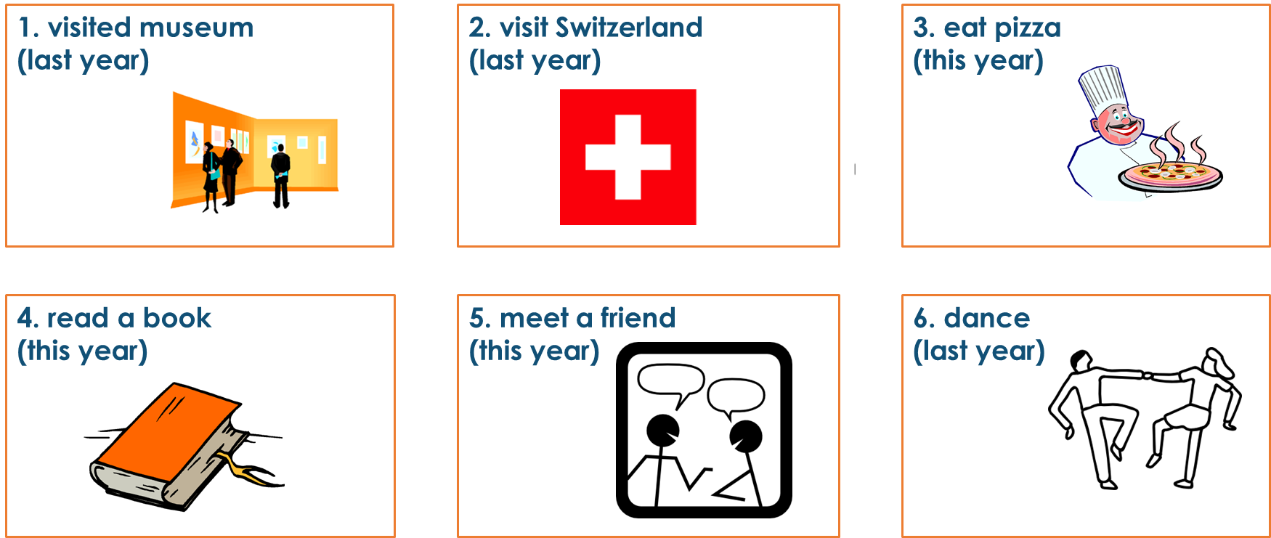

Chloes Urlaub
 | last year | this year
1. Fußball spielen
2. Postkarten schreiben
3. Tennis spielen
4. ein Eis essen
5. Italien besuchen
6. tanzen

Sam und Chloe im Urlaub [Person B]
Instructions
You are Chloe, chatting with your friend Sam about your holidays.
Listen to Sam and note what he did last year and what he is doing now.
Tick the grid.
Then, using your cards, tell Sam what you did last year on holiday and what you are doing now. Say one sentence for each card.
Remember to use the right verb(s) for past and present.
Don’t say ‘this year’ or ‘last year’.
Sams Urlaub
 | last year | this year
1. ein Museum besichtigen
2. die Schweiz besuchen
3. Pizza essen
4. ein Buch lesen
5. mit einem Freund treffen
6. tanzen

Chloes Urlaub
