Applying Your Knowledge Test
Y9 Term 2 German

Your name: ______________________ Your class / name of teacher: ______________________

The test is in four sections:

Section A: Listening (10 minutes)
Section B: Reading comprehension (20 minutes)
Section C: Writing (20 minutes)
Section D: Speaking (5-10 minutes)
Section E: Reading aloud (5-10 minutes)

This makes a total of around 55-65 minutes to complete the entire test.

Your teacher will have sent you an audio file for the listening test. Please check you have this ready to play.

Remember – always just have a go! If you know some words, just write / say them!

Just do what you can!

Total marks

Listening | /20
Reading comprehension (written modality) | /8
Writing | /20
Speaking | /20
Reading aloud and comprehension (oral modality) | /12
TOTAL SCORE | /80
TOTAL %

SECTION A (LISTENING)

PART A

You will hear Wolfgang talk about Matthias coming to visit. In the grid below, you will see some activities he mentions. You must decide who does the activity, and when. For each question, circle one answer for ‘who?’ and one answer for ‘when?’.

You will hear the story twice, with a 20 second gap in between. After hearing the story for the second time, you will have another minute to complete the grid. First, you have 20 seconds to read the activities.

 | Activity | Who? |  | When?
1. | Going to the city | Wolfgang | Mia & Wolfgang | last week | next week
 |  | Mia | Wolfgang & Matthias | normally

2. | Cycling in the wood | Wolfgang | Mia & Wolfgang | last week | next week
 |  | Mia | Wolfgang & Matthias | normally

3. | Cleaning the house | Wolfgang | Mia & Wolfgang | last week | next week
 |  | Mia | Wolfgang & Matthias | normally

4. | Buying food | Wolfgang | Mia & Wolfgang | last week | next week
 |  | Mia | Wolfgang & Matthias | normally

5. | Boring week | Wolfgang | Mia & Wolfgang | last week | next week
 |  | Mia | Wolfgang & Matthias | normally

6. | Chatting with friends | Wolfgang | Mia& Wolfgang | last week | next week
 |  | Mia | Wolfgang & Matthias | normally

7. | Swimming on Wednesday | Wolfgang | Mia& Wolfgang | last week | next week
 |  | Mia | Wolfgang & Matthias | normally

8. | Improving sport performance | Wolfgang | Mia& Wolfgang | last week | next week
 |  | Mia | Wolfgang & Matthias | normally

Now turn to the next page for Part B listening.
PART B

Now listen to the story for a third time. You will then have two minutes to answer the questions in English.
 |  | (1 mark per question)
a) | How long is Matthias staying with Wolfgang?
b) | What does Wolfgang say he will enjoy?
c) | What did Mia NOT do last week?
d) | Which two sports do Wolfgang and Mia normally do?

TOTAL MARKS AVAILABLE (LISTENING): 20
SECTION B (READING COMPREHENSION)

Read the text about Angela Merkel below and answer the questions that follow.
PART A

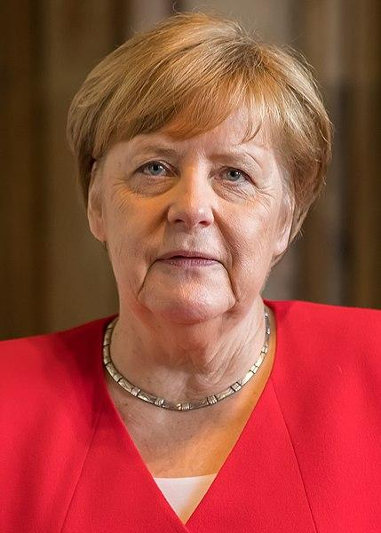
Number these events in the order that they happened. Write the numbers 1-6 in the boxes on the right (1= happened first, 6 = happened last).
Angela Merkel war 16 Jahre lang Kanzlerin* von Deutschland. Sie ist in Ostdeutschland aufgewachsen. Sie hat Chemie an der Universität studiert. Danach hat sie als Wissenschaftlerin gearbeitet. 1989 ist sie Politikerin* geworden. Sie hat sehr viel gearbeitet und 2005 ist sie als erste Frau in Deutschland Kanzlerin geworden. 2015 gab es einen Krieg in Ländern wie Syrien, und Hunderttausende von Menschen sind nach Deutschland gekommen. Einige Politiker haben gesagt, dass das zu viel war. Aber Merkel wollte ihnen helfen und hat gesagt „wir schaffen das“. Merkel war als Kanzlerin sehr bekannt. Manche Menschen in Deutschland haben sie „Mutti“ genannt*, denn sie hat sehr lange für das Land gearbeitet. 2021 hat Merkel sich entschieden, nicht wieder Kanzlerin zu werden. Am 8. Dezember 2021 ist Olaf Scholz Kanzler geworden.
Kanzler – Chancellor; Politiker – politician; genannt - called

© Raimond Spekking

Merkel studied chemistry at university
Merkel became Chancellor
Olaf Scholz became Chancellor
Merkel worked as a scientist
Merkel grew up in East Germany
Hundreds of thousands of people came to Germany
PART B
Put a cross (x) in the correct column to show whether the statements below are true (T), false (F), or not mentioned in the text (NM).

 | T | F | NM
Merkel was born in West Germany
Merkel was a scientist before becoming a politician
There was a war in Syria
Merkel was the second woman to become German Chancellor
People called her “Mutti”

TOTAL MARKS AVAILABLE (READING COMPREHENSION): 8
SECTION C (WRITING)

PART A

Read Mia’s postcard. Fill the blanks with a sensible word that starts with the given letter.
Hallo Katja!
Ich bin mit meiner Familie nach Italien g_______. Hier feiern wir Onkel Heinrichs 50. G___________! Gestern haben wir ein g______ Fest mit seinen Freunden gefeiert, die alle sehr nett waren. Die Stimmung w____ toll und wir haben alle viel Kuchen gegessen. Ich habe mich sehr gefreut aber danach konnte ich n______ einschlafen. Vorgestern* s____ wir zum Strand gegangen. Wir sind an der Küste und von unserem Haus führt ein kleiner Weg zum Strand. M________ werden wir Touristen sein. Wir wollen die S________ entdecken, weil sie sehr h_______ ist. Es gibt interessante Museen, aber ich denke wir werden leider nicht genug Z___ haben, sie alle zu sehen.
Mia
*Vorgestern – the day before yesterday

PART B
What happened last week? What will happen next week?

Write between one and three sentences in German for each picture. Write your sentences in the blank box on the right. Use all of the German words under the boxes.
Try to show that you know what the words mean by writing full sentences that make sense. Remember that you will need to change the form of some of the words. You can use your imagination if you like!

1. Last week
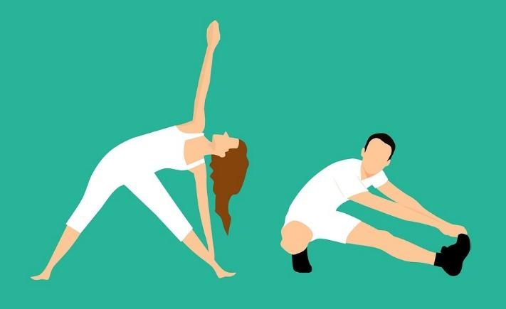
können / aktiv / machen / (der) Sport

2. Next week
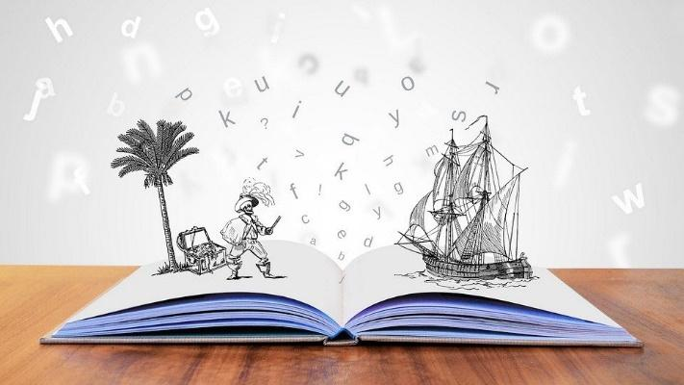
vorhaben / ein Dichter / traditionell / einladen

TOTAL MARKS AVAILABLE (WRITING): 20
SECTION D (SPEAKING)
Mia and her friends are talking about what they all did last week, when it was the school holidays. Look at the pictures showing some of the things they got up to.
Then, complete the six sentences (numbered 1 - 6, below the photos) about what they could say about their school holidays. Pick a different activity and use a different verb for each sentence.
For each sentence you say, you will get 2 marks for expressing the meaning (comprehensibility), and 1 mark for speaking accurately (clarity). You can also get up to 2 marks for speaking fluently, across the whole activity.
You have 2 minutes to prepare your answers before you speak.
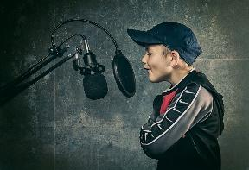
Do your best to say something, even if you’re not totally sure what to say. The main thing is to have a go! You can make up funny sentences if you wish!
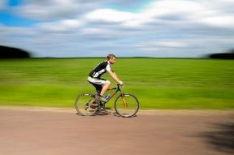

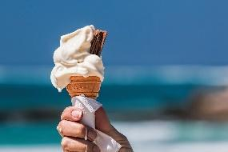
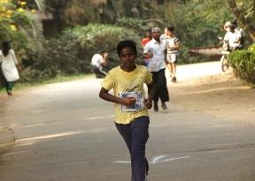
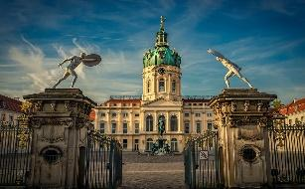

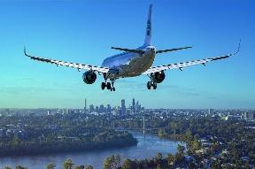
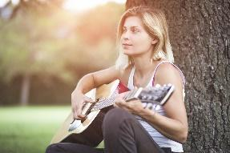
Letzte Woche
1. | 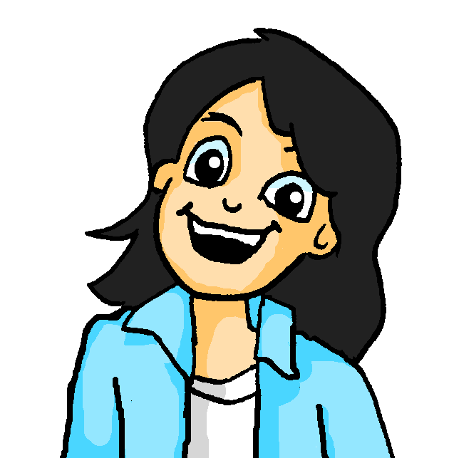  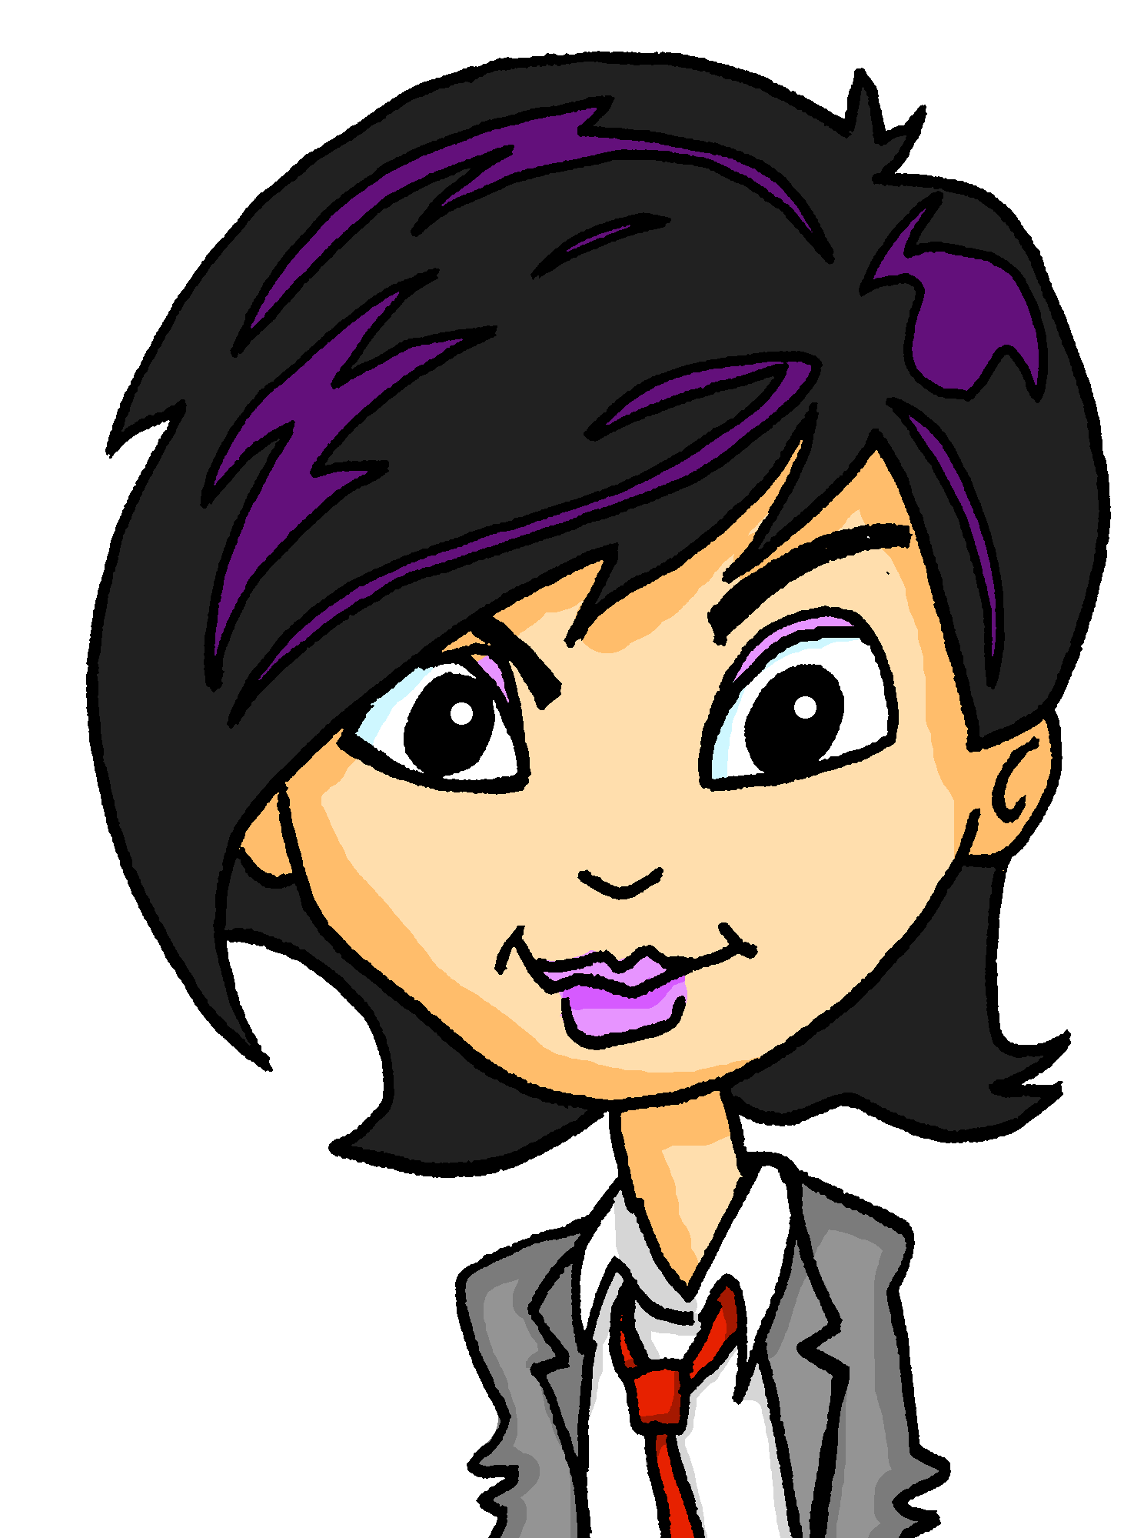 | Montag … ich …
2. | 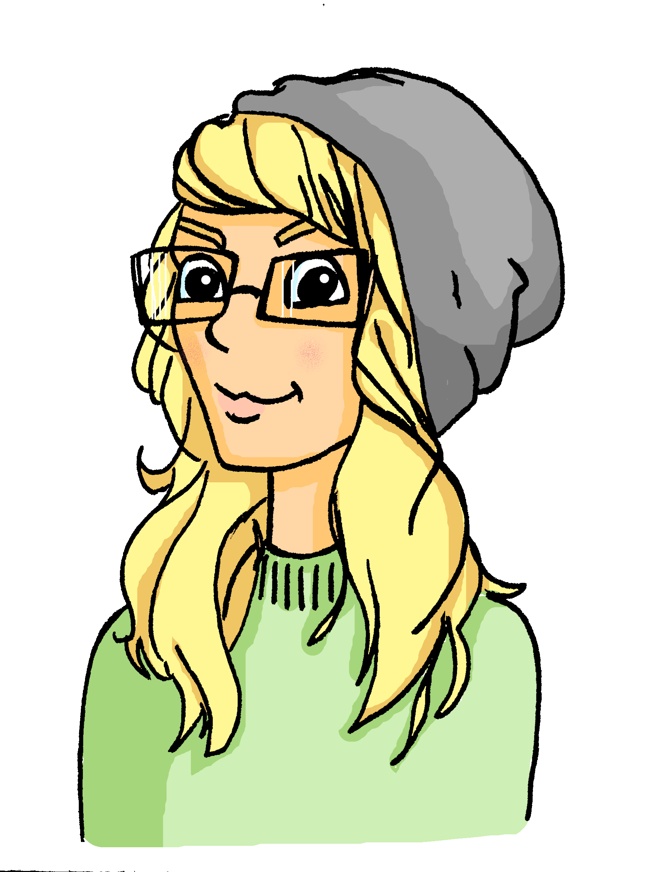 | Dienstag … Katja…
3. |  | Mittwoch … wir…
4. |  | Samstag … sie …

Now, ask Mia and Wolfgang two questions in German.
Remember to choose a different activity for each question.
5. |  | Mia, did you …?
6. |  | Mia, did you and Wolfgang …?

TOTAL SCORE AVAILABLE (SPEAKING): 20

SECTION E (READING ALOUD & COMPREHENSION)

PART A

Read the following text aloud.

You won’t know some of the words – don’t worry! Just do your best to read them aloud as you think they should sound in German.

There are five sections. For each section you read, you can get up to 1 mark for being understandable (clear) and up to 1 mark for being fluent.

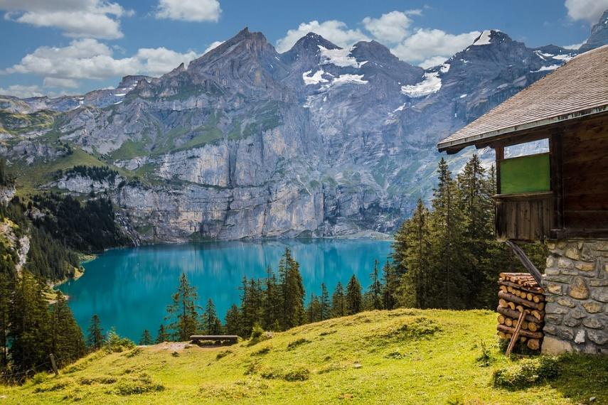 | Die Schweiz ist ein demokratisches Land in der Mitte Europas.  Es gibt viel Tourismus in den Alpen in der Schweiz.  Das Land hat am 1. August Geburtstag und an diesem Tag gibt es immer Feuerwerken.  Die Schweiz hat eine Armee. Das Land bleibt aber immer neutral und deshalb nimmt es nicht an Konflikten teil.  Die Schweiz hat vier Sprachen und viele Dialekte! Im Parlament muss man oft übersetzen!

PART B

Now say, in English, any 4 facts mentioned in the text about Switzerland. You will get half a mark for each fact.

TOTAL SCORE AVAILABLE (READING ALOUD & COMPREHENSION): 12

When you have finished, go back to the Vocaroo window. Click on the red button.
Click on "Save & Share". Copy the URL. Paste the URL for your Vocaroo recording below:
Vocaroo link:

