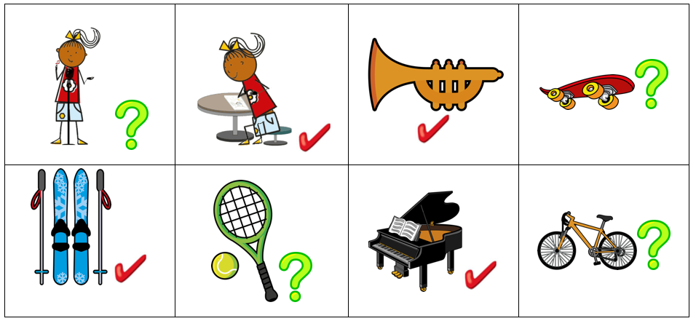
Partner A
Using the ‘tu’ (you, singular) form of the verb, write either a question (?) or statement () for each picture in grid 1.
You and your partner take it in turns to read a sentence chosen at random from grid 1.
As you listen to your partner’s sentences, identify the correct picture from grid 2, and then add either a (?) if you hear a question or () for a statement.
Grid 1

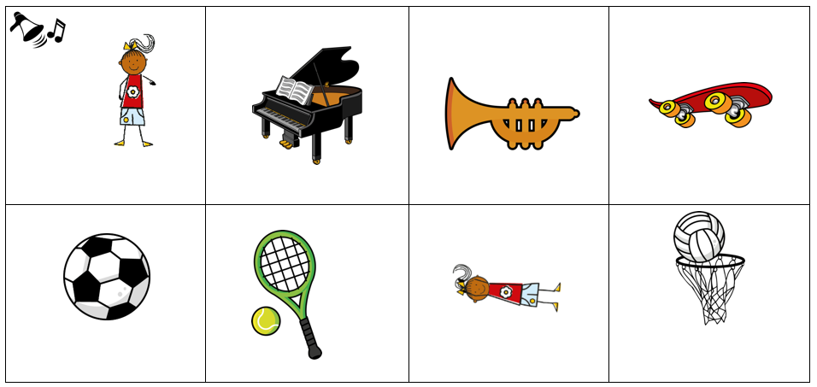
Grid 2

If you finish, both partners draw a 3 x 3 blank bingo grid in their books. Without showing your partner, write a different question or statement into each square. Try to choose sentences that you don’t think your partner will have.
Take it in turns to say one of your sentences. If you both have it, you both cross off that square. If one doesn’t have it, only the one who has it crosses it off. The winner is the one to cross off all his/her squares first.
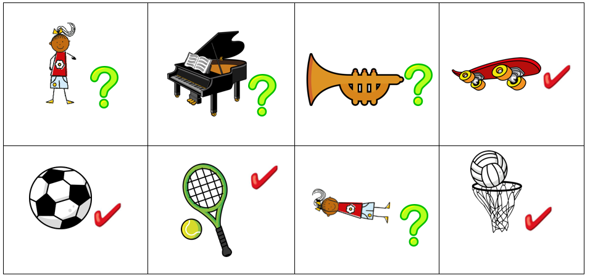
Partner B
Using the ‘tu’ (you, singular) form of the verb, write either a question (?) or statement () for each picture in grid 1.
You and your partner take it in turns to read a sentence chosen at random from grid 1.
As you listen to your partner’s sentences, identify the correct picture from grid 2, and then add either a (?) if you hear a question or () for a statement.
Grid 1

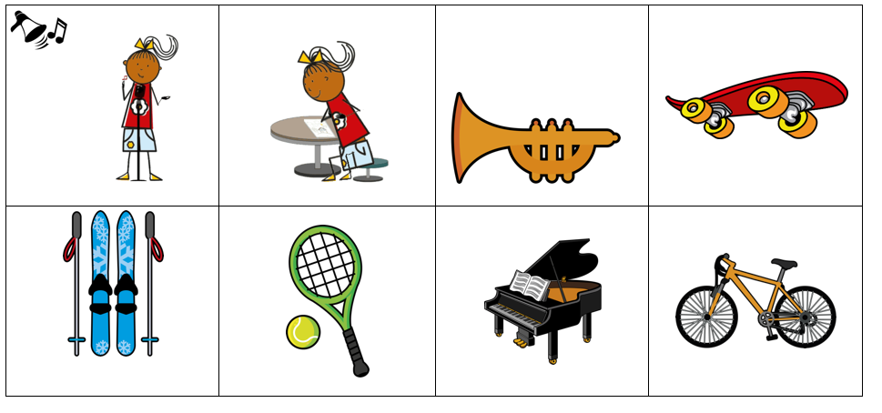
Grid 2

If you finish, both partners draw a 3 x 3 blank bingo grid in their books. Without showing your partner, write a different question or statement into each square. Try to choose sentences that you don’t think your partner will have.
Take it in turns to say one of your sentences. If you both have it, you both cross off that square. If one doesn’t have it, only the one who has it crosses it off. The winner is the one to cross off all his/her squares first.

