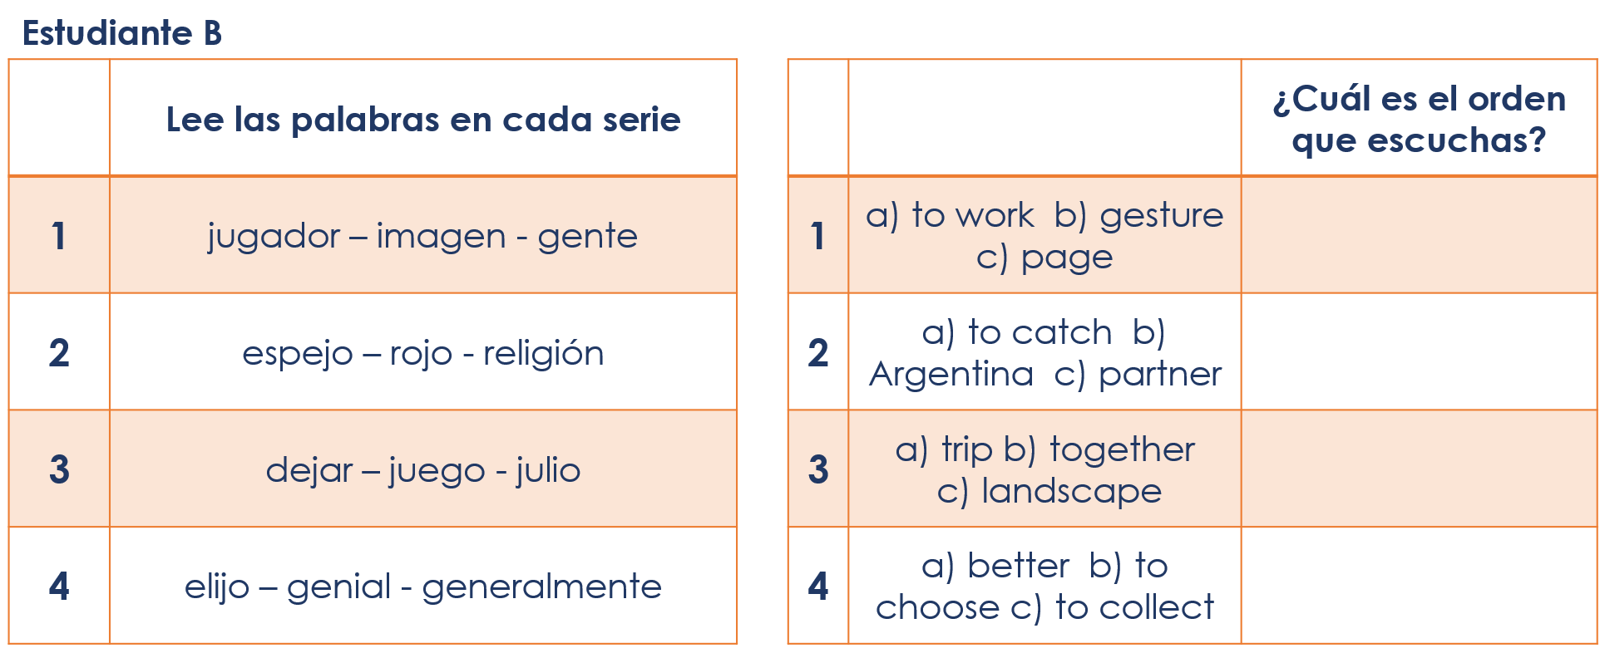
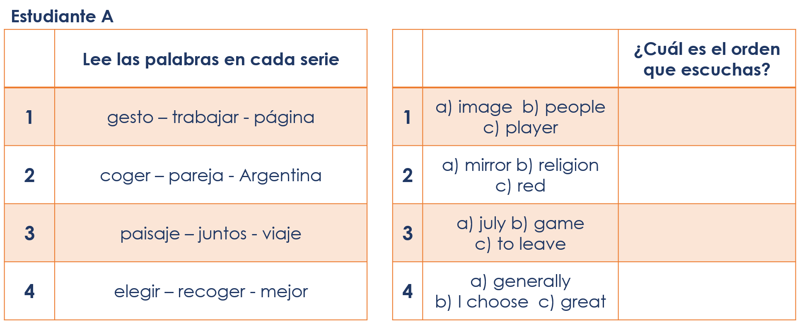
Year 8 Spanish Term 2.1 Week 6 – Speaking cards (3)

