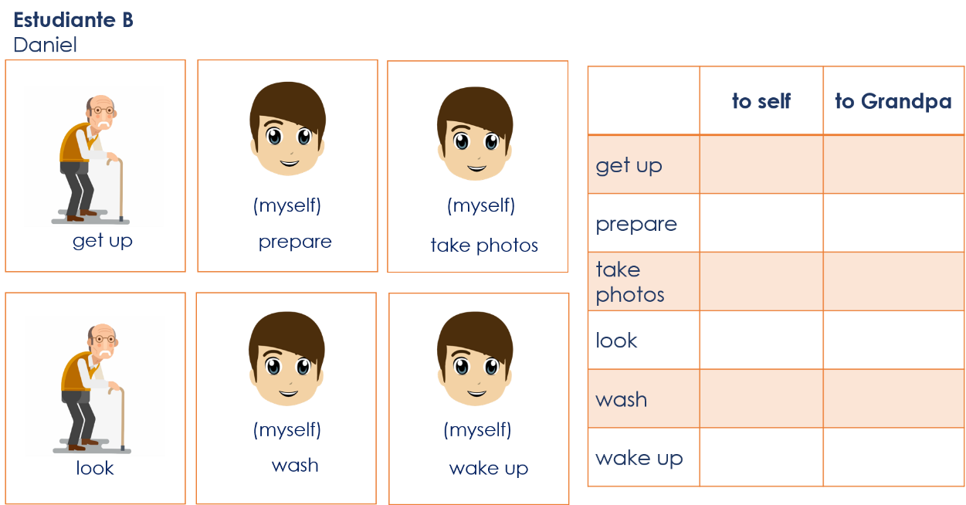
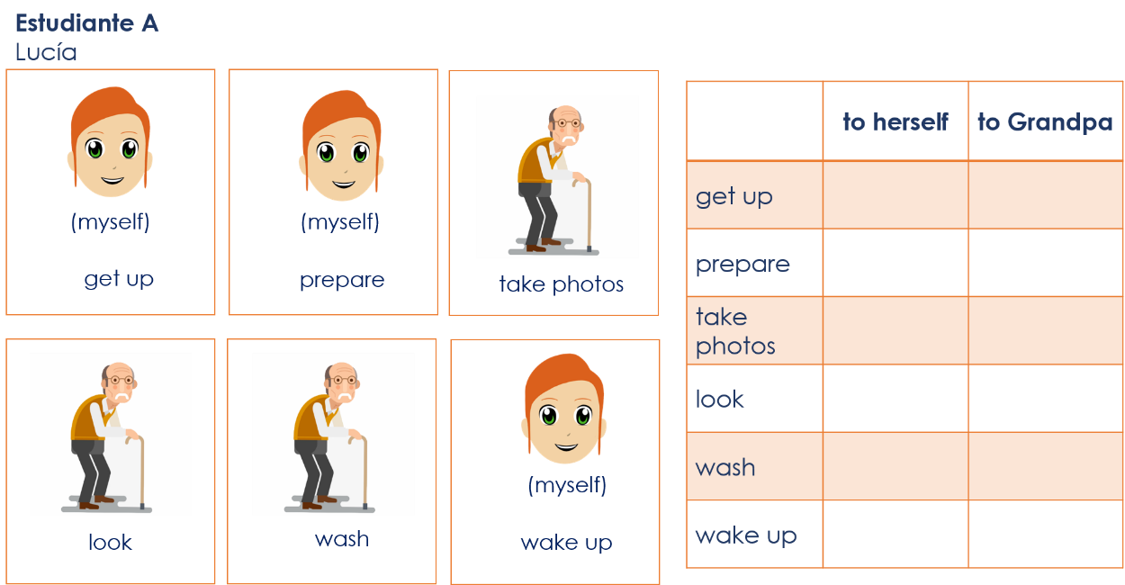
Year 8 Spanish Term 2.1 Week 6 – Speaking cards (2)
to herself
to himself
to herself
to himself

