How do I find and download Assessment Tests on the NCELP Resource Portal?
- From the Resource Portal homepage, click on the orange ‘All Resources’ button under ‘Browse by’.

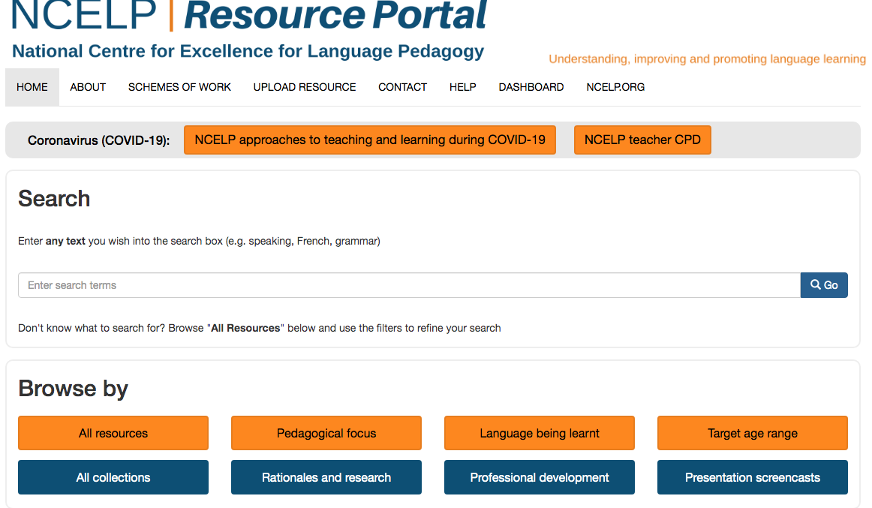

- On the left hand side menu bar click on ‘Type / Purpose of resource’. A short drop-down menu will appear. Click on ‘Tests / assessments’

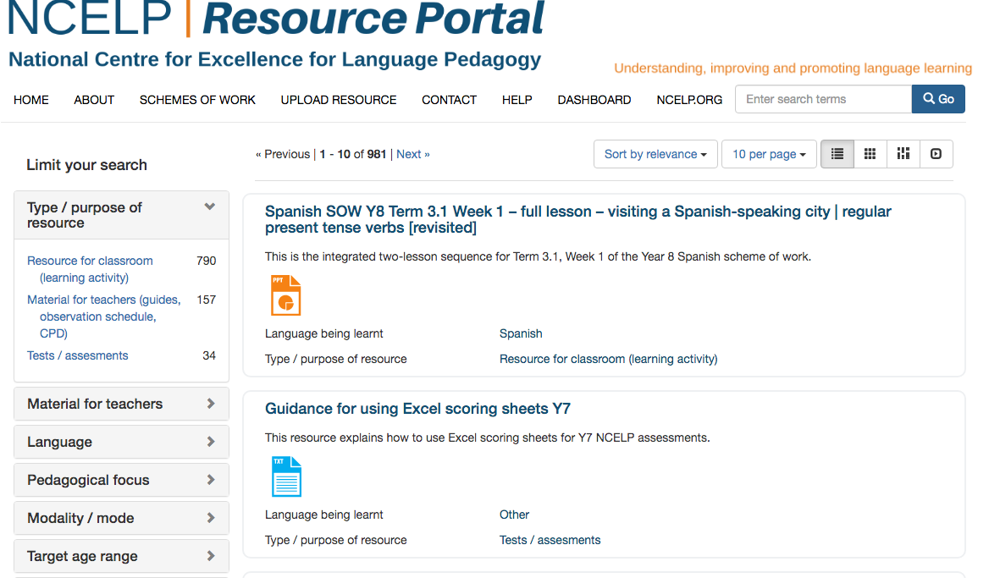

- Scroll down to find the resource you are looking for. At the bottom of the page you can click on ‘Next’ or the numbers to go to the next page of resources. Click on the title of the resource.

