Spot the difference – Spanish (TENER versus SER)
-----------------------------------------------------------------------------------------------------------------------
Picture A
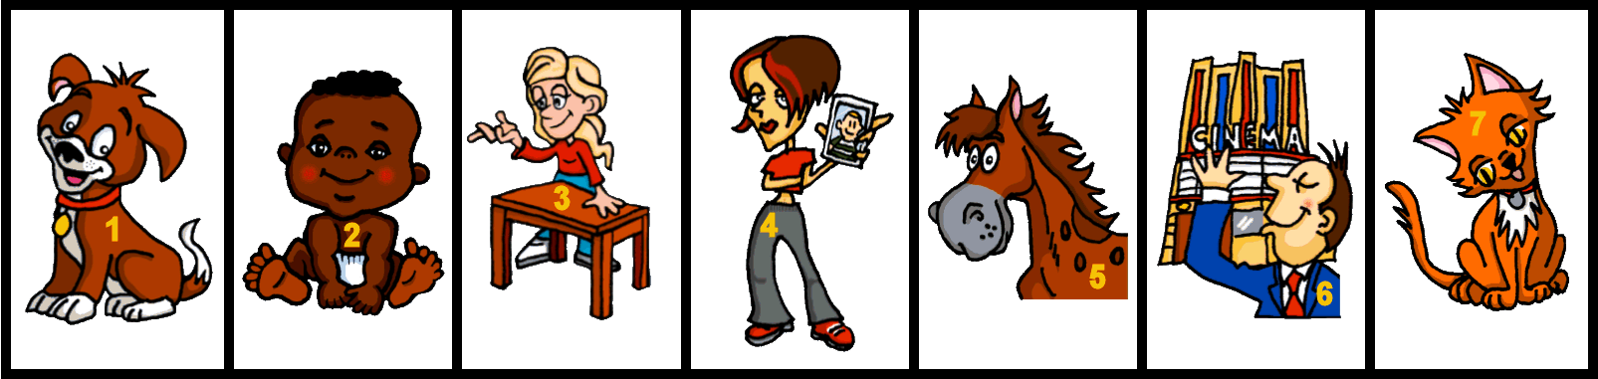
-----------------------------------------------------------------------------------------------------------------------
Picture B
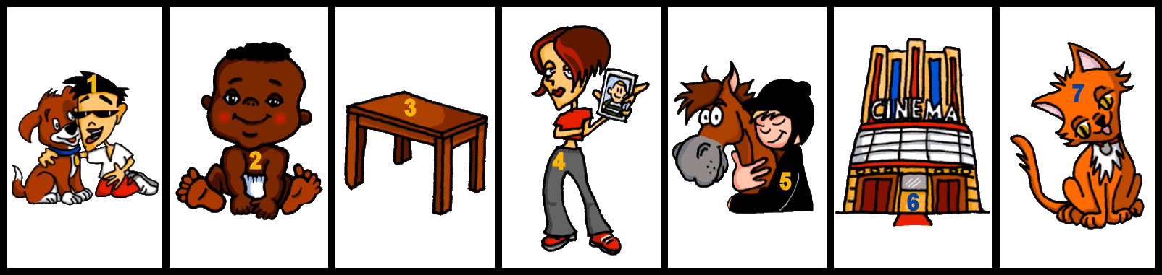
-----------------------------------------------------------------------------------------------------------------------
Picture A
-----------------------------------------------------------------------------------------------------------------------
Picture B

Teacher instructions
This pair speaking task focuses on the difference between ‘es’ and ‘tiene’.
Students describe the pictures they have, one by one, using the numbers as identifiers.
They have to work out if they have the same picture or a different one.
The only difference in what they say will be in the verb ‘is’ or ‘has’.
Students can tick for same, and cross for different.
NB: Sheet formatted for two pairs of pupils, so make EIGHT copies for a class of 32.
The task works fine in black and white.
ANSWERS: 2, 4, 7 are the same, the rest are different.
Language needed for the task:
Word | Word class | Word frequency
tener | verb | 19
ser | verb | 7
perro | noun (m) | 888
bebé | noun (m) | 2028
mesa | noun (f) | 525
foto | noun (f) | 882
caballo | noun (m) | 907
gato | noun (m) | 1728
cine | noun (m) | 952

Sample statements.

A
1 Número uno es un perro.
2 Número dos es un bébé.
3 Número tres tiene una mesa.
4 Número cuatro tiene una foto.
5 Número cinco es un caballo.
6 Número séis tiene un cine.
7 Número siete es un gato.
B
1 Número uno tiene un perro.
2 Número dos es un bébé.
3 Número tres es una mesa.
4 Número cuatro tiene una foto.
5 Número cinco tiene un caballo.
6 Número séis es un cine.
7 Número siete es un gato.

Source of frequency rankings: Davies, M. & Davies, K. (2018). A frequency dictionary of Spanish: Core vocabulary for learners (2nd ed.). London: Routledge.

