Names and ages jigsaw task – Spanish
-----------------------------------------------------------------------------------------------------------------------
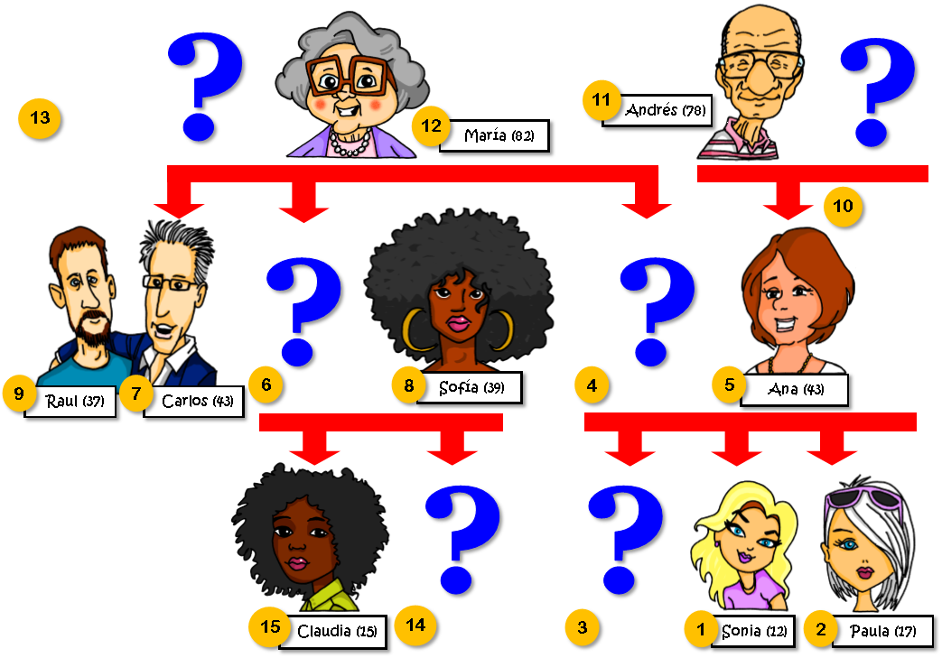
Picture A

-----------------------------------------------------------------------------------------------------------------------
Picture B
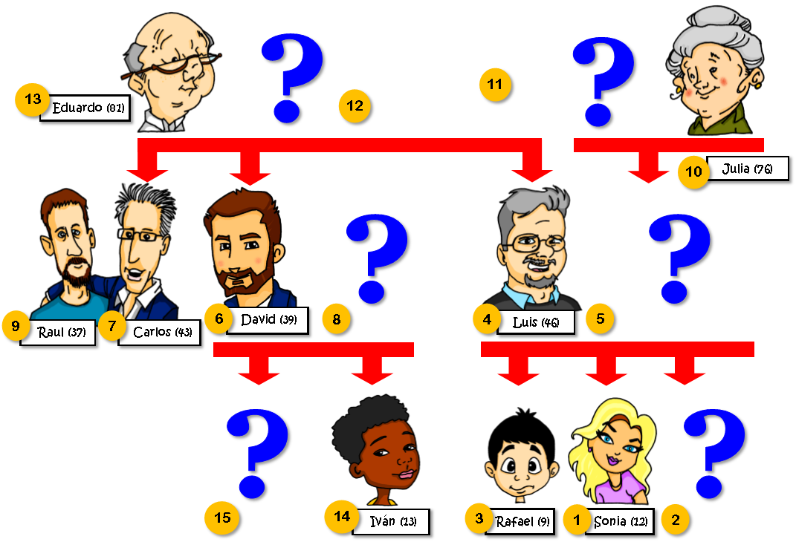

Teacher instructions
This activity is designed for beginner or Year 7 students. Divide students into pairs and give each student one picture, A or B. Both A and B have information missing.
To complete the family tree, students ask:
‘Número [X], ¿quién es?’
and
‘Número [X], ¿cuántos años tiene?
Language required
Correct use of ‘tiene’ [tener] for age and ‘es’ [ser] for identification. Knowledge of numbers is also needed.
In addition, pupils use their decoding knowledge to sound out the names.
Students transcribe the names, using their SSC knowledge. They then check their answers at the end of the task, with their partner.

