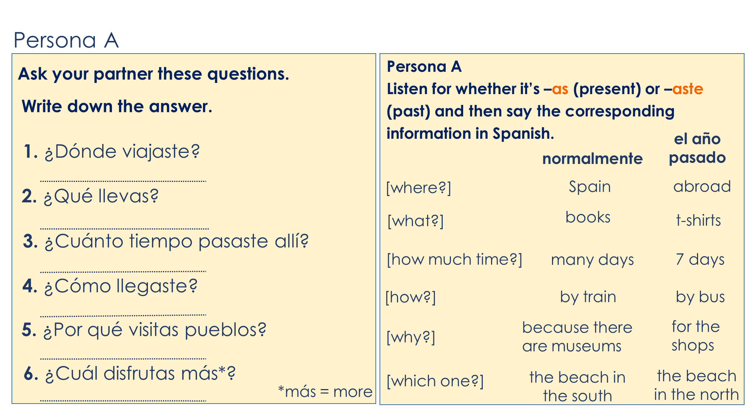
Year 8 Spanish Term 1.1 Week 2 – Lesson 2 speaking cards
