Il ou ils? [-IR verbs]
Listen. Marc is talking about his friend Pierre and his other friends. But you’re in a very noisy street! The verb ending tells you if Marc is referring to Pierre (tick  ‘il’) or to all of his friends tick  ‘ils’).
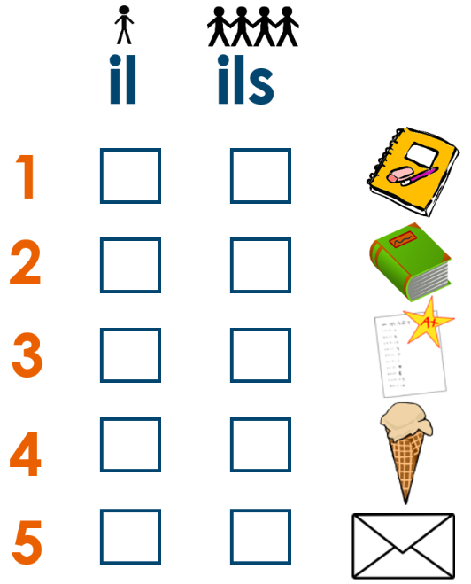
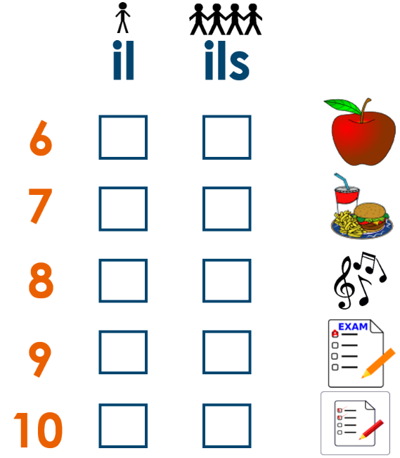

-----------------------------------------------------------------------------------------------------------------------

Il ou ils? [-IR verbs]
Listen. Marc is talking about his friend Pierre and his other friends. But you’re in a very noisy street! The verb ending tells you if Marc is referring to Pierre (tick  ‘il’) or to all of his friends tick  ‘ils’).

