How do I download Schemes of Work from the NCELP Resource Portal?
There are various options to find and download Schemes of Work for French, German or Spanish.
The quickest option is as follows:
- From the NCELP Resources Portal (https://resources.ncelp.org/), under the ‘Browse By’ Section, there is a ‘NCELP Teaching materials and schemes of work’ section with links that you can click on for each language.
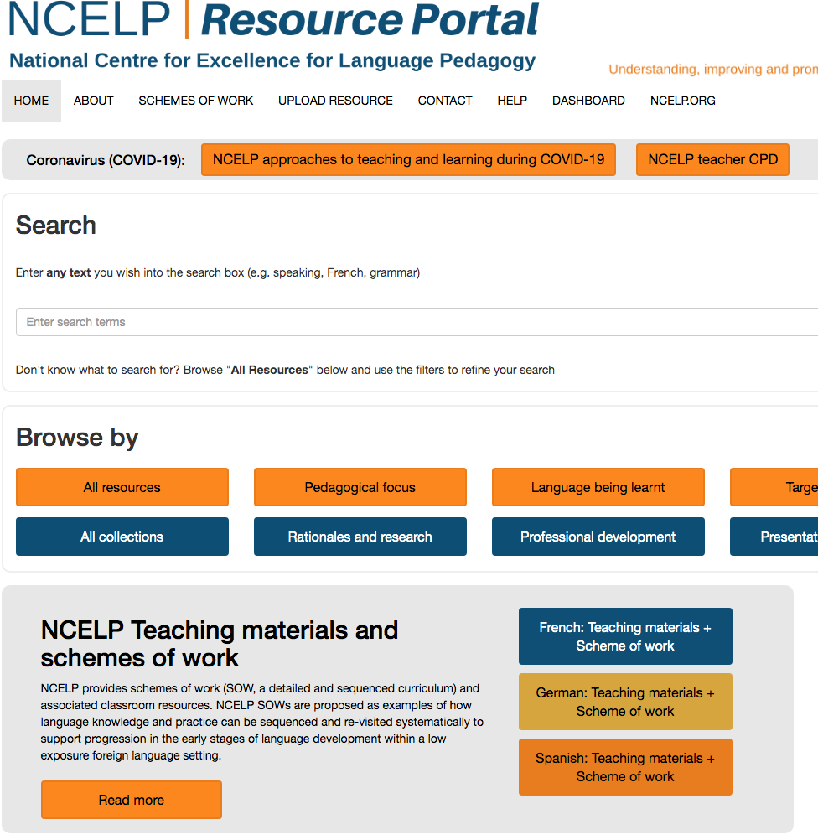

- After clicking on your chosen language (in this example, Spanish), click on either the Year 8 or Year 7 heading, or the blue ‘Download All’ button beneath.

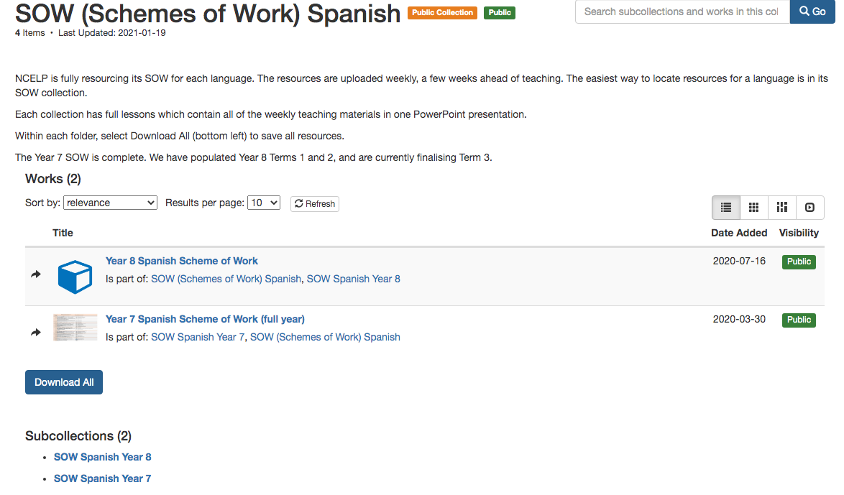

- Having clicked on your chosen year group (in this example year 7), click the blue ‘Download’ button to start downloading the Excel spreadsheet. When the download has completed you can open it and save it to your own computer.
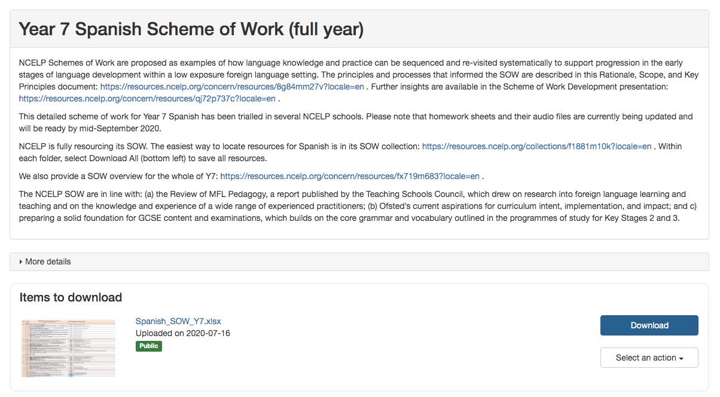
An alternative to this process is to click on the Schemes of Work link at the top of the Resources Portal page.
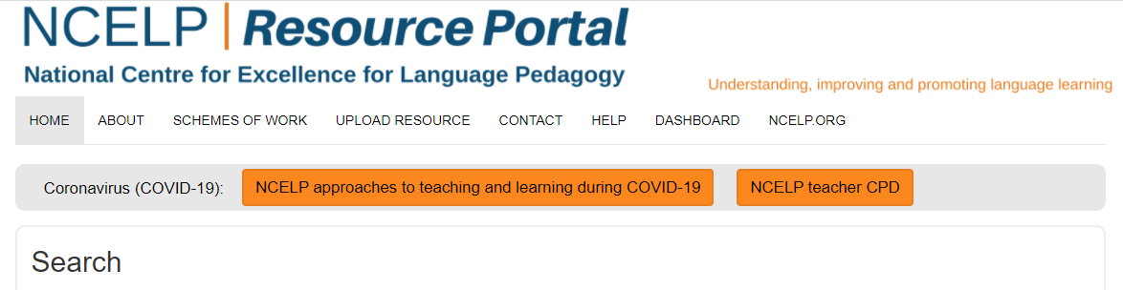

This option takes you to a page with links to the Schemes of Work, Schemes of Work Overviews, Resource Collections and Language Guides for French, German and Spanish in Years 7 and 8.

