**A**

**B**

**4.**

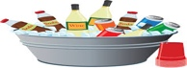

Because I want to drink something.

**(f)**

**(m)**

Because I want to read the news.

**A**

**B**

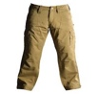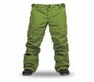

in the market

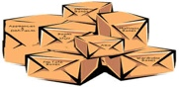

**(m)**

**(f)**

in the shop

**Person A**

**A**

**B**

**5.**



They are 30 euros. euros.

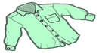

**(f)**

They are 27 euros. euros.

**(m)**

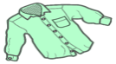

**A**

**B**

**2.**

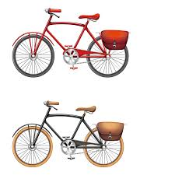

**(f)**

**(m)**

this week

this Saturday

**A**

**B**

**6.**



**(f)**

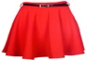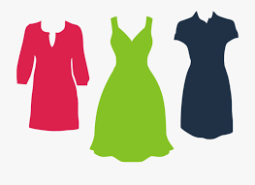

**(m)**

They are pretty.

They are short.

**A**

**3.**

**B**

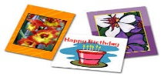

**(m)**

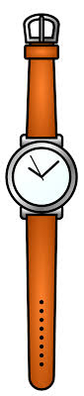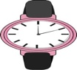

**(f)**

my Dad

my Mum

**4.**

**A**

**B**

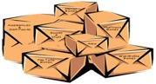

in the kitchen

in the shop

**(f)**

**(m)**

**A**

**B**

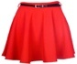

They are 29 euros.

They are 24 euros.

**(f)**

**(m)**

**Person B**

**5.**

**A**

**B**



at the weekend

this Sunday

**(f)**

**(m)**

**2.**

**A**

**B**

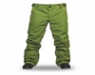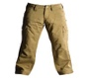

They are not expensive.

I like the colour.

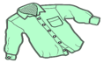

**(m)**

**(f)**



**6.**

**A**

**B**

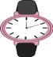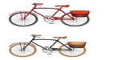

**(m)**

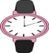

my aunt

**(f)**

my grandfather

**3.**

**A**

**B**

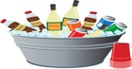

**(f)**

They are very practical/ useful.

**(m)**

They are tasty.

**A**

**B**



in the market



**(m)**

**(f)**

in the shop

**A**

**B**

**4.**



Because I want to drink something.

**(f)**

**(m)**

Because I want to read the news.

**A**

**B**

**6.**



**(f)**



**(m)**

They are pretty.

They are short.

**5.**

**A**

**B**



at the weekend

this Sunday

**(f)**

**(m)**

**3.**

**A**

**B**



**(f)**

They are very practical/ useful.

**(m)**

**6.**

**A**

**B**



**(m)**



my aunt

**(f)**

my grandfather

**Person A**

**A**

**B**



They are 29 euros.

They are 24 euros.

**(f)**

**(m)**

**Person B**

**A**

**B**

**2.**



**(f)**

**(m)**

this week

this Saturday

**A**

**B**

**5.**



They are 30 euros. euros.



**(f)**

They are 27 euros. euros.

**(m)**



**A**

**3.**

**B**



**(m)**

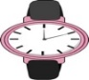

**(f)**

my Dad

my Mum

**4.**

**A**

**B**



in the kitchen

in the shop

**(f)**

**(m)**

**2.**

**A**

**B**



They are not expensive.

I like the colour.



**(m)**

**(f)**



They are tasty.