Applying your knowledge test
Y8 Term 3 German

Your name: ______________________ Your class / name of teacher: ______________________

The test is in four sections:

Section A: Listening (10 minutes)
Section B: Reading comprehension (20 minutes)
Section C: Writing (20 minutes)
Section D: Speaking (5-10 minutes)
Section E: Reading aloud (5-10 minutes)

This makes a total of around 65-75 minutes to complete the entire test.

Your teacher will have sent you an audio file for the listening test. Please check you have this ready to play.

Remember – always just have a go! If you know some words, just write / say them!

Just do what you can!

Total marks

Listening | /20
Reading comprehension (written modality) | /8
Writing | /20
Speaking | /20
Reading aloud and comprehension (oral modality) | /12
TOTAL SCORE | /80
TOTAL %

SECTION A (LISTENING)

PART A

You will hear Wolfgang talk about his week and Mia’s week. Here are some activities he mentions (plus some that he does not mention!). You have 20 seconds to read the activities.

go swimming visit friend clean room
go to cinema go to school
stay at home go shopping do bike tour

Write one activity into each space in the grid below. You must decide who does the activity, and when.

You will hear the story twice, with a 20 second gap in between. After hearing it twice, you will have another minute to finish the grid.

^{when?}  _{who?} | last weekend | today | next weekend
Wolfgang | 1. travel to Hamburg  2. ___________________ | 1. ___________________ | 1. read book  2. ___________________
Mia | 1. ___________________ | 1. visit market | 1. ___________________
Wolfgang and Mia |  | 1. have an exciting week  2. ___________________

PART B

Now listen for a third time. You will then have two minutes to answer the questions in English.
Write as many details as you can
(2 marks per question)
a) | What does Wolfgang think of the train journey?
b) | What does Wolfgang not want to do next weekend?
c) | What are Wolfgang and Mia allowed to do on Sunday evening, and why do they want to do this?
d) | What does Mia have to do first?
Now turn the page and move on to the next section.
TOTAL MARKS AVAILABLE (LISTENING): 20

SECTION B (READING COMPREHENSION)

You are going on a school exchange to Germany. Your exchange partner’s name is Hans. Hans sends you a text as the bus is arriving. You open your map and try to follow his instructions.

PART A
Your map isn’t very clear! Read the text and write the English for the words in bold in the right places on the map.
Museum

BESUCH IN DEUTSCHLAND
Du kommst in der Stadt an und Hans schickt dir eine SMS.
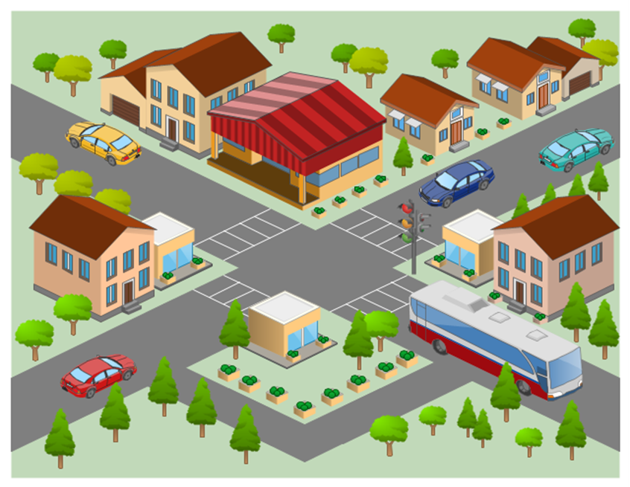
Hallo!
Willkommen¹ in unserer Stadt! Früher gab es ein Theater neben dem Museum, aber jetzt gibt es dort ein großes Schwimmbad. Vor dem Schwimmbad gibt es ein Café. Hier kann man andere junge Leute treffen. Neben dem Café, auf der linken Seite, ist das Kino. Hinter dem Schwimmbad gibt es ein kleines Haus. Auf der anderen Straßenseite gibt es zwei Gebäude. Links ist die Bibliothek – sie ist sehr klein! Rechts ist das neue Theater. Vor dem Theater ist der große Park. Im Park gibt es eine kleine Tanzschule. Meine Schwester lernt dort tanzen!
Bis bald², Hans
¹willkommen = welcome
²bis bald = see you soon

Si vous sortez l’hôtel et traversez la rue, vous trouvez un café excellent avec une belle vue du parc. Le parc est en bas de la carte. À gauche du parc, il y a une petite place.
À l’autre côté du parc, vous trouvez un jardin anglais.
Près du jardin est le musée local de Saint-Clair-des-Monts.

Now read further details from Hans about the town and answer the questions that follow.
Früher war die Stadt klein und ruhig. Sie ist immer noch schön und freundlich aber es gibt hier jetzt mehr zu tun. Vor zwanzig Jahren, sagt meine Mutter, gab es hier einen Markt. Jetzt gibt es hier ein großes Geschäft und zu viele Autos. Es ist manchmal gefährlich! Es gab damals Konzerte im Park. Meine Lieblingsband hat hier gespielt! Sehr viele Leute waren¹ immer in der Stadtmitte. Die Stadt hatte auch früher ein anderes Theater. Das neue Theater ist ein großes Gebäude und hat mehr Platz. In zwei Monaten wird meine Schwester mit ihrer Tanzschule im Theater tanzen! Am Wochenende schwimme ich gern. Letzte Woche bin ich ins Schwimmbad gegangen. Nächstes Jahr will ich auch mehr Fußball spielen!
¹waren = were

PART B

Put a tick next to the things that describe what the town was like in the past.

small |  |  | lots of people in town centre
more to do there |  |  | has a market
quiet |  |  | concerts in the park
dangerous |  |  | more room in the theatre
PART C
Number these events in the order they happen. Write the numbers 1-4 in the boxes on the right (1= happened first, 4 = will happen last).
Hans – going to the swimming pool
Hans’ sister – dancing in the theatre
Hans’ favourite band – playing in the town
Hans – playing more football

TOTAL MARKS AVAILABLE (READING COMPREHENSION): 8

SECTION C (WRITING)

PART A

Look at the picture and complete the missing words in the text. The number of gaps tells you how many letters are missing.

Heute ist Samstag!
Mia g _ _ _ heute mit ihrer Mutter in die Stadt, aber Wolfgang b _ _ _ _ _ zu Hause .
Er will seine H_ _ _ _ _ _ _ _ _ _ _ machen und dann Schlagzeug s _ _ _ _ _ _ . Das ist t _ _ _ !
Mia wird mit Mutti n _ _ _ Kleidung kaufen und viel Kaffee t _ _ _ _ _ _ .
Wolfgang spielt lieber M_ _ _ _ , aber er m _ _ _ arbeiten! M _ _ _ _ _ _ _ _ _ lernt er nicht gern!
Danach soll er die K _ _ _ _ putzen und das
E _ _ _ _ kochen!

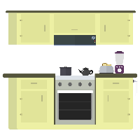

PART B
What happened last week? What will happen next week?
Write between one and three sentences in German for each picture. Write your sentences in the blank box on the right. Use all of the German words under the pictures.
Try to show that you know what the words mean by writing full, interesting, and varied sentences that make sense. You can use your imagination if you like!

Last week
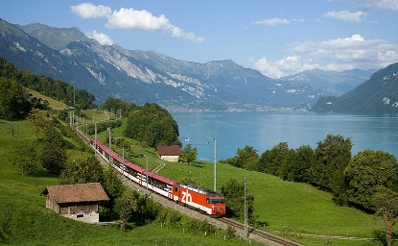

fahren / der Zug / schön / der See
Next week

besuchen / der Freund / das Konzert / Lieblings-

TOTAL MARKS AVAILABLE (WRITING): 20

SECTION D (SPEAKING)
Before you start this section of the test, please go to this website: vocaroo.com.
It will open in a new tab. Click the red record button, then come back to this test.

Look at the photo and answer the questions below in German. For each idea you say, you will get 2 marks for expressing the meaning, and 1 mark for speaking accurately. In total (parts A & B combined), you will get 2 marks for speaking fluently.
You have 2 minutes to prepare all of your answers before you speak. It doesn’t matter if you make mistakes! Just try to keep going and say something that you know how to say.

PART A

What can you see in this photo? Try to say at least 4 different things in German. (12 marks)

Here are some ideas about what you could say. You can say different things if you wish!

• Say what you can see in the photo
• Describe the man in the foreground
• Say what the man is going to do
• Describe the woman on the left (you can use your imagination)

PART B

Ask the woman on the left 2 different questions in German. (6 marks)

TOTAL SCORE AVAILABLE (SPEAKING): 20
SECTION E (READING ALOUD & COMPREHENSION)

PART A

Read the following text aloud.

You won’t know some of the words – don’t worry! Just do your best to read them aloud as you think they should sound in German.
You will get marks for understandable and fluent pronunciation.
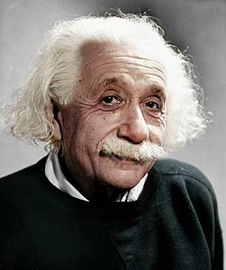
Albert Einstein war ein sehr wichtiger Wissenschaftler und auf der ganzen Welt bekannt.

Er war Physiker, und er hat die Relativitäststheorie geschrieben.

Seine Ideen sind kompliziert zu verstehen, aber man glaubt immer noch, dass sie richtig sind.

Seine Heimstadt war Ulm in Deutschland, aber er hat auch in Amerika gewohnt.

Er hat auch gesagt: „Die besten Dinge im Leben sind nicht die, die man für Geld bekommt.“

PART B

Now say, in English, any 4 facts mentioned in the text about Albert Einstein. You will get half a mark for each fact.

TOTAL SCORE AVAILABLE (READING ALOUD & COMPREHENSION): 12

When you have finished, go back to the Vocaroo window. Click on the red button.
Click on "Save & Share". Copy the URL. Paste the URL for your Vocaroo recording below:
Vocaroo link:

