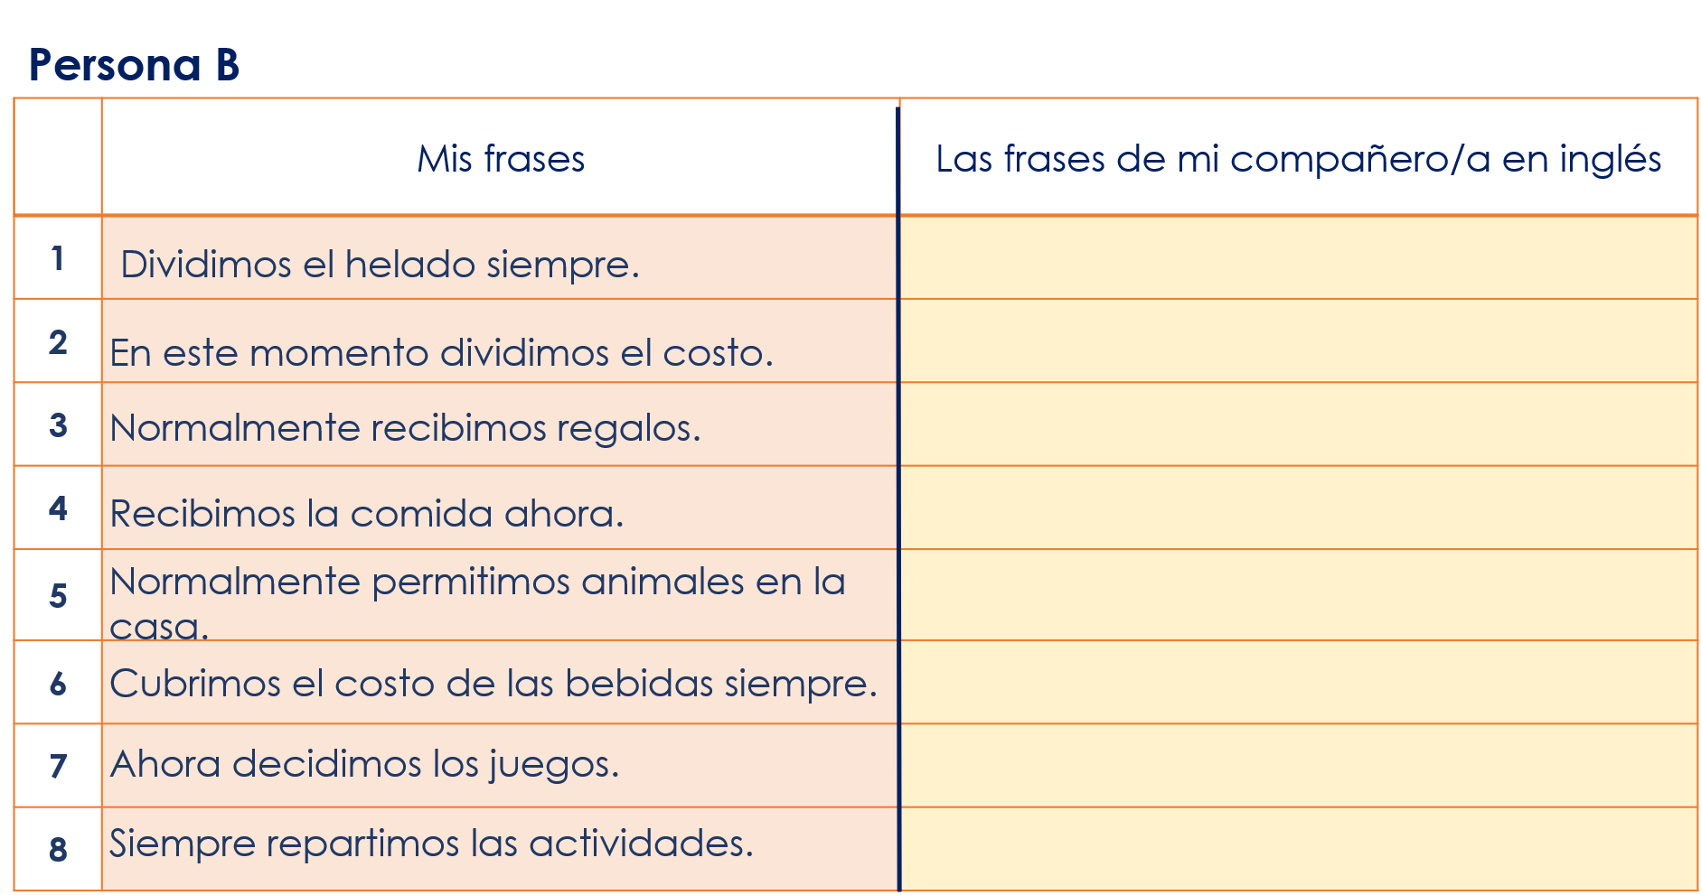
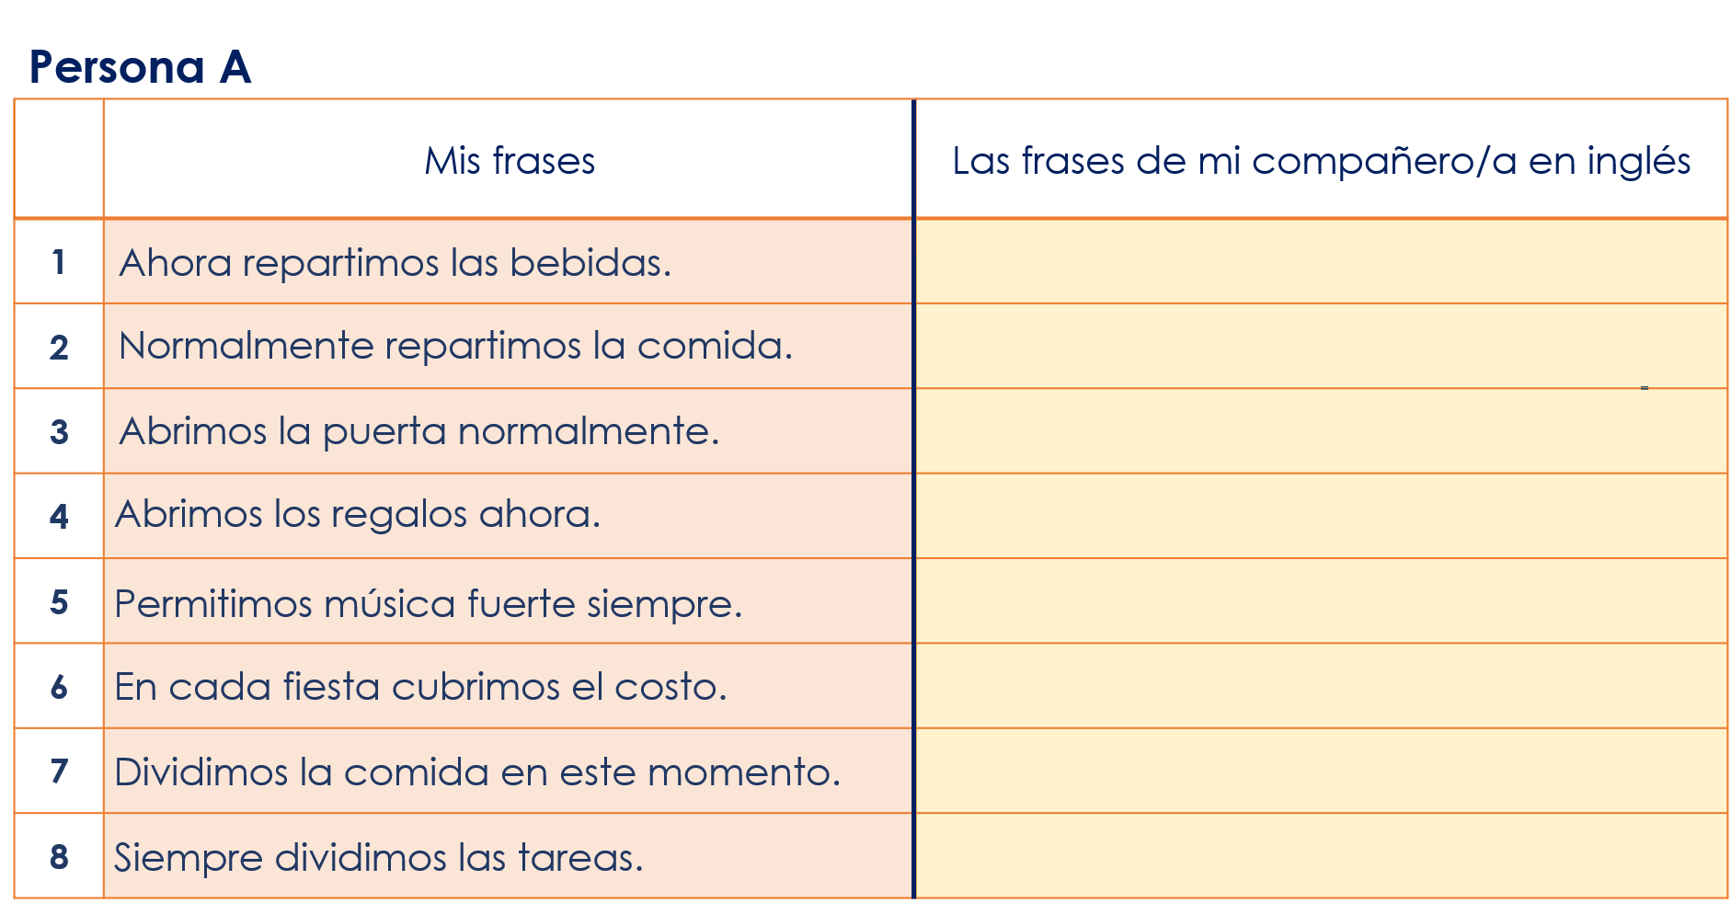
Year 8 Spanish Term 1.1 Week 7 – Lesson 2 speaking cards

