Spot the difference – 15 verbs [3rd person singular] German version
-----------------------------------------------------------------------------------------------------------------------
Picture A
Instructions
Look at the pictures. Describe to your partner what each person is doing. Use the numbers to identify the people. E.g. Eins schläft.
Find out how many activities you have in common with your partner.
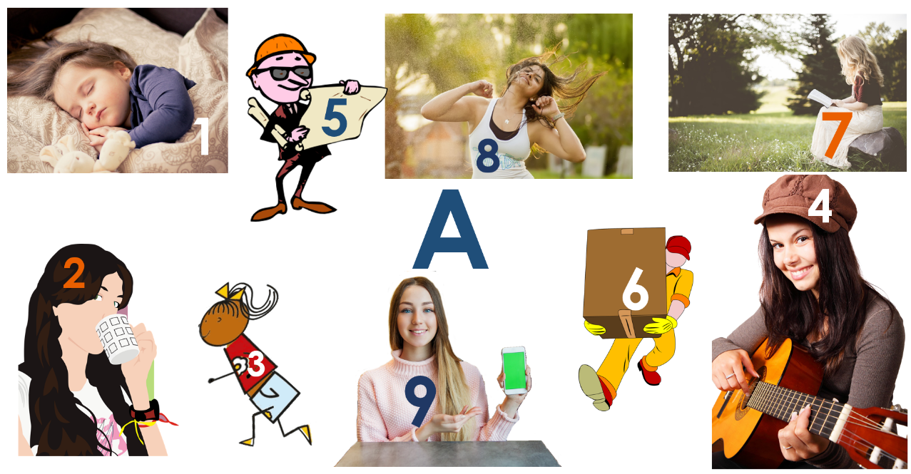

-----------------------------------------------------------------------------------------------------------------------
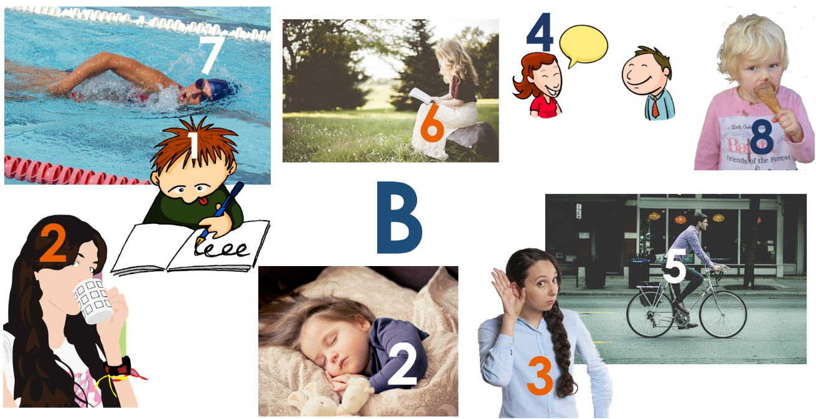
Picture B
Instructions
Look at the pictures. Describe to your partner what each person is doing. Use the numbers to identify the people. E.g. Eins schreibt.
Find out how many activities you have in common with your partner.
Teacher instructions

This activity is designed for Y7 or beginner learners of German. Divide students into pairs and give each student one picture, A or B. Students describe what the people in their picture are doing. Each person is numbered to reduce the cognitive load and focus attention on verbs rather than nouns. For example: Eins schläft / schreibt.
NB: the numbers do not match across the sets so as not to give the solution away in that way. This sustains the focus on the verbs alone.
The verbs are taken from the set of 15 high-frequency prototype verbs and accompanying PowerPoint resource.
* Word frequencies are given for the infinitive form of the verbs.
Word | Word class | Word frequency
spielt | verb | 197
schreibt | verb | 245
hört | verb | 1553
spricht | verb | 157
liest | verb | 323
trinkt | verb | 608
isst | verb | 654
schläft | verb | 787
arbeitet | verb | 200
schwimmt | verb | 1832
tanzt | verb | 2011
läuft | verb | 248
fährt | verb | 169
trägt | verb | 308
zeigt | verb | 154

Note. Source of frequency rankings: Jones, R.L & Tschirner, E. (2011). A frequency dictionary of German: Core vocabulary for learners. London: Routledge.

