Spot the difference – 15 verbs [3rd person singular] French version
-----------------------------------------------------------------------------------------------------------------------
Picture A
Instructions
Look at the pictures. Describe to your partner what each person is doing.
Use the numbers to identify the people. E.g. (Numéro) un dort.
Find out how many pictures you have in common.
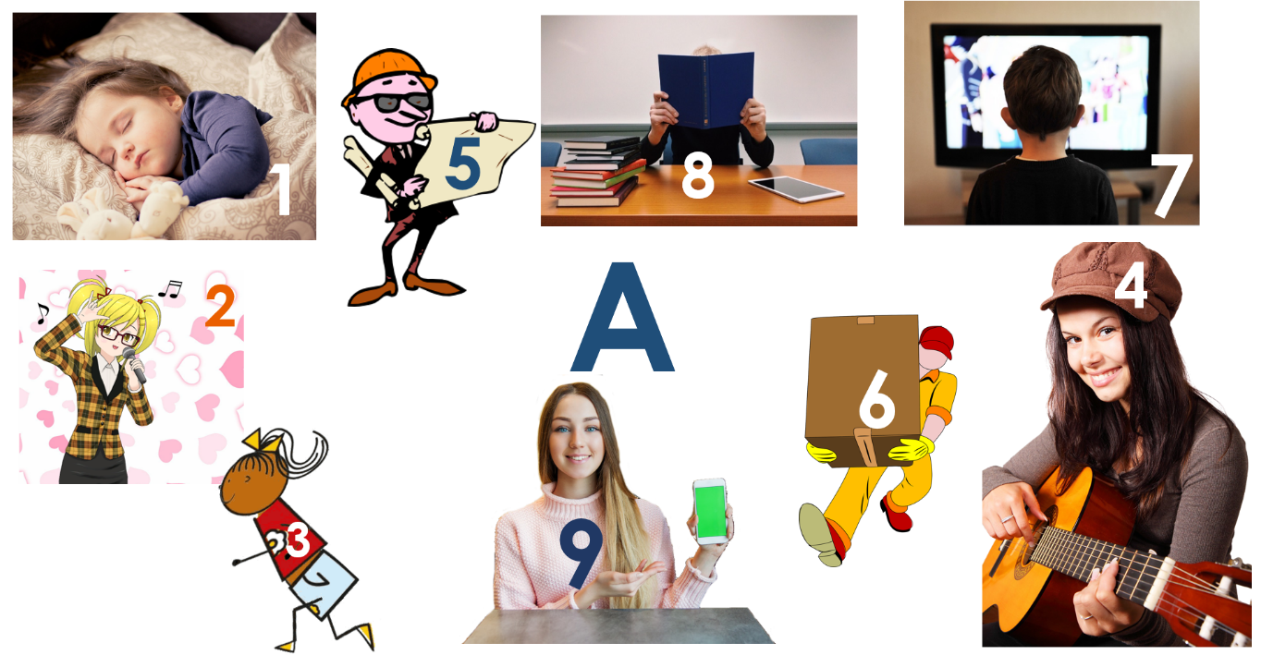

-----------------------------------------------------------------------------------------------------------------------
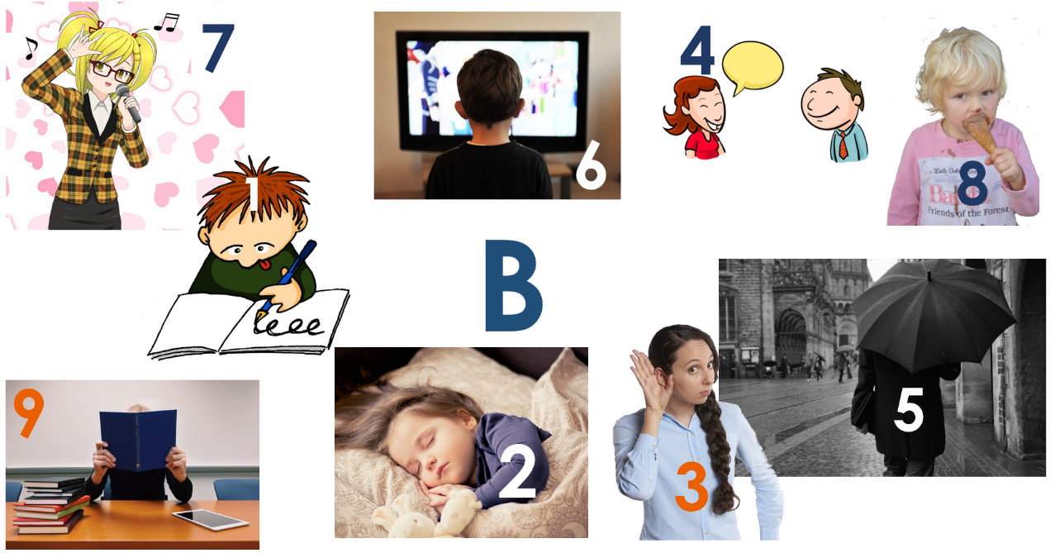
Picture B
Instructions
Look at the pictures. Describe to your partner what each person is doing.
Use the numbers to identify the people. E.g. (Numéro) un écrit.
Find out how many pictures you have in common.

Teacher instructions

This activity is designed for Y7 or beginner learners of French. Divide students into pairs and give each student one picture, A or B. Students describe what the people in their picture are doing. Each person is numbered to reduce the cognitive load and focus attention on verbs rather than nouns. For example: (Numéro) un dort / écrit.
NB: the numbers do not match across the sets so as not to give the solution away in that way. This sustains the focus on the verbs alone.
The verbs are taken from the set of 15 high-frequency prototype verbs and/or the 25 most common verbs accompanying PowerPoint resources.
* Word frequencies are given for the infinitive form of the verbs.
Word | Word class | Word frequency
joue | verb | 219
écrit | verb | 382
écoute | verb | 429
parle | verb | 106
regarde | verb | 425
chante | verb | 1820
mange | verb | 1338
dort | verb | 1836
travaille | verb | 290
étudie | verb | 960
sort | verb | 309
court | verb | 1447
porte | verb | 105
montre | verb | 108

Note: Source of frequency rankings: Londsale, D., & Le Bras, Y. (2009). A Frequency Dictionary of French: Core vocabulary for learners London: Routledge.

