Access your audio file at www.ncelp.org/audio/GY7T1-2W4 (or scan the QR code above).
Then follow all 9 steps. Steps 1-8 take about 10 minutes. Step 9 takes about 10 minutes.

- Listen to the new words and meanings (German and English). Tick once completed: ⃝
- Say after me (German and English). Tick once completed: ⃝
- Say with me (5 times - just German). Tick once completed: ⃝
- I say German - you say English (pause then answer aloud). Tick once completed: ⃝
- Now, in a different order - I say German, you write English.

1 |  | 5
2 |  | 6
3 |  | 7
4 |  | 8
- I say German, you write German. Check answers at Step 8 - the order is as in Quizlet.
1 |  | 5
2 |  | 6
3 |  | 7
4 |  | 8
- Now, in a different order – I say English, you say German. Tick once completed: ⃝
- Now go to Quizlet to check your answers to Step 6. Tick once completed: ⃝
- Practice on Quizlet for 10 minutes. Do the following tasks on Quizlet: Write (both translating into English and into German); Spell (hear & type); Test (all questions).
Quizlet QR code: 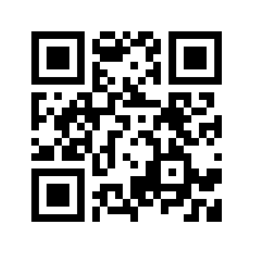 Quizlet link: https://quizlet.com/_7a08wd

