Names and ages jigsaw task – German
-----------------------------------------------------------------------------------------------------------------------
Picture A
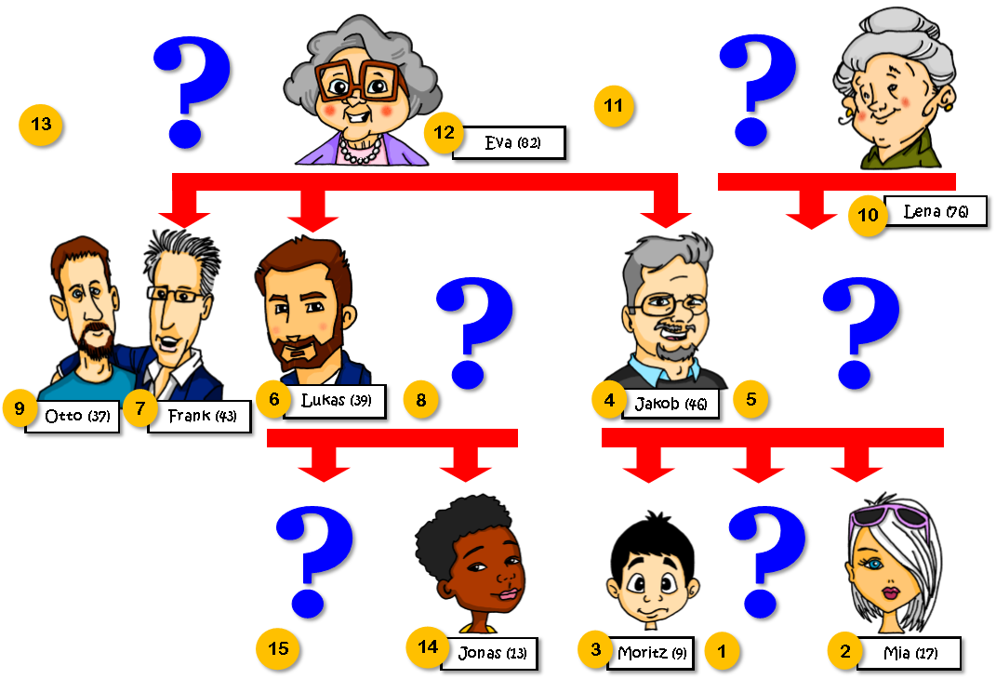

-----------------------------------------------------------------------------------------------------------------------
Picture B
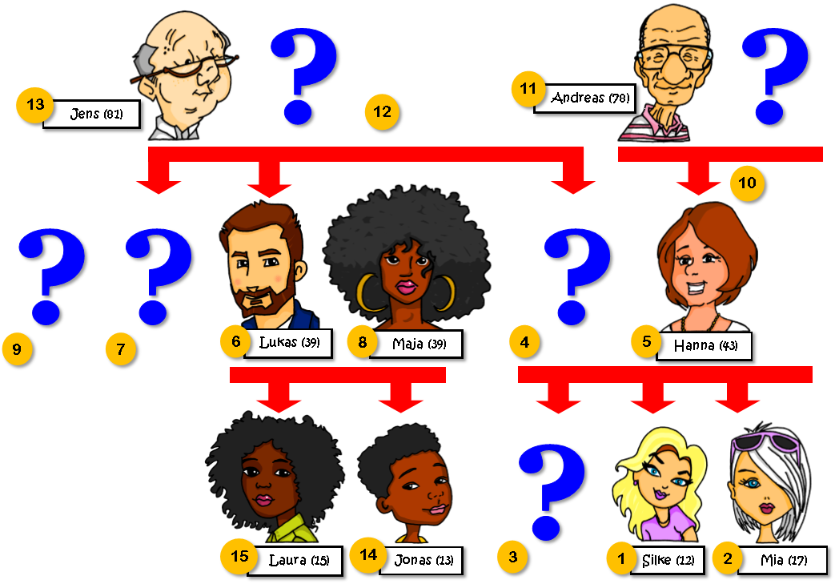

Teacher instructions
This activity is designed for beginner or Year 7 students. Divide students into pairs and give each student one picture, A or B. Both A and B have information missing.
To complete the family tree, students ask:
‘Nummer [X], ¿wer ist das?’
and
‘Nummer [X], ¿wie alt ist er/sie?’
Language required
Correct use of ‘ist’ [sein] for age and identification. Knowledge of numbers is also needed.
Practice in the use of two question words, ‘who’ and ‘how’ is important – ‘wer’ is often confused by beginner German learners because of its phonemic similarity with the English ‘where’. It is also helpful to practise using the pronouns ‘he’ and ‘she’. This is a useful precursor to applying the same pronouns later, to refer to gendered nouns, e.g., (der Tisch er is alt. die Tür sie ist offen.). This is another area of difficulty for beginner learners of German.
In addition, pupils use their decoding knowledge to sound out the names.
Students transcribe the names, using their SSC knowledge. They then check their answers at the end of the task, with their partner.

