**Student A**

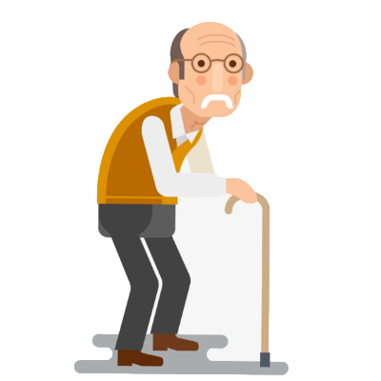

get up

wash

take photos

prepare coffee

write

teach Spanish



(myself)

(myself)





(myself)

**Student B**



wash

take photos

prepare coffee

write

teach Spanish



(myself)

(myself)

get up



(myself)

(myself)