**2.**

**B**

**A**

**B**

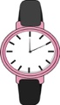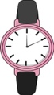

**[book]**

**[books]**

**[souvenir]**

**[souvenirs]**

**[watch]**

**[watches]**



**€12**



**€8**



**€27**



**€14**

**[dulce]**



**€13**



**€3**

**[dulces]**

**[pen]**



**€5**

**[pens]**

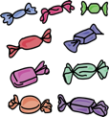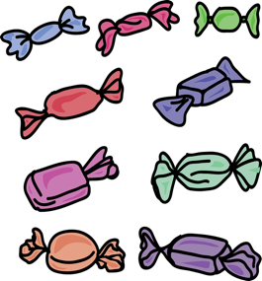

**[wedding dress]**



**€150**



**€80**

**[wedding dresses]**

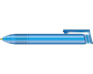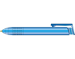

**A<**

**B**

**A**

**B**

**1**

**4**

**5**

**Persona B**

**Persona A**

1. How much are those books?
2. How much is that sweet?
3. How much are those pens?
4. How much is that wedding dress?
5. How much are those souvenirs?
6. How much is that watch?

**A**

**B**

**A**

**2**

**B**

**A<**

**B**

**3**

**6**

**6**





**€71**



**€61**

**€10**

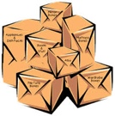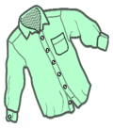

**[shirt]**

**[shirts]**

**[guitar]**

**[guitars]**

**[box]**

**[boxes]**

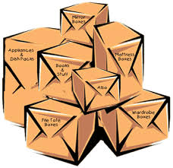

**€13**



**€110**



**€9**



**€57**



**€34**



**€11**



**€5**



**[drink]**

**[drinks]**

**[t-shirt in a small size]**

**[t-shirts in a small size]**

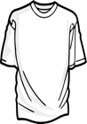

**[bag]**

**[bags]**

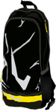

**€98**



**€66**



**4**

**1**

1. How much are those bags?
2. How much is that shirt?
3. How much is that guitar?
4. How much are those boxes?
5. How much are those drinks?
6. How much is that t-shirt in size small?

**5**

**2**

**6**

**3**



**€42**



**€25**



**€100**