How do I find Homework Sheets and Answer Sheets on the NCELP Resource Portal?
- In Year 7, homework sheets can be found using the Language, Year Number, Term Number, Week Number system. For example, type in ‘German Y7 Term 3.1 Week 4 Homework sheet’ into the search box, click the blue ‘Go’ button and then click on the link.

- Homework sheets in Year 8 can be found in the same link as the full lesson for the week in which they will be set. For example, if you have searched for the German Year 8 Term 2.1 Week 1 full lesson, when you click on the link to this lesson, you will also find the homework sheet for the vocabulary to be learned as homework for the next week, namely Term 2.1 Week 2. Click the blue ‘Download’ button to download the sheet.

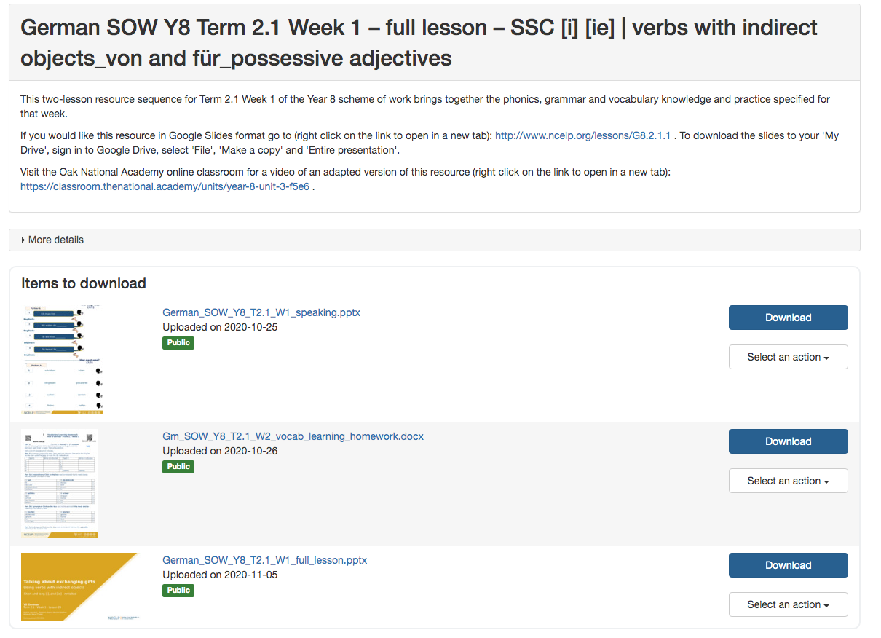

- Homework answer sheets are found separately and are searched for using the same Language, Year Number, Term Number, Week Number naming system. For example, to find the answers for the German Year 8 Term 2.1 Week 2 homework type in ‘German Y8 Term 2.1 Week 2 vocabulary learning homework answers’ and then click the blue ‘Go’ button.

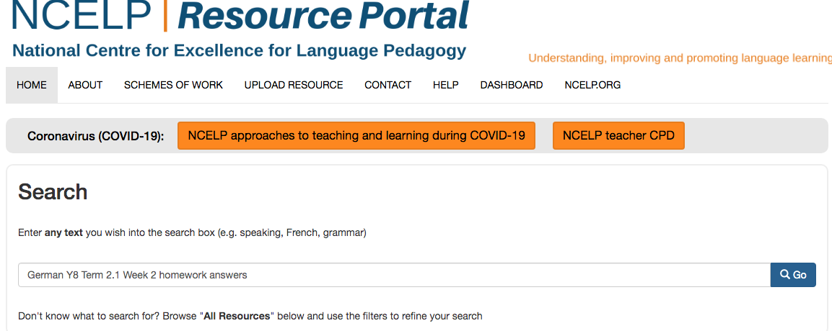
- Next click on the name of the resource.

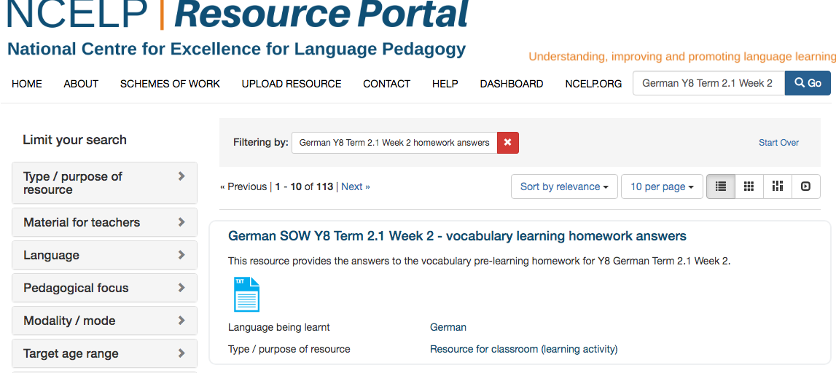
- Now click on the blue ‘Download’ button on the right to download the resource onto your computer.
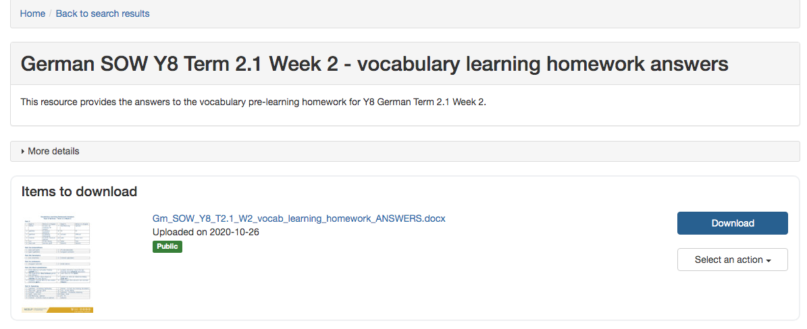
Homework sheets can also be accessed from the SOW as can the Quizlet links. Click on the ‘Resources’ tab at the bottom of the spreadsheet to find all the resources linked.

