Applying your knowledge test
Y8 Term 3 Spanish

Your name: ______________________ Your class / name of teacher: ______________________

The test is in four sections:

Section A: Listening (10 minutes)
Section B: Reading comprehension (20 minutes)
Section C: Writing (20 minutes)
Section D: Speaking (5-10 minutes)
Section E: Reading aloud (5-10 minutes)

This makes a total of around 60-70 minutes to complete the entire test.

Your teacher will have sent you an audio file for the listening test. Please check you have this ready to play.

Remember – always just have a go! If you know some words, just write / say them!

Just do what you can!

Total marks

Listening | /20
Reading comprehension (written modality) | /8
Writing | /20
Speaking | /20
Reading aloud & comprehension (oral modality) | /12
TOTAL SCORE | /80
TOTAL %

SECTION A (LISTENING)

PART A

You will hear Lucía talk about what she and Daniel like doing. Here are some activities she mentions (plus some that she does not mention!). You have 10 seconds to read the activities.
play in the garden read a book spend time at the beach
meet some friends look for and listen to birds
go to the city clean the kitchen go to a clothes shop

Write one activity into each space in the grid below. You must decide who does the activity, and when.

You will hear the story twice, with a 20 second gap in between. After hearing it twice, you will have another minute to finish the grid.

^{when?}  _{who?} | in the past | in general | in the future
Lucía | 1. ____________________ | 1. ____________________ | 1. Wash the car
Daniel | 1. ____________________  2. Went up a mountain | 1. Loves going to the countryside | 1.____________________
Lucía and Daniel |  | 1. ____________________ | 1. ____________________

PART B

Now listen for a third time. You then have two minutes to answer the questions in English.
Write as many details as you can
(2 marks per question)
a) | Why does Daniel love going to the countryside?
b) | What did Lucía buy?
c) | What did Daniel do up on the mountain?
d) | How does Lucía compare the new bar with the bars in the city?

TOTAL MARKS AVAILABLE (LISTENING): 20

SECTION B (READING COMPREHENSION)

You are spending your summer holiday in Jaca, a mountain town in Spain. You are given a map and an information leaflet about summer time in the town.

PART A The map isn’t very clear! Read the text and write the English for the words in bold in the right places on the map.

¡BIENVENIDOS¹ A JACA!
Aquí tienes un plano² del pueblo.
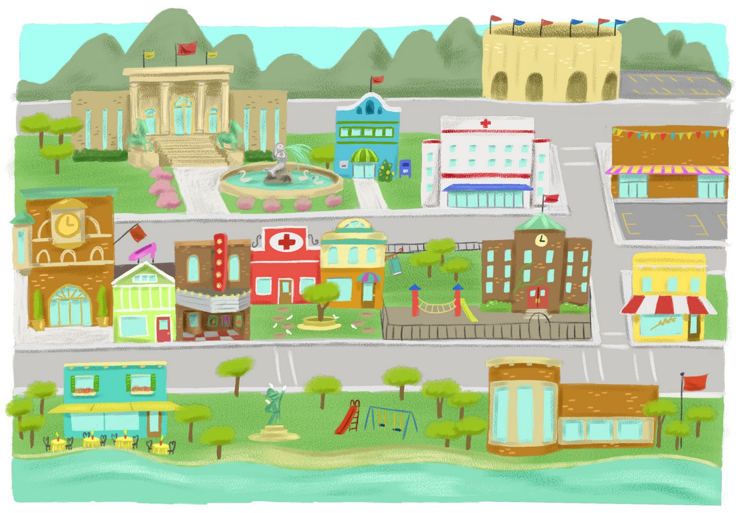
La torre está delante del teatro y al lado de una tienda de libros. A la derecha hay un jardín pequeño con solo un árbol. Detrás del árbol hay un café. Si vas al otro lado de la calle, llegas a la iglesia. La iglesia está al lado del río y también está muy cerca de la escuela.
Si tomas la calle a la derecha de la escuela, puedes ver el estadio al fondo de la calle. En esta zona del pueblo, también hay un museo de historia. El museo es grande y tiene una fuente³. Puedes visitar el museo y luego, si quieres, puedes comprar algo en la tienda de regalos. La tienda es un edificio pequeño y azul.
¹bienvenidos = welcome ² un plano = map ³ una fuente = fountain

Si vous sortez l’hôtel et traversez la rue, vous trouvez un café excellent avec une belle vue du parc. Le parc est en bas de la carte. À gauche du parc, il y a une petite place.
À l’autre côté du parc, vous trouvez un jardin anglais.
Près du jardin est le musée local de Saint-Clair-des-Monts.

teatro

Now read the general information about the town, and answer the questions that follow.
Información para organizar las vacaciones
Jaca es un pueblo en las montañas. Es famoso porque tiene edificios antiguos. Si quieres visitar este lugar, debes viajar en autobús porque no hay una estación de tren.

Jaca ofrece muchas actividades. Cada verano en julio el pueblo celebra el festival de Santa Orosia y muy pronto va a organizar un concierto de música tradicional¹. El diciembre pasado el colegio organizó unas clases de arte. El próximo año mucha gente va a participar en la primera carrera² de barcos en el río.

El teatro no está abierto porque hay problemas con las paredes, pero el cine es una opción. También puedes ir al parque y a los partidos de fútbol en el estadio. Sin embargo, debes ir a otro pueblo si necesitas ir al banco o el mercado.
¹tradicional = traditional ²carrera = race

PART B
Put a tick next to the places that you can go to in Jaca at the moment.

a train station |  |  | a park
a stadium |  |  | a theatre
a cinema |  |  | a bank
a market |  |  | old buildings
PART C
Number these events in the order they happen. Write the numbers 1-4 in the boxes on the right (1= happened first, 4 = will happen last).
boat race on the river
Santa Orosia festival
traditional music concert
art classes

TOTAL MARKS AVAILABLE (READING): 8
SECTION C (WRITING)
PART A
Look at the picture and complete the missing words in the text. The number of gaps tells you how many letters are missing.
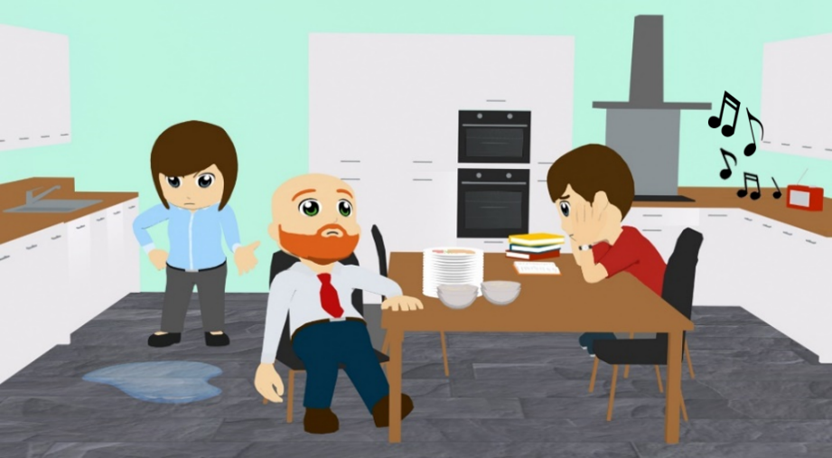
Daniel, Diego y Ana están en la c_ _ _ _ _ y t_ _ _ _ _ unos problemas. Diego no q_ _ _ _ _ comer porque los platos están s_ _ _ _ _. Él parece bastante c_ _ _ _ _ _. Ana está e_ _ _ _ _ _ porque hay a_ _ _ en el suelo. Daniel parece a_ _ _ _ _ _ _. No quiere hacer los d_ _ _ _ _ _. Él debe l_ _ _ un libro, p_ _ _ hay mucho r_ _ _ _.
PART B
What happened last week? What will happen next week?

Write between one and three sentences in Spanish for each picture. Write your sentences in the blank box on the right. Use all of the Spanish words under the boxes.
Try to show that you know what the words mean by writing full, interesting, and varied sentences that make sense. You can use your imagination if you like!

1. Last week
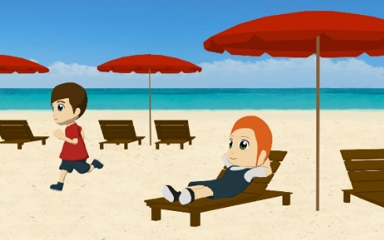
hacer / playa / ejercicio / descansar
2. Next week
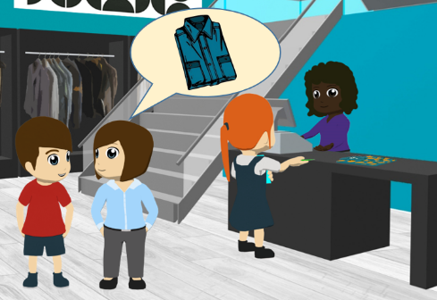
tienda / sábado / ropa / caro

TOTAL MARKS AVAILABLE (WRITING): 20

SECTION D (SPEAKING)
Before you start this section of the test, please go to this website: vocaroo.com.
It will open in a new tab. Click the red record button, then come back to this test.

Look at the photo and follow the instructions below. For each idea you say, you will get 2 marks for expressing the meaning, and 1 mark for speaking accurately. In total (parts A & B combined), you will get 2 marks for speaking fluently.
You have 2 minutes to prepare all of your answers before you speak. It doesn’t matter if you make mistakes! Just try to keep going and say something that you know how to say.

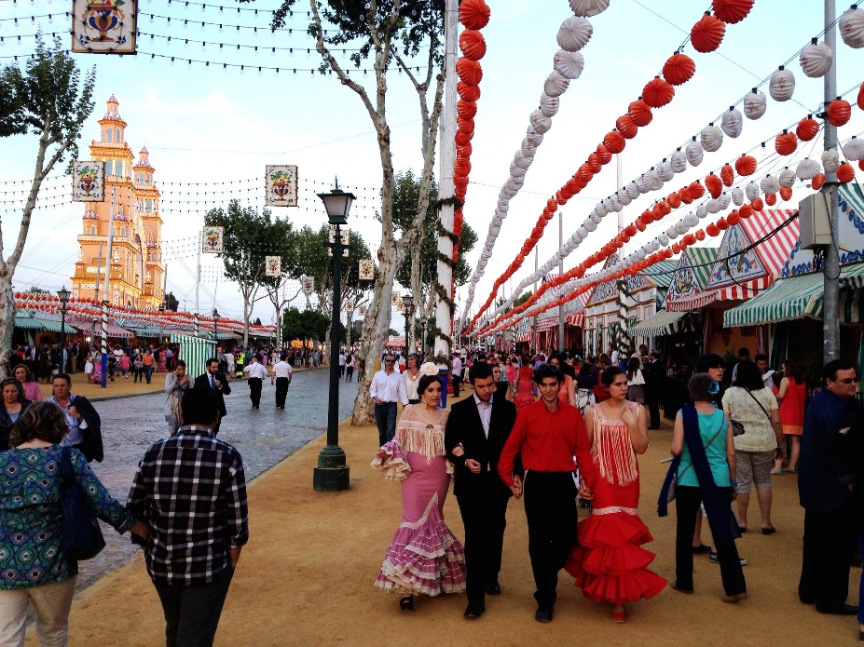

PART A

What can you see in this photo? Try to say at least 4 different things. (12 marks)

Here are some ideas about what you could say. You can say different things if you wish!

• Say what things you can see in the place
• Say what else there is in the street or town (you can use your imagination)
• Describe any of the people in the middle (you can use your imagination)
• Say what one of the people in the picture is doing

PART B

Ask the woman in the centre of the picture 2 different questions. (6 marks)
TOTAL SCORE AVAILABLE (SPEAKING): 20
SECTION E (READING ALOUD & COMPREHENSION)

PART A

Read the following text aloud.

You won’t know some of the words – don’t worry! Just do your best to read them aloud as you think they should sound in Spanish.

You will get marks for understandable and fluent pronunciation.

Juan Luis Guerra es un músico de la República Dominicana, un país pequeño en el Caribe.
Su música es muy conocida, especialmente la canción ‘Ojalá que llueva café’.
Antes de aprender la guitarra estudió filosofía en la universidad.
Ahora da conciertos en todo el mundo y gana muchos premios.
Dice que su música celebra y honra la cultura de su nación.

Juan Luis Guerra en concierto

PART B

Now say, in English, any 4 facts mentioned in the text about Juan Luis Guerra. You will get half a mark for each fact.

TOTAL SCORE AVAILABLE (READING ALOUD & COMPREHENSION): 12

When you have finished, go back to the Vocaroo window. Click on the red button.

Click on "Save & Share". Copy the URL. Paste the URL for your Vocaroo recording below:
Vocaroo link:

