Applying Your Knowledge Test
Y9 Term 2 Spanish

Your name: ______________________ Your class / name of teacher: ______________________

The test is in four sections:

Section A: Listening (10 minutes)
Section B: Reading comprehension (20 minutes)
Section C: Writing (20 minutes)
Section D: Speaking (5-10 minutes)
Section E: Reading aloud (5-10 minutes)

This makes a total of around 60-70 minutes to complete the entire test.

Your teacher will have sent you an audio file for the listening test. Please check you have this ready to play.

Remember – always just have a go! If you know some words, just write / say them!

Just do what you can!

Total marks

Listening | /24
Reading comprehension (written modality) | /8
Writing | /20
Speaking | /20
Reading aloud and comprehension (oral modality) | /12
TOTAL SCORE | /84
TOTAL %

SECTION A (LISTENING)

PART A

You will hear Lucía talk about a trip to Cantabria. In the grid below, you will see some activities she mentions. You must decide who does the activity, and when. For each question, circle one answer for ‘who?’ and one answer for ‘when?’.

You will hear the story twice, with a 20 second gap in between. After hearing the story for the second time, you will have another minute to complete the grid. First, you have 20 seconds to read the activities.

 | Activity | Who? |  | When?
1. | travel to Cantabria | Lucía | Daniel | last year | next year
 |  | Lucía and Daniel | other people | usually in the past

2. | organise something | Lucía | Daniel | last year | next year
 |  | Lucía and Daniel | other people | usually in the past

3. | travel around | Lucía | Daniel | last year | next year
 |  | Lucía and Daniel | other people | usually in the past

4. | give encouragement | Lucía | Daniel | last year | next year
 |  | Lucía and Daniel | other people | usually in the past

5. | manage to finish in third place | Lucía | Daniel | last year | next year
 |  | Lucía and Daniel | other people | usually in the past

6. | take someone home | Lucía | Daniel | last year | next year
 |  | Lucía and Daniel | other people | usually in the past

7. | come again | Lucía | Daniel | last year | next year
 |  | Lucía and Daniel | other people | usually in the past

8. | swim in the river | Lucía | Daniel | last year | next year
 |  | Lucía and Daniel | other people | usually in the past

PART B

Now listen to the story for a third time. You will then have two minutes to answer the questions in English.

Write as many details as you can
(2 marks per question)
a) | Which part of Cantabria is mentioned? When was the trip?
b) | Why did they go there?
c) | Where does the path start and finish?
d) | What happened to Daniel? When?

TOTAL MARKS AVAILABLE (LISTENING): 24
SECTION B (READING COMPREHENSION)

Read the text about Frida Kahlo below and answer the questions that follow.
PART A

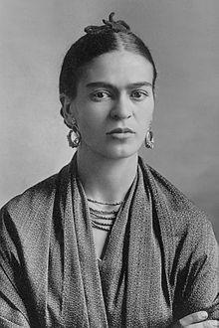
Number these events in the order that they happened. Write the numbers 1-6 in the boxes on the right (1= happened first, 6 = happened last).
Frida Kahlo nació en Ciudad de México en 1907. Cuando era niña empezó a estar muy enferma. Soportó múltiples operaciones, pero siempre tuvo el apoyo de su padre.
Aunque ahora es conocida por su pintura*, al principio pensó en estudiar medicina. Aprendió a pintar gracias a su primer trabajo con un artista, quien le enseñó a dibujar.
Un día sufrió un accidente terrible cuando estaba viajando en autobús. Pasó meses en su cama y su pasión por la pintura* creció. Unos años después comenzó a salir con Diego Rivera, un artista famoso, y se casaron*. Entonces, ambos viajaron a Estados Unidos para vivir allí. Cuatro años más tarde volvieron a México.
En 1939 organizó una exhibición en París, donde conoció a Picasso. También enseñó en una escuela. Murió en 1954 por sus numerosos problemas de salud.
*pintura = painting *casarse = to get married

Frida taught in a school.
Frida and Diego moved to the United States.
Frida met Picasso.
Frida had an accident.
Frida started to go out with someone.
Frida learned how to draw.
PART B
Put a cross (x) in the correct column to show whether the statements below are true (T), false (F), or not mentioned in the text (NM).
 | T | F | NM
Frida was ill when she was a child.
Frida wanted to study medicine.
Frida learned how to draw in her school.
Frida never returned to Mexico.
Frida died in Mexico City.

TOTAL MARKS AVAILABLE (READING COMPREHENSION): 8
SECTION C (WRITING)

PART A

Read Lucía’s postcard. Fill the blanks with a sensible word that starts with the given letter.
¡Hola, Nadia!
Estoy de vacaciones en el s________ de Francia. Ayer fui a una playa p________ con mi hermano y ¡ n________ en el mar toda la tarde! Entonces ocurrió a________ raro. Estaba jugando en el agua cuando de repente noté un dolor en el p________. ¡Creo que un animal me atacó, pero escapó rápido! D________, mi hermano montó en bicicleta por el centro del pueblo. Yo c________ unos dulces muy ricos en la plaza. Todos los días m________ levanto bastante temprano porque quiero hacer muchas cosas. Mañana va a ser el ú________ día de vacaciones, así que voy a recorrer la zona. También voy a c________ unos regalos antes de regresar a casa. ¡Te echo de menos!
Adiós,
Lucía

PART B
What happened last week? What will happen next week?

Write between one and three sentences in Spanish for each picture. Write your sentences in the blank box on the right. Use all of the Spanish words under the boxes.
Try to show that you know what the words mean by writing full sentences that make sense. Remember that you will need to change the form of some of the words. You can use your imagination if you like!

1. Last week
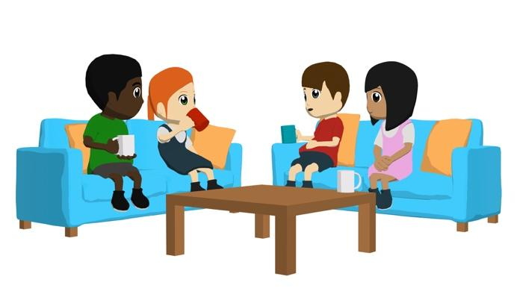

quedar / charlar / caliente / entonces
2. Next week
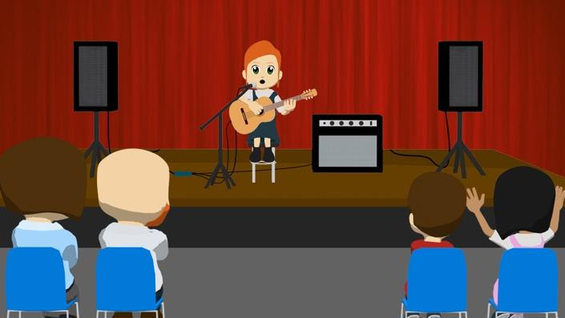
tocar / el espectáculo / por eso / la guitarra

TOTAL MARKS AVAILABLE (WRITING): 20

SECTION D (SPEAKING)
PART A
Before you start this section of the test, please go to this website: vocaroo.com.
It will open in a new tab. Click the red record button, then come back to this test.

Daniel and his friends are talking about what they all did last week, when it was the school holidays. Look at the pictures showing some of the things they got up to.
Then, complete the six sentences (numbered 1 - 6, below the photos) about what they could say about their school holidays. Pick a different activity and use a different verb for each sentence.
For each sentence you say, you will get 2 marks for expressing the meaning (comprehensibility), and 1 mark for speaking accurately (clarity). You can also get up to 2 marks for speaking fluently, across the whole activity.
You have 2 minutes to prepare your answers before you speak.
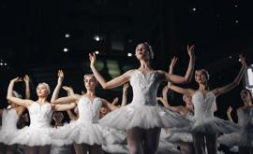
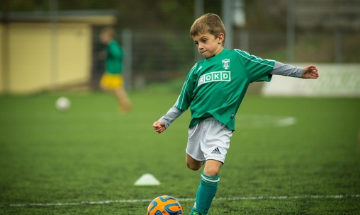
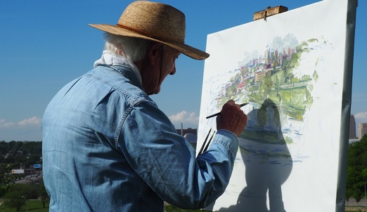
Do your best to say something, even if you’re not totally sure what to say. The main thing is to have a go! You can make up funny sentences if you wish!

La semana pasada durante las vacaciones …
1. |  | El lunes por la mañana yo …
2. |  | el martes Lucía…
3. |  | el miércoles Hugo…
4. |  | el sábado por la noche ellos…

PART B
Now, ask Daniel and Lucía two questions in Spanish.
Remember to choose a different activity for each question.
5. |  | Daniel, did you …?
6. |  | Daniel, did they …?

TOTAL SCORE AVAILABLE (SPEAKING): 20
SECTION E (READING ALOUD & COMPREHENSION)

PART A

Read the following text aloud.

You won’t know some of the words – don’t worry! Just do your best to read them aloud as you think they should sound in Spanish.

There are five paragraphs. For each paragraph you read, you can get up to 1 mark for being understandable (clear) and up to 1 mark for being fluent.

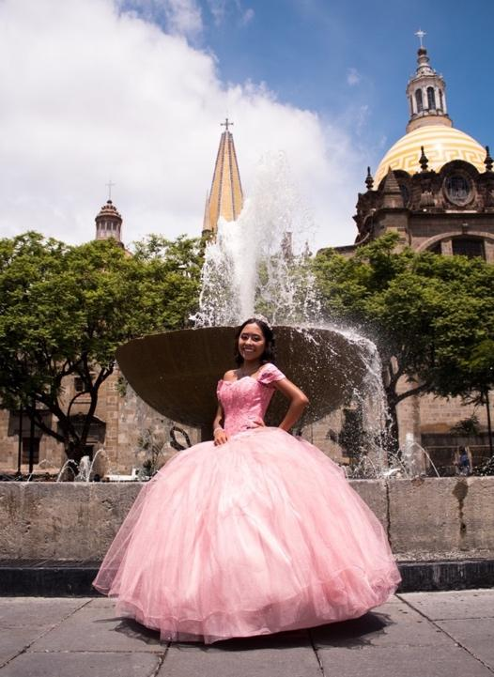 | La fiesta de los quince años es un momento importante, especialmente para la identidad de las chicas. Es la representación del paso a la vida adulta.  Es una tradición considerablemente conocida, pero su popularidad es mayor* en México.  En esta celebración la chica lleva un vestido precioso con muchas decoraciones.  Sus amigos la acompañan y ¡existe la posibilidad de invitar a más de cien personas! Los padres están visiblemente orgullosos y muestran mucha emoción.  Para la hija es una ocasión única, una oportunidad para cumplir su sueño.
 | *mayor = greater

PART B
Now say, in English, any 4 facts mentioned in the text about this tradition. You will get half a mark for each fact.

TOTAL SCORE AVAILABLE (READING ALOUD & COMPREHENSION): 12

When you have finished, go back to the Vocaroo window. Click on the red button.
Click on "Save & Share". Copy the URL. Paste the URL for your Vocaroo recording below:
Vocaroo link:

