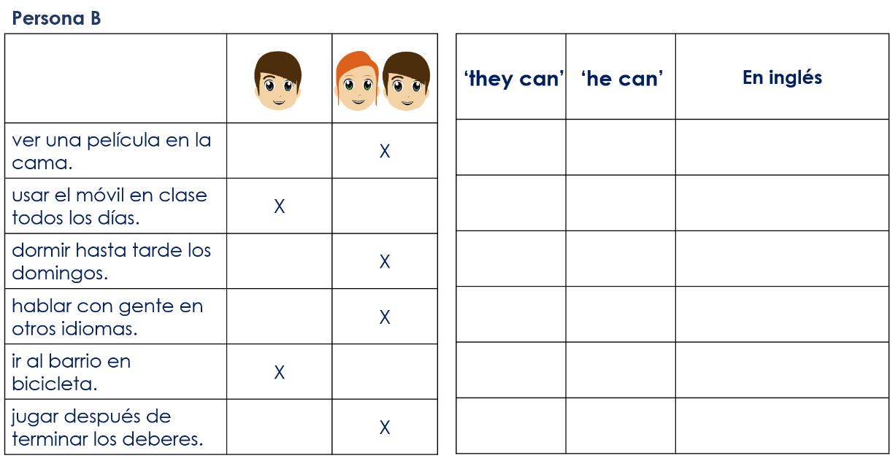
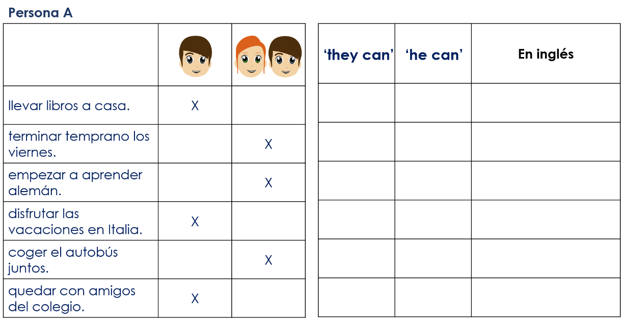
Year 8 Spanish Term 1.1 Week 6 – Speaking cards and listening grids

