Applying your knowledge test
(Y8 Term 3 French)
Mark scheme and transcript

SECTION A (LISTENING)
TRANSCRIPT

[For part A, students hear the text twice, with 20 seconds in between. For part B, students hear the text one more time. Leave a three second gap between each sentence.]

On aime apprendre des langues dans ma famille ! Le printemps dernier, j’ai voyagé en Allemagne avec Léa. J’ai parlé un peu d’allemand pour acheter des billets et des glaces. Mais Léa a fait la conversation avec les Allemands ! Elle étudie cette langue à l’école.

L’automne prochain, nous allons aller en Italie. L’italien, c’est ma matière préférée. C’est une belle langue intéressante. Léa ne va pas comprendre les conversations, mais ce n'est pas un problème. Je vais traduire pour toute la famille !

Nous apprenons l’anglais aussi. Je parle anglais mieux que Léa. Elle comprend des messages de nos amis à Londres, mais je réponds en anglais aussi. Pour plus facilement apprendre des langues, je lis des romans et inscris les nouveaux mots dans mon cahier.

PART A
write down new words go to Italy study German
translate have conversations with local people
pass English exam speak a bit of German watch English films

1 mark = Correctly assigning an activity to a person(s)
1 mark = Correctly assigning an activity to a time period
If a student writes more than one answer in the same box, they receive zero points for all items in that box.

2 marks / item = max. 12 marks in total

^{when?}  _{who?} | in the past | in general | in the future
Amir | 1. speak a bit of German | [1. read novels]  2. write down new words | 1. translate
Léa | 1. have conversations with local people | 1. study German
Amir and Léa | [1. go on a trip] | [1. like learning languages]  [2. learn English] | 1. go to Italy

PART B
2 marks / item = max. 8 marks in total

a) | Where did Amir and Léa visit last year, and when? | Germany (1) (last) spring (1)
b) | What did Amir buy? | tickets (1) ice creams (1)
c) | What does Amir say about Italian? | any two of: favourite subject (1) beautiful (1) interesting (1)
d) | Who speaks better English, Amir or Léa? What example does Amir give to show this? | Amir (1) He replies to messages in English / Léa can understand but not reply (1)

SECTION B (READING)
PART A
0.5 marks / item = max. 4 marks in total
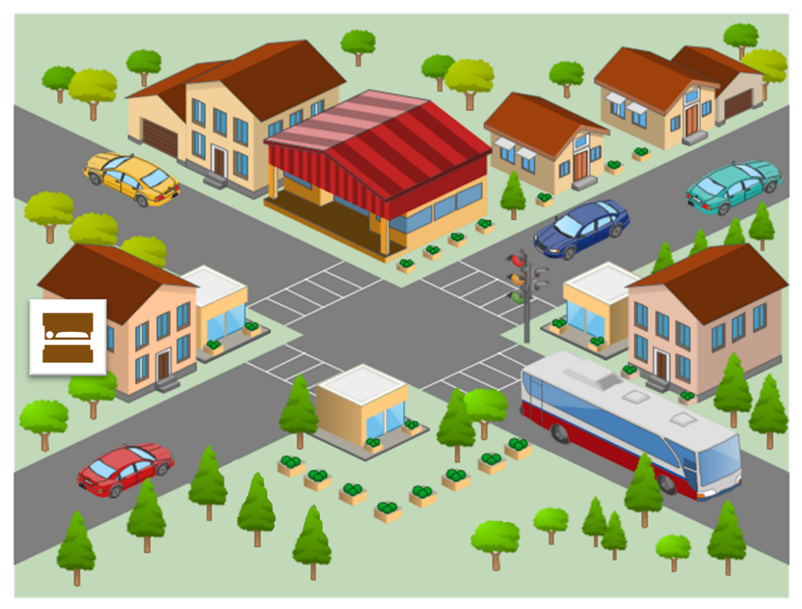
shop
school
museum
(English) garden
café
(little) square
hotel
post office
bank
PART B
0.5 marks / item = max. 2 marks in total
a restaurant |  |  | snow
picnic tables | ✓ |  | ski runs | ✓
a cinema | ✓ |  | a high school | ✓
a theatre |  |  | a university

PART C
0.5 marks / item = max. 2 marks in total
Half-marks may be awarded for correct recognition of a tense (but not adverb). Thus:
1.5 marks are awarded for the following orders: ‘3, 1, 2, 4’, ‘1, 3, 4, 2’
1 mark is awarded for the following order: ‘3, 1, 4, 2’

the closure of the theatre | 1
the bread festival | 3
the cheese festival | 2
the international ski competition | 4

SECTION C (WRITING)

PART A
1 marks / item = max. 12 marks in total
Notes on tolerance:

0.5 mark awarded for an otherwise correctly-spelled word with a missing accent, or with an unnecessary accent added to a non-accented letter.

1 mark awarded for an otherwise correctly-spelled word with an incorrect type of accent but on the appropriate letter.

Note on this tolerance: The NCELP achievement test rewards full accuracy of accent use, and more tolerance is desirable in the Applying Your Knowledge test so that a large proportion of the marks (1/6th in this case) of the marks cannot be lost due to the wrong choice of an accent.

Léa ne va pas à l’école aujourd’hui parce qu’elle est malade. Elle lit un peu de son livre, mais elle doit dormir.
La famille de Léa habite dans un petit appartement à Paris. Par la grande fenêtre, on peut regarder les oiseaux dans l’arbre.
La mère de Léa porte une chemise noire. Elle apporte un thé pour Léa, mais Léa ne veut pas boire en ce moment.

PART B
‘Sentence’ refers to groups of words that include a verb phrase.
1 mark awarded for the use of a word where its meaning is fully and accurately communicated.
0.5 mark awarded where the meaning of a word is communicated but it is not used accurately (e.g., the tense or person is inaccurate).
0 marks awarded where knowledge of the meaning and use of a word is not demonstrated.
NB: This test is based on the NCELP scheme of work. Thus, the mark scheme below assumes no prior knowledge of French other than the language covered in the NCELP SOW. Credit should also be given – following the above criteria – where language that has not been covered is used.

4 marks / set of 2-3 sentences = max. 8 marks in total

SECTION D (SPEAKING)
For each idea in parts A and B we suggest awarding 2 marks for meaning and 1 mark for accuracy for each, giving 3 points for each idea in total.
In addition, overall, there are 2 marks available for fluency in total over parts A and B.
For meaning:
2 marks awarded where the meaning of the idea is communicated with little effort required on the part of the listener.
1 mark awarded where the meaning of the idea is communicated with some effort required on the part of the listener.
0 marks awarded where the meaning of the sentence is not communicated.
For accuracy:
1 mark awarded where all or most of the features (vocabulary, grammar, pronunciation, intonation) are accurately produced.
0.5 mark awarded where some of the features (vocabulary, grammar, pronunciation, intonation) are accurately produced.
0 marks awarded where few or none of the features (vocabulary, grammar, pronunciation, intonation) are accurately produced.
For fluency for both parts A & B combined:
2 mark awarded where speech does not contain many hesitations in between clauses and/or only contains a small number of self-corrections.
1 mark awarded where there are a few hesitations and/or self-corrections
0 marks awarded where speech contains many hesitations or self-corrections.
Notes on tolerance
Where comprehension is not impeded, allow for a foreign accent in pronunciation.
Tolerance is likely to be greater in year 8 than in later years when students will have had more practice.

For overall fluency (parts A & B combined) = max. 2 marks in total
3 marks / idea (parts A & B) = max. 18 marks in total

SECTION E (READING ALOUD & COMPREHENSION)
PART A
This text is composed of roughly 80% words which have been covered in the NCELP Scheme of Work up to the point of these assessments. The other 20%, which have not yet been covered, are shaded grey in the marking grid below. These unfamiliar words are transparent cognates of English, whose SSCs have been covered in the SoW to date. The cognates provide a good test of SSC knowledge (as learners must inhibit their English SSCs), and aid comprehension for Part B where they must demonstrate understanding.

For each sentence we suggest awarding 1 mark for comprehensibility and 1 mark for fluency, giving 2 points for each sentence in total. However, there must a minimum level of comprehensibility (0.5 points) before points can be awarded for fluency.
1 mark awarded where words are pronounced very clearly and comprehensibly, with all or most of the features (SSCs, liaison, stress patterns) accurately produced.
Plus 1 mark awarded where the sentence is read very fluently (with few hesitations
and/or self-corrections)
Plus 0.5 mark awarded where the sentence is read quite fluently (with some
hesitations and/or self-corrections).
0.5 mark awarded where words are pronounced quite clearly and comprehensibly, with most of the features (SSCs, liaison, stress patterns) accurately produced.
Plus 1 mark awarded where the sentence is read very fluently (with few hesitations
and/or self-corrections).
Plus 0.5 mark awarded where the sentence is read quite fluently (with some
hesitations and/or self-corrections).
0 marks awarded where words are pronounced neither clearly nor comprehensibly, with few of the features (SSCs, liaison, stress patterns) accurately produced.
0 marks awarded for fluency where the unit is not awarded any marks for comprehensibility.
2 marks / sentence = max. 10 marks in total
 | Idea | Notes on tolerance
1. | Louis Pasteur est un scientifique français important dans l’histoire. | liaison is required with ‘est un’
2. | Il trouve une solution pour conserver des produits périssables.
3. | Comme résultat, on achète le lait pasteurisé au magasin aujourd’hui. | liaison is required with ‘on achète’
4. | Il crée aussi le premier vaccin contre une maladie dangereuse. | ignore <cc> in ‘vaccin’
5. | C’est pourquoi on dit qu’il est ‘le père de la médecine moderne’.
PART B
Notes:

Award 1/2 point for each fact correctly identified in the text, up to a maximum of 1 point for facts from a single sentence.

Permissible facts are listed in the grid below, each within [ ].

The facts can be expressed using any reasonable English formulation. Given the use of narrative present in the text, it is OK if the present tense is used in the English renderings (or the past, or a mixture).

max. 2 marks in total

 | Allow something like | Disallow
1. | Pasteur was an [important] [French] [scientist / scientific person]
2. | [He discovered / found] a way of [conserving or preserving] [products / (perishable) food]
3. | [That’s why] [we buy pasteurised milk / pasteurised milk is named after him / we call it pasteurised milk][today/ nowadays / now] | Just ‘we buy pasteurised milk (today)’
4. | [He created / developed / made] [the first / a vaccine] [against a dangerous disease] | Reference to dangerous diseases without reference to vaccines
5. | We say that [he is / he is known as] the [father of medicine]

Image information: By Unknown author - Britannica Kids, Public Domain, https://commons.wikimedia.org/w/index.php?curid=28583466
https://en.wikipedia.org/wiki/Louis_Pasteur#/media/File:Louis_Pasteur_experiment.jpg

