Applying your knowledge test
Y8 Term 3 French

Your name: ______________________ Your class / name of teacher: ______________________

The test is in four sections:

Section A: Listening (10 minutes)
Section B: Reading comprehension (20 minutes)
Section C: Writing (20 minutes)
Section D: Speaking (5-10 minutes)
Section E: Reading aloud (5-10 minutes)

This makes a total of around 55-65 minutes to complete the entire test.

Your teacher will have sent you an audio file for the listening test. Please check you have this ready to play.

Remember – always just have a go! If you know some words, just write / say them!

Just do what you can!

Total marks

Listening | /20
Reading comprehension (written modality) | /8
Writing | /20
Speaking | /20
Reading aloud and comprehension (oral modality) | /12
TOTAL SCORE | /80
TOTAL %

SECTION A (LISTENING)

PART A

You will hear Amir talk about language learning in his family. Here are some activities he mentions (plus some that he does not mention!). You have 20 seconds to read the activities.
write down new words go to Italy study German
have conversations with local people translate
pass English exam speak a bit of German watch English films

Write one activity into each space in the grid below. You must decide who does the activity, and when.

You will hear the story twice, with a 20 second gap in between. After hearing it twice, you will have another minute to finish the grid.

^{when?}  _{who?} | in the past | in general | in the future
Amir | 1. ____________________ | 1. read novels  2. ____________________ | 1. ____________________
Léa | 1. ____________________ | 1. ____________________
Amir and Léa | 1. go on a trip | 1. like language learning  2. learn English | 1. ____________________

PART B

Write as many details as you can
(2 marks per question)
a) | Where did Amir and Léa visit last year, and when?
b) | What did Amir buy?
c) | What does Amir say about Italian?
d) | Who speaks better English, Amir or Léa? What example does Amir give to show this?
Now listen for a third time. You then have two minutes to answer the questions in English.
Now turn the page and move on to the next section.

TOTAL MARKS AVAILABLE (LISTENING): 20

SECTION B (READING COMPREHENSION)

You are spending your summer holiday in Saint-Clair-des-Monts, a mountain town in France. You are given a map and an information leaflet about summer time in the town.

PART A
The map isn’t very clear! Read the text and write the English for the words in bold in the right places on the map.

BIENVENUE¹ À SAINT-CLAIR-DES-MONTS !
Voici un plan² de la ville.
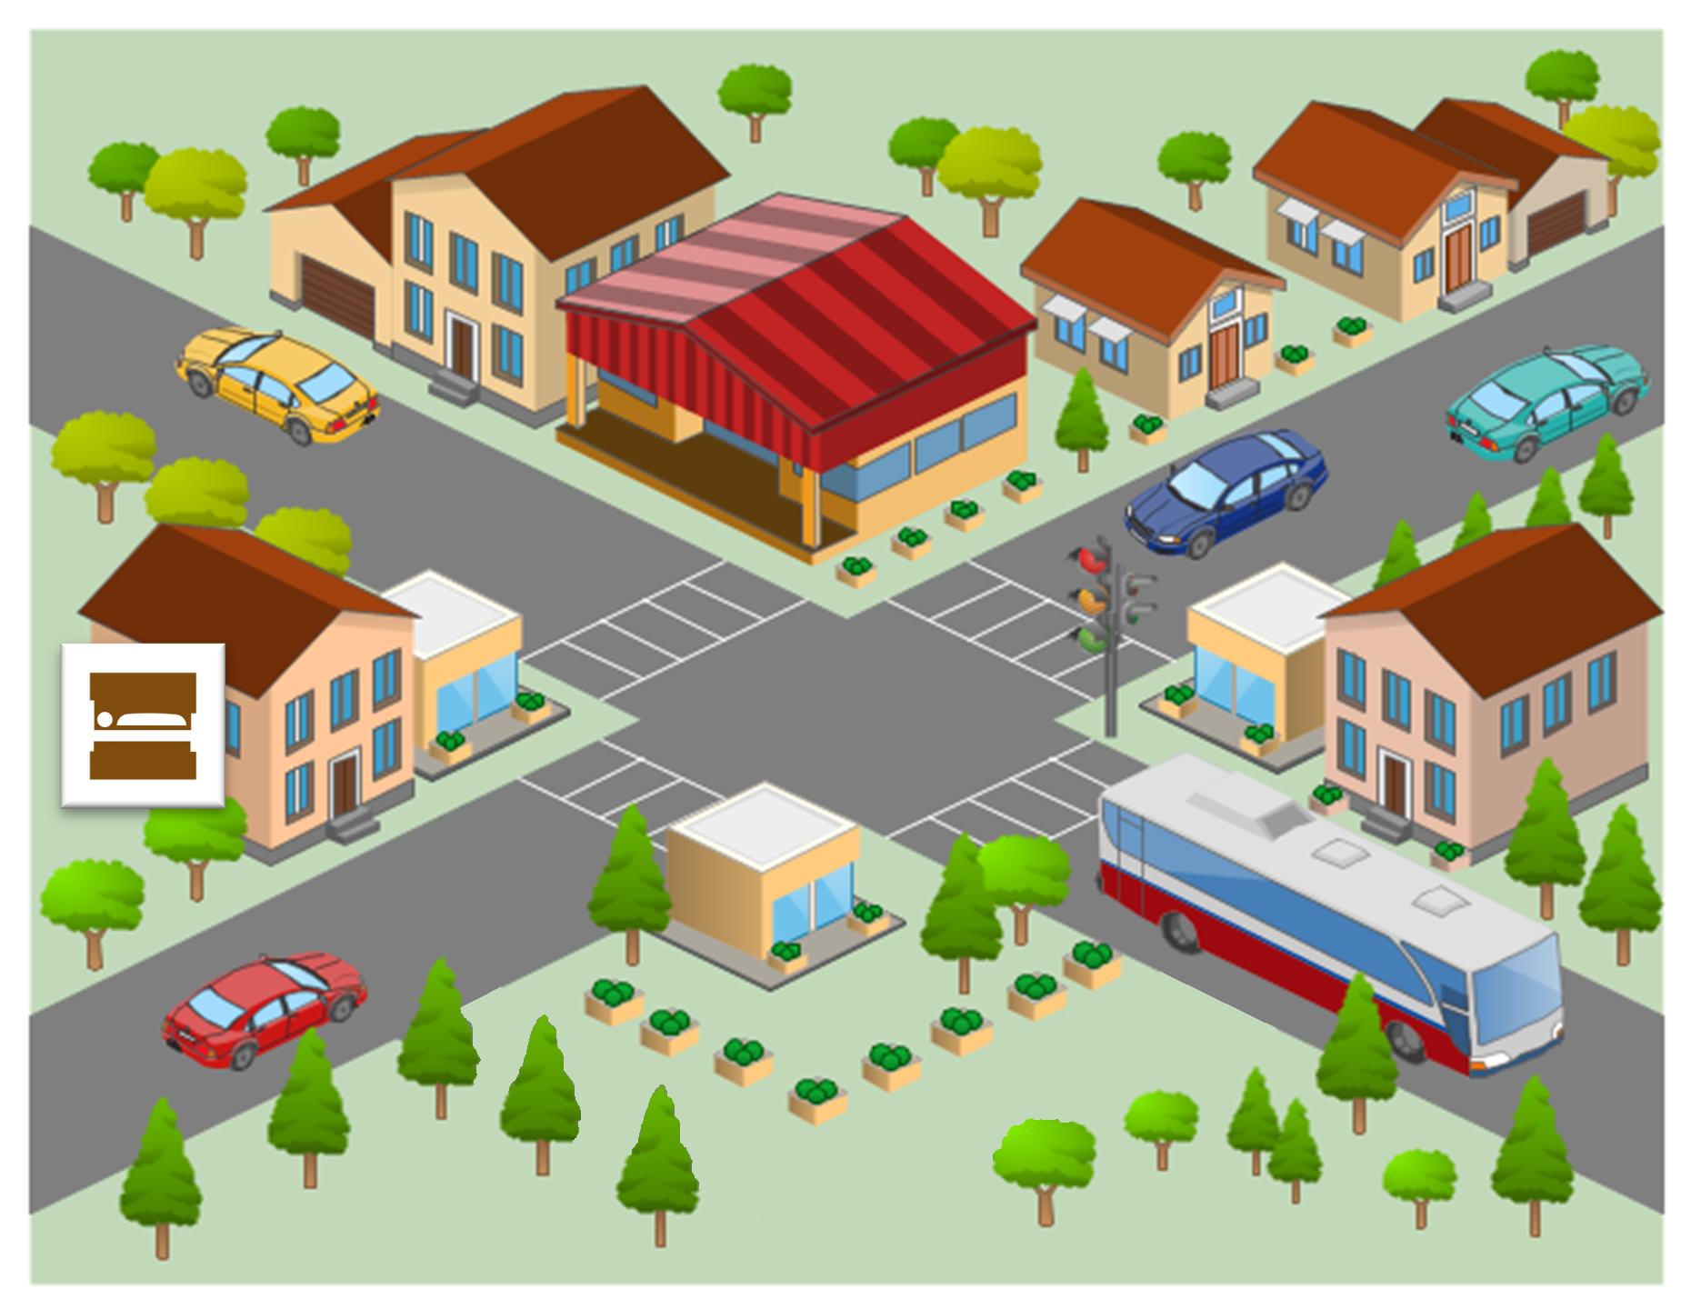
Si vous sortez de l’hôtel et traversez la rue, vous allez trouver un café avec une belle vue du parc. Le parc est en bas de la carte. À gauche, il y a une petite place. À droite on trouve le jardin anglais.
Près du parc il y a le musée local de Saint-Clair-des-Monts. C’est un lieu populaire³, et il y a toujours⁴ un grand bus devant le bâtiment. À côté du musée, vous trouvez l’école.
En haut de la carte il y a un grand magasin. Le magasin est entre deux autres bâtiments, la banque et la poste. Le bâtiment qui est moins petit est la poste.
¹bienvenue = welcome ² le plan = map ³populaire = popular ⁴toujours = always

Si vous sortez l’hôtel et traversez la rue, vous trouvez un café excellent avec une belle vue du parc. Le parc est en bas de la carte. À gauche du parc, il y a une petite place.
À l’autre côté du parc, vous trouvez un jardin anglais.
Près du jardin est le musée local de Saint-Clair-des-Monts.

hotel
Now read the general information about the town, and answer the questions that follow.
Voici des informations pour mieux organiser les vacances.
Le café est excellent. Ici, on prépare des repas pour les événements
nationaux. Ce mois, on a mangé de bons sandwichs pendant la Fête
du pain, et on va très bientôt célébrer la Fête du fromage !
Dans le parc, il y avait un restaurant, mais aujourd’hui vous trouvez des
tables pour manger dehors. Il y a un cinéma aussi, mais notre théâtre a fermé
l’année dernière.
Il n’y a pas de neige à Saint-Clair-des-Monts en été, mais on peut faire des promenades sur les pistes. En hiver, on va organiser une compétition internationale de ski.
Il y a un lycée pour les élèves locaux, mais on doit aller à Chambéry (une autre ville près d’ici) pour aller à l’université.

PART B

Put a tick next to the things that can be found in Saint-Clair-des-Monts at the moment.

a restaurant |  |  | snow
picnic tables |  |  | ski runs
a cinema |  |  | a high school
a theatre |  |  | a university
PART C

Number these events in the order they happen. Write the numbers 1-4 in the boxes on the right (1= happened first, 4 = will happen last).
the closure of the theatre
the bread festival
the cheese festival
the international ski competition

TOTAL MARKS AVAILABLE (READING COMPREHENSION): 8
SECTION C (WRITING)
PART A
Look at the picture and complete the missing words in the text. The number of gaps tells you how many letters are missing.

Léa ne v_ pas à l’école aujourd’hui parce qu’elle est m_ _ _ _ _ . Elle l_ _ un peu de son livre, mais elle doit d_ _ _ _ _.
La f_ _ _ _ _ _ de Léa habite dans un petit a__ _ _ _ _ _ _ _ _ à Paris. Par la grande
f _ _ _ _ _ _, on peut regarder les oiseaux dans l’a_ _ _ _.
La mère de Léa p _ _ _ _ une chemise
n_ _ _ _. Elle apporte un t _ _ pour Léa, mais Léa ne v_ _ _ pas boire en ce moment.

PART B
What happened last week? What will happen next week?

Write between one and three sentences in French for each picture. Write your sentences in the blank box on the right. Use all of the French words under the boxes.
Try to show that you know what the words mean by writing full, interesting, and varied sentences that make sense. You can use your imagination if you like!

1. Last week
travailler / l’examen / dur / note
2. Next week
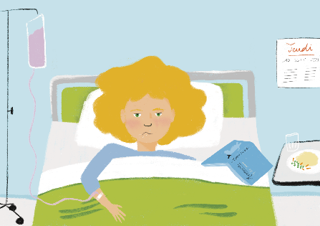
jeudi / l’hôpital / rester / son OR sa OR ses

TOTAL MARKS AVAILABLE (WRITING): 20

SECTION D (SPEAKING)
Before you start this section of the test, please go to this website: vocaroo.com.
It will open in a new tab. Click the red record button, then come back to this test.

Look at the photo and answer the questions below in French. For each idea you say, you will get 2 marks for expressing the meaning, and 1 mark for speaking accurately. In total (parts A & B combined), you will get 2 marks for speaking fluently.
You have 2 minutes to prepare all of your answers before you speak. It doesn’t matter if you make mistakes! Just try to keep going and say something that you know how to say.

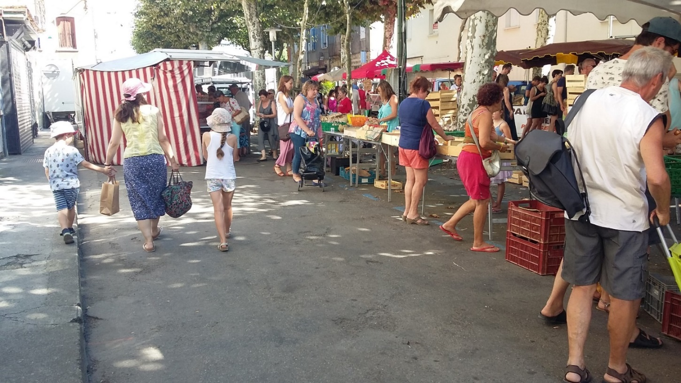
PART A

What can you see in this photo? Try to say at least 4 different things in French. (12 marks)

Here are some ideas about what you could say. You can say different things if you wish!

• Say something about the weather
• Say what there is in the town (you can use your imagination)
• Describe any of the three people on the left (you can use your imagination)
• Say what one of the people in the picture is doing

PART B

Ask the man on the right 2 different questions in French. (6 marks)
TOTAL SCORE AVAILABLE (SPEAKING): 20
SECTION E (READING ALOUD & COMPREHENSION)

PART A

Read the following text aloud.

You won’t know some of the words – don’t worry! Just do your best to read them aloud as you think they should sound in French.

You will get marks for understandable and fluent pronunciation.

Louis Pasteur est un scientifique français très important dans l'histoire.
Il trouve une solution pour conserver des produits périssables.
Comme résultat, on achète le lait ‘pasteurisé’ au magasin aujourd’hui.
Il crée aussi le premier vaccin contre une maladie dangereuse.
C'est pourquoi on dit qu'il est ‘le père de la médecine moderne’.
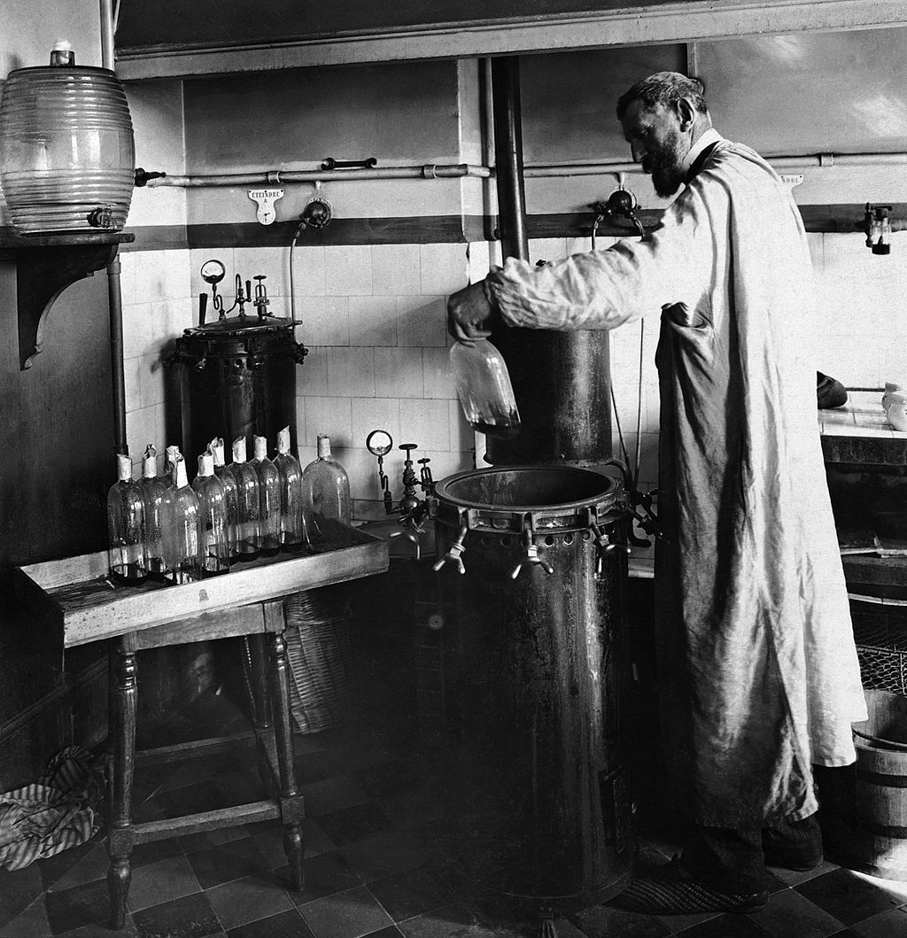
Louis Pasteur (1822-1895) dans son laboratoire

PART B

Now say, in English, any 4 facts mentioned in the text about Louis Pasteur. You will get half a mark for each fact.

TOTAL SCORE AVAILABLE (READING ALOUD & COMPREHENSION): 12

When you have finished, go back to the Vocaroo window. Click on the red button.
Click on "Save & Share". Copy the URL. Paste the URL for your Vocaroo recording below:
Vocaroo link:

