Generally we start at 10 in the morning.

Today I am teaching Chinese.

Sometimes we buy pens in school.

Normally you organise the classes.

This afternoon I am listening to songs in class.

Now you are dancing on the table.

Say these sentences in Spanish:
Estudiante A
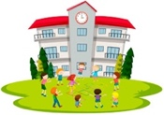
 |  | who? | it happens regularly | it’s happening now
1 | teach _________________
2 | work _________________
3 | speak _________________
4 | write _________________
5 | study _________________
6 | participate _________________

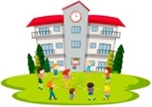
- Normally I write many emails.
- Generally we study without chairs.
- Today you are participating in a market.

- At the moment, I am teaching science.
- Sometimes we work in silence.
- Now you are speaking in Chinese.

Say these sentences in Spanish:
Estudiante B

 |  | who? | it happens regularly | it’s happening now
1 | organize _________________
2 | listen to _________________
3 | dance _________________
4 | start _________________
5 | teach _________________
6 | buy _________________

Estudiante A
Say these sentences in Spanish:
- Normally you organise the classes.
- This afternoon I am listening to songs in class.
- Now you are dancing on the table.

- Generally we start at 10 in the morning.
- Today I am teaching Chinese.
- Sometimes we buy pens in school.
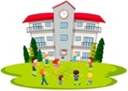
 |  | who? | it happens regularly | it’s happening now
1 | teach _________________
2 | work _________________
3 | speak _________________
4 | write _________________
5 | study _________________
6 | participate _________________

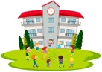
Say these sentences in Spanish:
Estudiante B
- At the moment, I am teaching science.
- Sometimes we work in silence.
- Now you are speaking in Chinese.

- Normally I write many emails.
- Generally we study without chairs.
- Today you are participating in a market.

 |  | who? | it happens regularly | it’s happening now
1 | organize _________________
2 | listen to _________________
3 | dance _________________
4 | start _________________
5 | teach _________________
6 | buy _________________
- Normally you organise the classes.
- This afternoon I am listening to songs in class.
- Now you are dancing on the table.

Say these sentences in Spanish:
Estudiante A
- Generally we start at 10 in the morning.
- Today I am teaching Chinese.
- Sometimes we buy pens in school.
 |  | who? | it happens regularly | it’s happening now
1 | teach _________________
2 | work _________________
3 | speak _________________
4 | write _________________
5 | study _________________
6 | participate _________________

Estudiante B
Say these sentences in Spanish:
- Normally I write many emails.
- Generally we study without chairs.
- Today you are participating in a market.

- At the moment, I am teaching science.
- Sometimes we work in silence.
- Now you are speaking in Chinese.

 |  | who? | it happens regularly | it’s happening now
1 | organize _________________
2 | listen to _________________
3 | dance _________________
4 | start _________________
5 | teach _________________
6 | buy _________________

