Student A
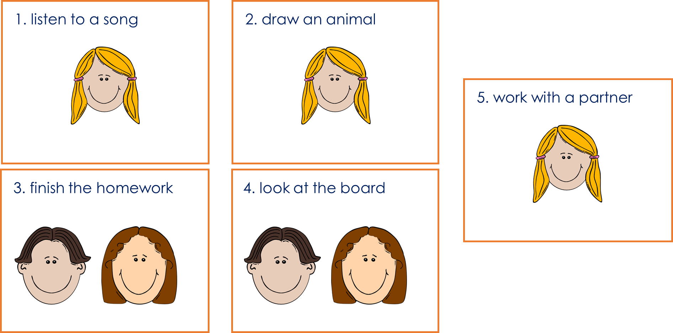

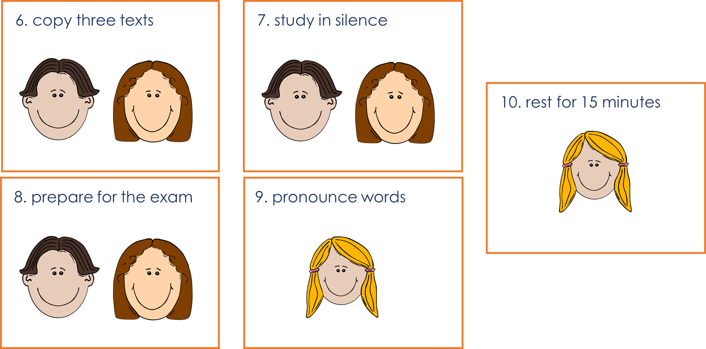
Student B

(Student B) How many students… | one | more than one
have to listen to a Spanish song?
have to draw an animal?
have to finish their homework?
have to look at the board?
have to work with a partner?
------------------------------------------------------------------------------------------------------------------------------------------------------------------
(Student A) How many students… | one | more than one
have to copy three texts?
have to study in silence?
have to prepare for the exam?
have to pronounce new words?
have to rest for 15 minutes?!

