What did I say? [Partner A, Version 1]
Imagine you are facetiming (or skyping etc) with a French friend. You are going to imitate one of those conversations where the connection isn’t great and keeps ‘glitching out’ so you can’t quite hear everything that is being said! So, when you are speaking you will miss out some words. You will see whether your partner can work out what you must have said by using the rest of the sentence.
Partner A
Read each sentence out in French but do not say out loud the word that is crossed out. Take care to say the correct form of the verb. This tells your partner whether you’re talking about one of your friends or more than one. Your partner will choose between two pictures (showing one or more than one).
Then, the connection gets better so you say the whole sentence the 2nd time around. S/he will then complete the sentence in French – so repeat and allow time for writing. Your partner will then tell you in English what s/he has understood about what your friends do.
1 | He finishes the homework.
2 | They choose a book.
3 | They finish the work.
4 | She chooses an ice cream.
5 | He finishes the letter.

Partner A
Listen to your partner reading out 5 sentences. For each, circle the correct picture (one or more than one person). It is the verb form that tells you this. Then try to complete each sentence that your partner reads out. What have you found out what your partner’s friends do? Tell him/her in English.
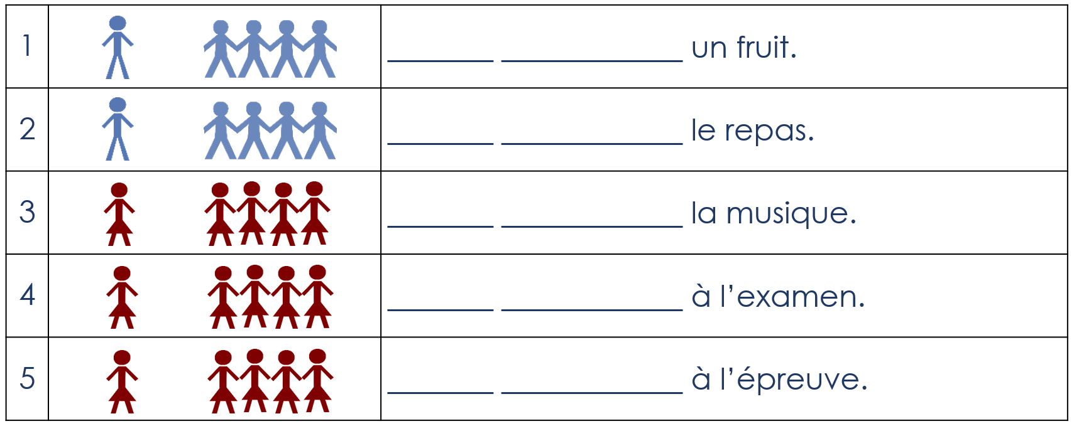

What did I say? [Partner A, Version 2]
Imagine you are facetiming (or skyping etc) with a French friend. You are going to imitate one of those conversations where the connection isn’t great and keeps ‘glitching out’ so you can’t quite hear everything that is being said! So, when you are speaking you will miss out some words. You will see whether your partner can work out what you must have said by using the rest of the sentence.
Partner A
Read each sentence out in French but do not say out loud the word that is crossed out. Take care to say the correct form of the verb. This tells your partner whether you’re talking about one of your friends or more than one. Your partner will choose between two pictures (showing one or more than one).
Then, the connection gets better so you say the whole sentence the 2nd time around. S/he will then complete the sentence in French – so repeat and allow time for writing. Your partner will then tell you in English what s/he has understood about what your friends do.
1 | Il finit/finissent les devoirs.
2 | ils choisit/choissent un livre.
3 | Elles finit/finissent le travail.
4 | Elle choisit/choisissent une glace.
5 | Il finit/finissent la lettre.

Partner A
Listen to your partner reading out 5 sentences. For each, circle the correct picture (one or more than one person). It is the verb form that tells you this. Then try to complete each sentence that your partner reads out. What have you found out what your partner’s friends do? Tell him/her in English.

What did I say? [Partner B, Version 1]
Imagine you are facetiming (or skyping etc) with a French friend. You are going to imitate one of those conversations where the connection isn’t great and keeps ‘glitching out’ so you can’t quite hear everything that is being said! So, when you are speaking you will miss out some words. You will see whether your partner can work out what you must have said by using the rest of the sentence.
Partner B
Listen to your partner reading out 5 sentences. For each, circle the correct picture (one or more than one person). It is the verb form that tells you this. Then try to complete each sentence that your partner reads out. What have you found out what your partner’s friends do? Tell him/her in English.
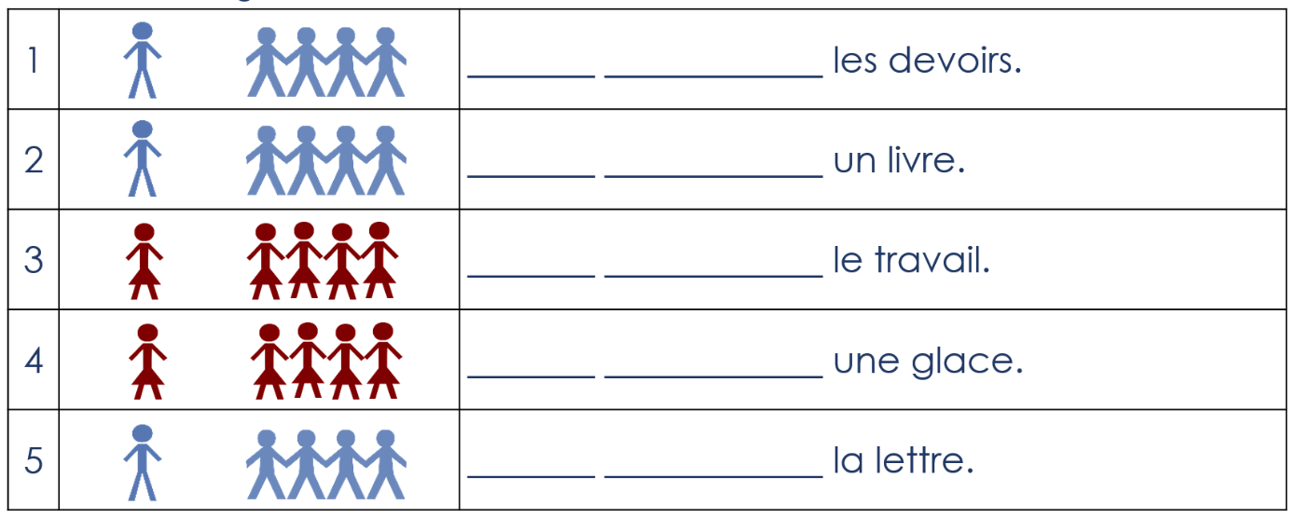

Partner B
Read each sentence out in French but do not say out loud the word that is crossed out. Take care to say the correct form of the verb. This tells your partner whether you’re talking about one of your friends or more than one. Your partner will choose between two pictures (showing one or more than one).
Then, the connection gets better so you say the whole sentence the 2nd time around. S/he will then complete the sentence in French – so repeat and allow time for writing. Your partner will then tell you in English what s/he has understood about what your friends do.

6 | They choose a fruit.
7 | They finish the meal.
8 | She chooses music.
9 | They succeed in the exam.
10 | She succeeds in the test.

What did I say? [Partner B, Version 2]
Imagine you are facetiming (or skyping etc) with a French friend. You are going to imitate one of those conversations where the connection isn’t great and keeps ‘glitching out’ so you can’t quite hear everything that is being said! So, when you are speaking you will miss out some words. You will see whether your partner can work out what you must have said by using the rest of the sentence.
Partner B
Listen to your partner reading out 5 sentences. For each, circle the correct picture (one or more than one person). It is the verb form that tells you this. Then try to complete each sentence that your partner reads out. What have you found out what your partner’s friends do? Tell him/her in English.

Partner B
Read each sentence out in French but do not say out loud the word that is crossed out. Take care to say the correct form of the verb. This tells your partner whether you’re talking about one of your friends or more than one. Your partner will choose between two pictures (showing one or more than one).
Then, the connection gets better so you say the whole sentence the 2nd time around. S/he will then complete the sentence in French – so repeat and allow time for writing. Your partner will then tell you in English what s/he has understood about what your friends do.
6 | Ils choisit/choisissent un fruit.
7 | Ils finit/finissent le repas.
8 | Elle choisit/choisissent la musique.
9 | Elles réussit/réussissent à l’examen.
10 | Elle réussit/réussissent à l’épreuve.

